

Requirement & Design Specification
Global Assess Management System (GAMS)
Version: 1.0

– Hanoi, May 2026 –

Record of Changes
Version | Date | A*  M, D | In charge | Change Description
*A - Added M - Modified D - Deleted

Contents
Record of Changes 2
I. Overview 5
1. System Context 5
2. External Entities 5
3. Business Processes 5
3.1 Sale Process 6
3.2 Customer Support 6
4. User Requirements 6
4.1 UCs for Guest 7
4.2 UCs for Student 7
4.3 … 7
5. System Functionalities 7
5.1 Screens Flow 7
5.2 Screen Authorization 8
5.3 Non-UI Functions 8
II. Functional Requirements 9
1. Feature Name1 9
1.1 SubFeature Name1.1 9
1.2 SubFeature Name1.2 9
2. User Authentication 9
2.1 User Register 9
3. System Administration 9
3.1 Master Data 9
3.2 User Management 10
III. System Design 11
1. Software Architecture 11
1.1 Overall Architectural Diagram 11
1.2 Component Descriptions 11
2. Code Package Design 11
2.1. Package Diagram 12
2.2 Package Descriptions 12
3. Database Design 12
3.1 Database Schema 13
3.2 Table Descriptions 13

I. Overview

1. System Context
The Generator Warehouse Management System (GAMS) is an internal web-based application designed to replace the current manual processes for managing generator inventory, import/export operations, and sales transactions within the warehouse. The system provides role-based access for four primary user groups: Warehouse Admin, Warehouse Manager, Warehouse Staff, and Sales Staff — each with distinct responsibilities and permissions.
The context diagram below illustrates the system boundary, external entities, and the data flows between them for the current release. The system handles user authentication and authorization, generator catalog management, import/export receipt workflows with approval processes, order management, and inventory auditing.
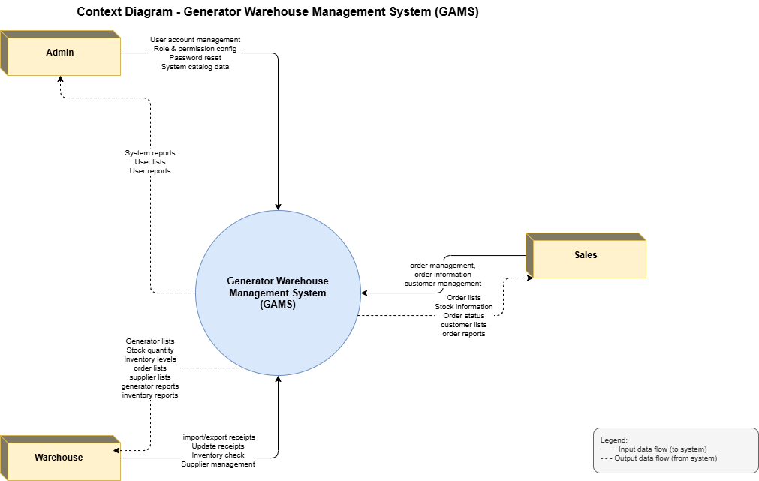

2. Feature Tree
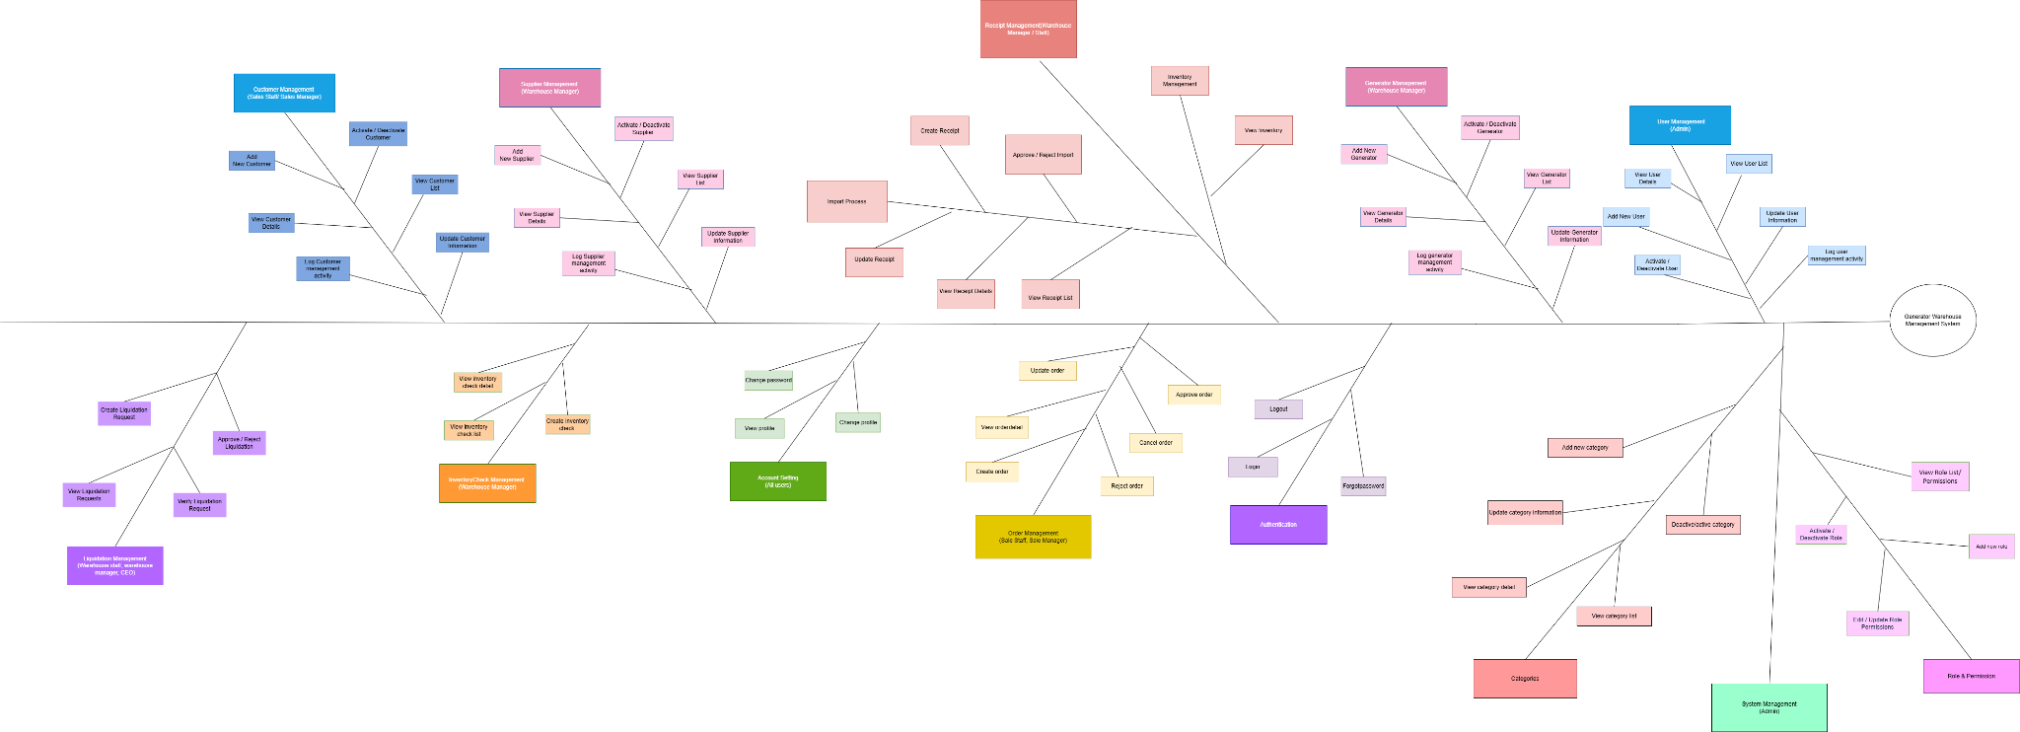

2. External Entities

# | Entity | Description
1 | Admin | An internal user responsible for managing system users and access control. Admin has access to a dedicated interface to manage user accounts, manage roles and their permissions.
2 | Warehouse Manager | An internal user with managerial access to warehouse operations, responsible for approving or rejecting pending import and export tickets. Warehouse Manager also view import/ export reports, perform inventory counts and manage generator information.
3 | Warehouse Staff | An internal user responsible for daily warehouse transactions. Warehouse Staff can view generator lists and details, view lists of import/export tickets, create and update import and export tickets, search/lookup inventory levels to check current stock quantities.
4 | Sales Staff | An internal user responsible for managing customer transactions. Sales Staff can create and manage purchase/sale tickets for generators.

3. Business Processes
[Provide business processes () using the swim-lane diagram(s) like sample below
A business process a collection of activities that takes one or more kinds of input and creates an output that is of value to the customer. The customer for a business process may be a traditional external customer (the person who buys the finished product), or it may be an internal customer (such as a colleague in another department)]

3.1 Sale Process
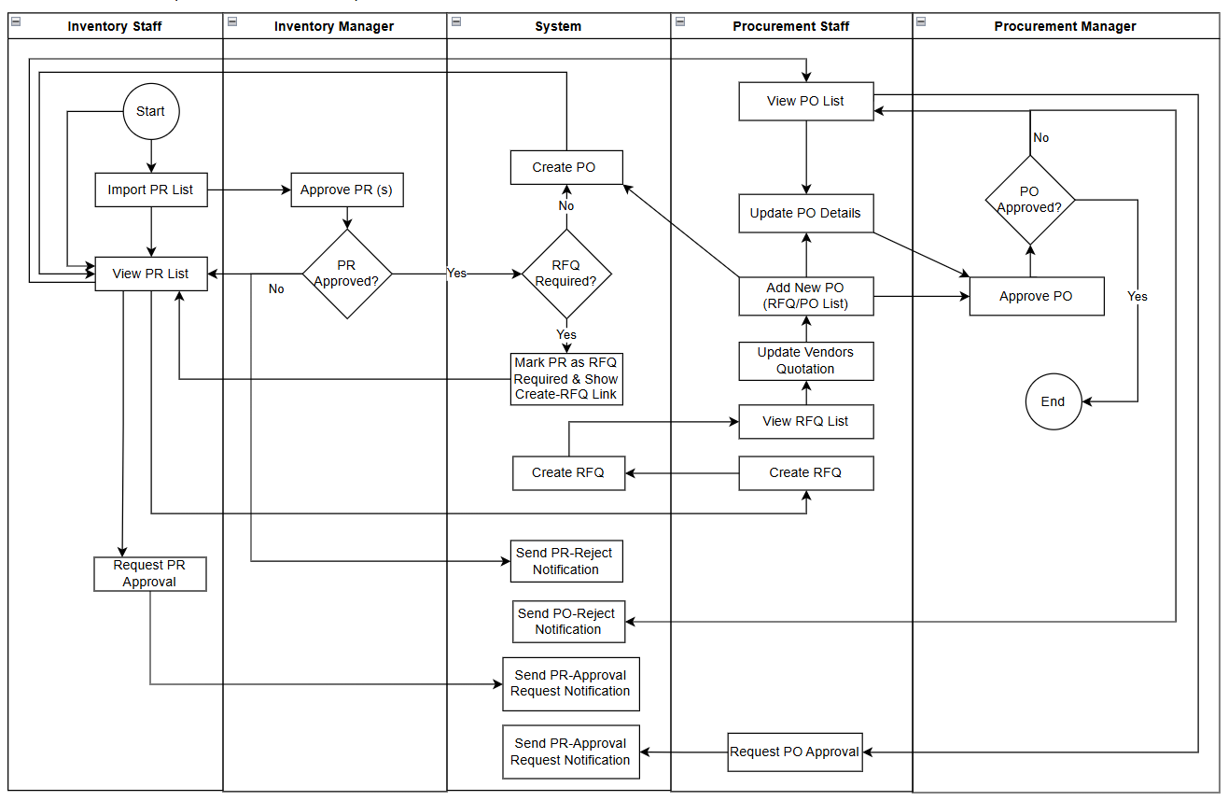

3.2 Customer Support

4. User Requirements

ID | Use Case | Feature | Main Actor | Use Case Description
UC-01 | View User List | User Management | Admin | Admin can view the complete list of all internal user accounts in the system
UC-02 | View User Detail | User Management | Admin | Admin can view detailed information of a specific internal user including role and account status
UC-03 | Add New User | User Management | Admin | Admin creates and assigns a new internal account to staff
UC-04 | Activate/Deactivate User | User Management | Admin | Admin can activate or deactivate a staff account to control system access
UC-05 | Update User Information | User Management | Admin | Admin can update personal or account information of an existing internal user
UC-06 | View Password Reset Requests | User Management | Admin | Admin views the list of pending password reset requests submitted by users, including requester name, request date, and current status.
UC-07 | Process Password Reset Request | User Management | Admin | Admin reviews a password reset request, assigns a new temporary password, and approves or rejects the request. The user is notified of the outcome.
UC-08 | View Role List | Role Management | Admin | Admin can view all roles defined in the system (Manager, Warehouse Staff, Sale Staff)
UC-09 | View Role Permissions | Role Management | Admin | Admin can view the permissions and access rights assigned to each role 7
UC-10 | Update Role Information | Role Management | Admin | Admin can update the name or description of an existing role
UC-11 | Activate/Deactivate Role | Role Management | Admin | Admin can activate or deactivate a role to control its availability
UC-12 | Edit Role Permissions | Role Management | Admin | Admin can modify the set of permissions granted to a specific role
UC-13 | View System Categories list | System Configuration | Admin | Admin can view the complete list of all product/system categories defined in the system.
UC-14 | View Specific Category | System Configuration | Admin | Admin can view detailed information and attributes of a specific system category.
UC-15 | Update Category Information | System Configuration | Admin | Admin can update the name, description, or metadata of an existing system category.
UC-16 | Add New Category | System Configuration | Admin | Admin can create and configure a new category in the system configuration settings.
UC-17 | Deactivate/Activate Category | System Configuration | Admin | Admin can activate or deactivate a system category to control its availability across other functional modules (e.g., product management).
UC-18 | Login | User Authentication | All Users | User logs in with username and password. System authenticates via BCrypt and redirects to role-based dashboard.
UC-19 | Change Password | User Authentication | All Users | Logged-in user changes password. Requires old password verification and compliance with complexity rules.
UC-20 | Forgot Password | User Authentication | All Users | User requests password reset via username. Admin grant a new password
UC-21 | Logout | User Authentication | All Users | User logs out. System clears session, removes auth cookies, redirects to Login screen.
UC-22 | View Profile | User Profile | All Users | User views personal information: ID, name, join date, roles, account status.
UC-23 | Edit Profile | User Profile | All Users | User edits allowed fields (full name, phone, address). Username and Email are locked.
UC-24 | Home Page | Home Page | All Users | User accesses the home page after login. System displays role-based dashboard information and quick navigation to authorized features.
UC-25 | View Generator List | Generator Management | Warehouse Manager, Warehouse Staff, Sale Manager, Sale Staff | User views the complete list of generator models in the system catalog, including model name, brand, power rating (kVA), unit price, and availability status.
UC-26 | View Generator Detail | Generator Management | Warehouse Manager, Warehouse Staff, Sale Manager, Sale Staff | User views detailed information of a specific generator model including full specifications, description, and current stock levels.
UC-27 | Add New Generator | Generator Management | Warehouse Manager,Warehouse Staff | Warehouse Manager adds a new generator model to the system catalog with complete information: model, brand, power rating, unit price, and description.
UC-28 | Update Generator Information | Generator Management | Warehouse Manager,Warehouse Staff | Warehouse Manager updates the information of an existing generator model in the catalog (e.g., price, description).
UC-29 | Activate/Deactivate Generator | Generator Management | Warehouse Manager,Warehouse Staff | Warehouse Manager activates or deactivates a generator model to control whether it can be included in sale orders.
UC-30 | View inventory | Inventory  Management | Warehouse Manager, Warehouse Staff, Sale Staff | Users view current inventory levels of each generator model per warehouse, including quantity on hand. Supports filtering by warehouse and product.
UC-31 | Create Inventory Audit | Inventory Management | Warehouse Staff | Warehouse staff conducts a physical count and creates an inventory audit record detailing the actual quantity of generators on hand to propose an adjustment.
UC-32 | Approve Inventory Audit | Inventory Management | Warehouse Manager | Warehouse Manager reviews the physical count discrepancies against system records and approves the audit. The system automatically adjusts inventory and logs the transaction.
UC-33 | View Stock Card | Inventory Management | Warehouse Manager, Warehouse Staff, Sale Staff | Users view the stock card (inventory transaction history) of a specific generator at a specific warehouse, showing all IMPORT, EXPORT, and ADJUST transactions over time.
UC-34 | View Order List | Order Management | Sale Staff, Sale Manager, Warehouse Manager | The user views the list of all sale orders with filters by status (PENDING, APPROVED, REJECTED, CANCELLED), date range, and creator.
UC-35 | View Order Detail | Order Management | Sale Staff, Sale Manager, Warehouse Manager | Users view the full details of a sale order including customer information (name, phone, email, address, tax code, company name), ordered products, quantities, unit prices, total amount, and status history.
UC-36 | Create Order | Order Management | Sale Staff | Sale staff creates a new sale order for a customer (individual or company), selects generator models, quantities, and prices. The order is created in PENDING status awaiting approval.
UC-37 | Update Order | Order Management | Sale Staff, Sale Manager | Sale Staff can edit their own PENDING order (customer info, line items). Sale Manager can additionally edit orders created by staff before approving.
UC-38 | Approve Order | Order Management | Sale Manager | Sale Manager approves a PENDING sale order, transitioning it to APPROVED status and triggering the warehouse export process.
UC-39 | Reject Order | Order Management | Sale Manager | The Sale Manager rejects a PENDING sale order with a specific reason, transitioning it to REJECTED status.
UC-40 | Cancel Sale Order | Order Management | Sale Staff, Sale Manager | Sale staff or Sale Manager cancels an order that has not yet been fully processed (PENDING or APPROVED without a completed export receipt).
UC-41 | View Receipt List | Receipt Management | Warehouse Manager, Warehouse Staff | User views the list of all import/export receipts with filters by type (IMPORT/EXPORT), status (PENDING_RECONCILED, COMPLETED, CANCELLED), warehouse, and date range.
UC-42 | View Receipt Detail | Receipt Management | Warehouse Staff, Warehouse Manager | User views full details of a receipt including the list of scanned serial numbers, linked warehouse, associated sale order, creator, and approver.
UC-43 | Create Import Receipt | Receipt Management | Warehouse Staff | Warehouse staff creates an import receipt, selects a warehouse, and enters or scans the serial number of each incoming generator unit. The receipt is created in PENDING_RECONCILED status awaiting manager approval.
UC-44 | Create Export Receipt | Receipt Management | Warehouse Staff | Warehouse staff creates an export receipt linked to an APPROVED sale order, selects a warehouse, and scans the serial number of each unit being dispatched. The receipt is created in PENDING_RECONCILED status awaiting manager approval.
UC-45 | Approve Receipt | Receipt Management | Warehouse Manager | Warehouse Manager approves a valid import or export receipt, transitioning it to COMPLETED. The system automatically updates inventory quantities and logs the transaction to the stock card.
UC-46 | Reject Receipt | Receipt Management | Warehouse Manager | Warehouse Manager rejects an import or export receipt with a specific reason, transitioning it to CANCELLED status. No inventory changes are applied.
UC-47 | View Warehouse Detail | Warehouse Management | Warehouse Manager, Warehouse Staff | User views detailed information of a specific warehouse including location details and current inventory levels per product.
UC-48 | Update Warehouse Information | Warehouse Management | Warehouse Manager | Warehouse Manager updates the information of an existing warehouse.
UC-49 | View Inventory Check List | Inventory Check Management | Warehouse Manager | Warehouse Manager views a list of all inventory check records in the system, including creation dates, statuses, and assigned staff.
UC-50 | View Inventory Check Detail | Inventory Check Management | Warehouse Manager | Warehouse Manager views the detailed information of a specific inventory check record, including expected quantities, actual counted quantities, variances, and system adjustment remarks.
UC-51 | Create Inventory Check | Inventory Check Management | Warehouse Manager | Warehouse Manager creates a new inventory check sheet for a specific warehouse to log and reconcile physical stock levels against the system records.
UC-52 | View Sales Report | Reports | Sale Manager | Sale Manager views a sales performance report by period (daily/weekly/monthly): total orders, total revenue, approval and cancellation rates, and best-selling generator models.
UC-53 | View Inventory Report | Reports | Warehouse Manager | Warehouse Manager views an inventory report by warehouse and product: quantity on hand, total inventory value, and alerts for low-stock items.
UC-54 | View System Statistics | Reports | Admin | Admin views system-wide statistics including total users, active roles, number of orders by status, total receipts, and overall inventory value.
UC-55 | View Import Proposal List | Import Proposal Management | Sales Staff, Sale Manager | User views the list of all import proposals filtered by status (DRAFT, PENDING, APPROVED, REJECTED).
UC-56 | View Import Proposal Detail | Import Proposal Management | Sales Staff, Sale Manager | User views full details of an import proposal including requested generator models, quantities, estimated costs, and supplier info.
UC-57 | Create Import Proposal | Import Proposal Management | Sales Staff | Sale staff creates a proposal to import more generators, selecting models, quantities, and suppliers. Set to PENDING status.
UC-58 | Edit Import Proposal | Import Proposal Management | Sales Staff | Sale staff can edit their own PENDING or DRAFT import proposals
UC-59 | Delete Import Proposal (Draft) | Import Proposal Management | Sales Staff | Sale staff can delete an import proposal if it is still in DRAFT status.
UC-60 | Approve Import Proposal | Import Proposal Management | Sale Manager | Sale Manager approves a PENDING import proposal, changing status to APPROVED (ready for Warehouse Staff to import).
UC-61 | Reject Import Proposal | Import Proposal Management | Sale Manager | Sale Manager rejects a PENDING import proposal with a reason, changing status to REJECTED.
UC-62 | Cancel Import Proposal | Import Proposal Management | Sale Staff | Sale Manager cancels an approved proposal if the import plan changes before the warehouse receives goods.
UC-63 | View Customer List | Customer Management | Sales Staff, Sale Manager | User views the complete list of customers in the system.
UC-64 | Active/Deactive Customer | Customer Management | Sale Manager | Sale staff activates or deactivates a customer profile to control order eligibility
UC-65 | View Customer Detail | Customer Management | Sales Staff, Sale Manager | User views detailed customer profile, contact information, tax codes, and order history.
UC-66 | Create Customer | Customer Management | Sales Staff | Sale staff creates a new customer profile with complete contact and identification info.
UC-67 | Edit Customer information | Customer Management | Sales Staff | Sale staff updates contact, address, or company metadata of an existing customer.
 | View Supplier List | Supplier Management
 | View Supplier Detail | Supplier Management
 | Create Supplier | Supplier Management
 | Edit Supplier Information | Supplier Management
 | Activate/Deactivate Supplier | Supplier Management

4.1 UCs for Admin
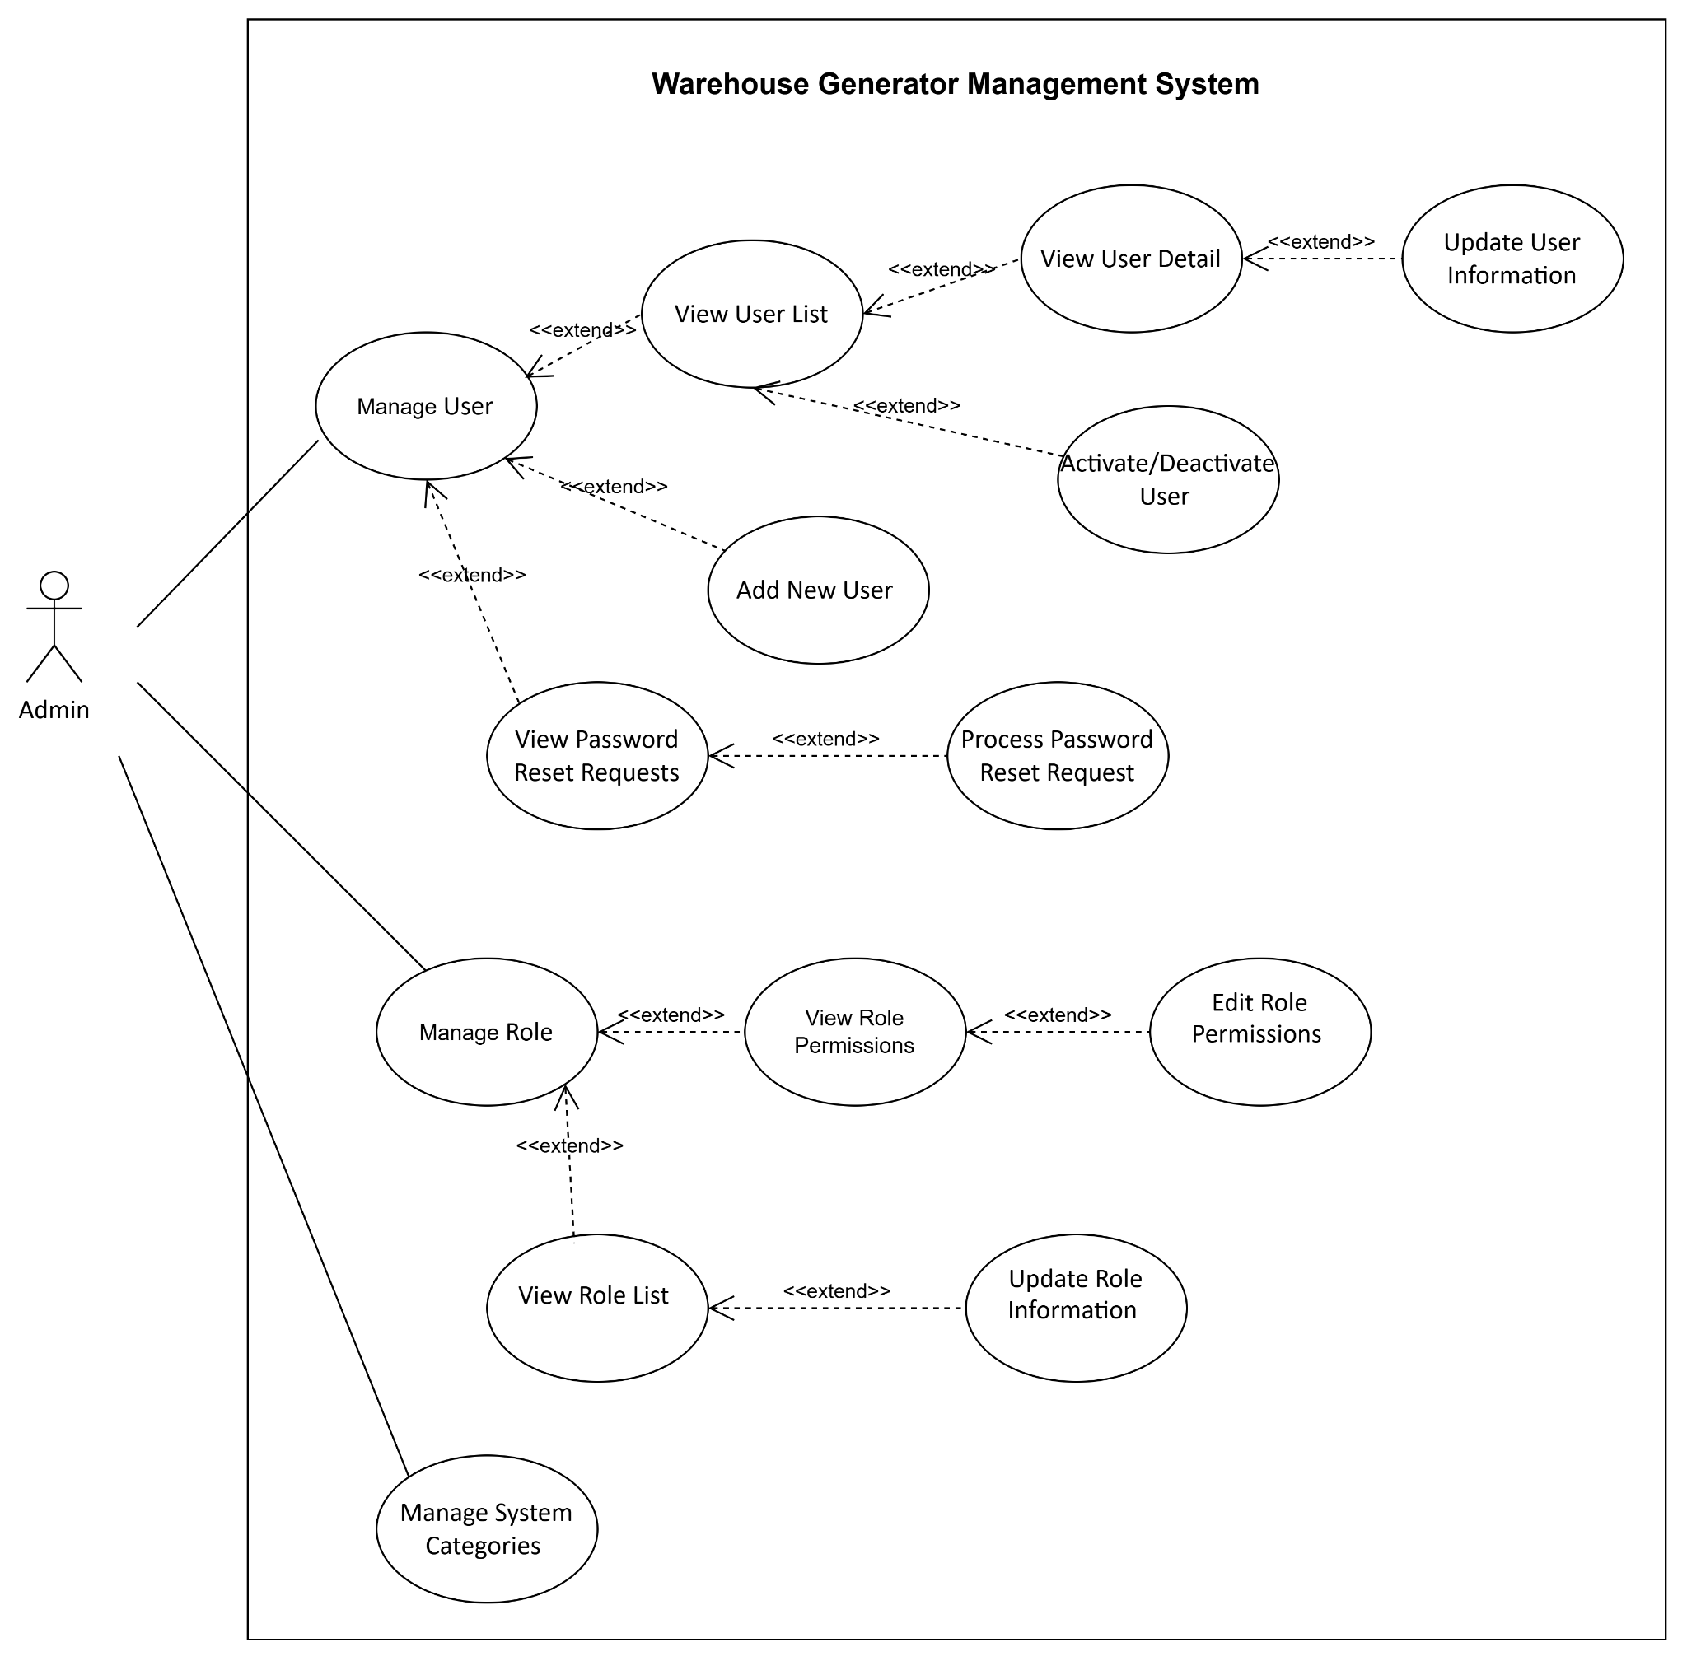

4.2 UCs for All Users
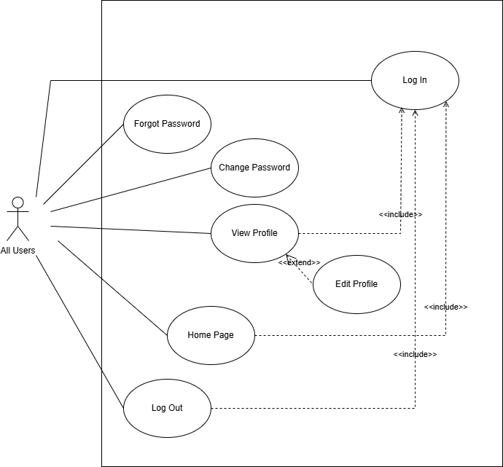

4.3 UCs for Sale Staff
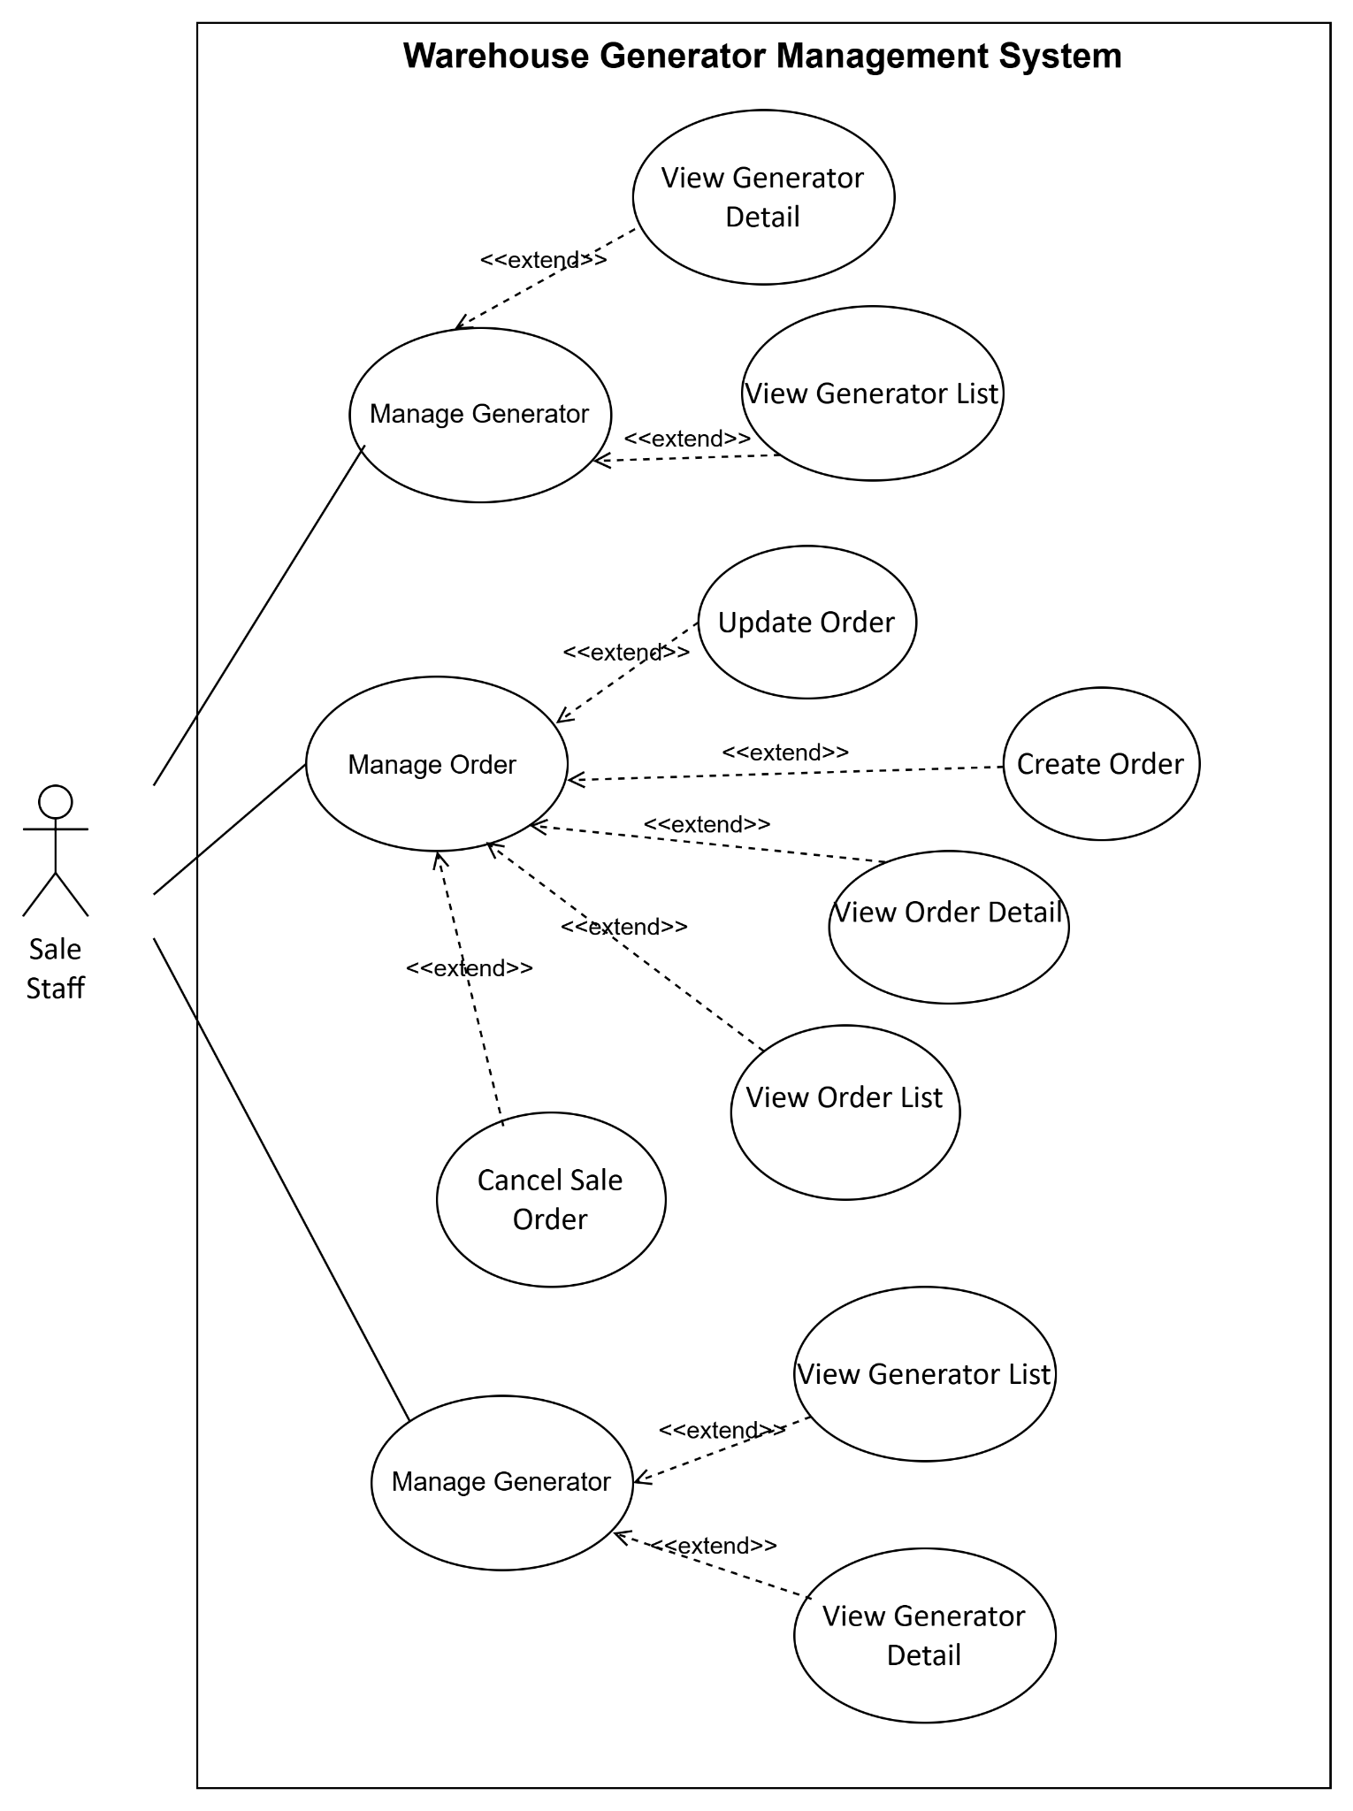

4.4 UCs for Warehouse Staff
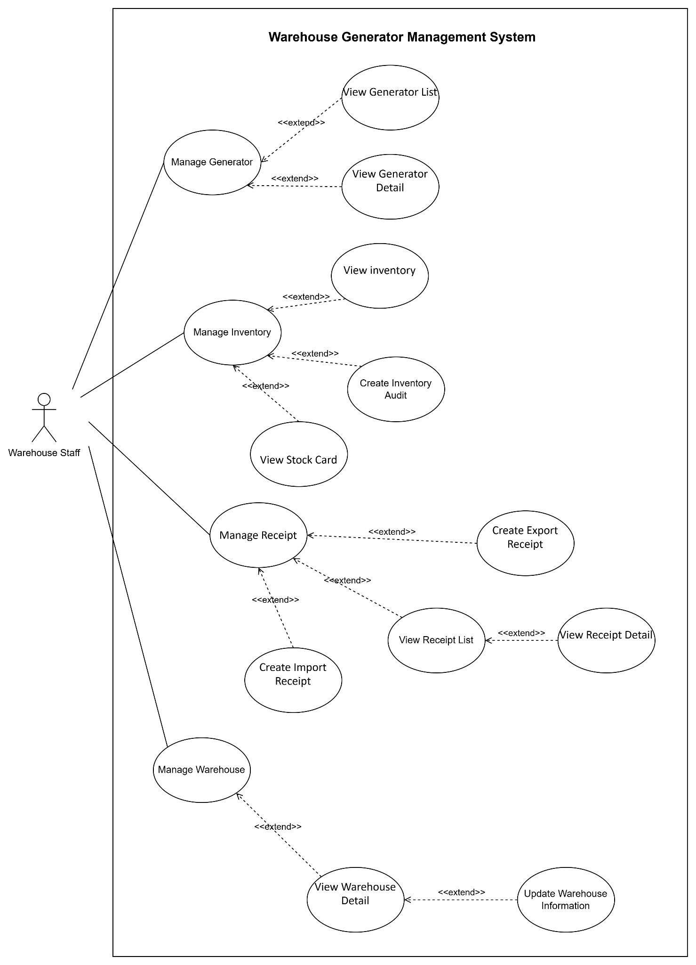

4.5 UCs for Sale Manager
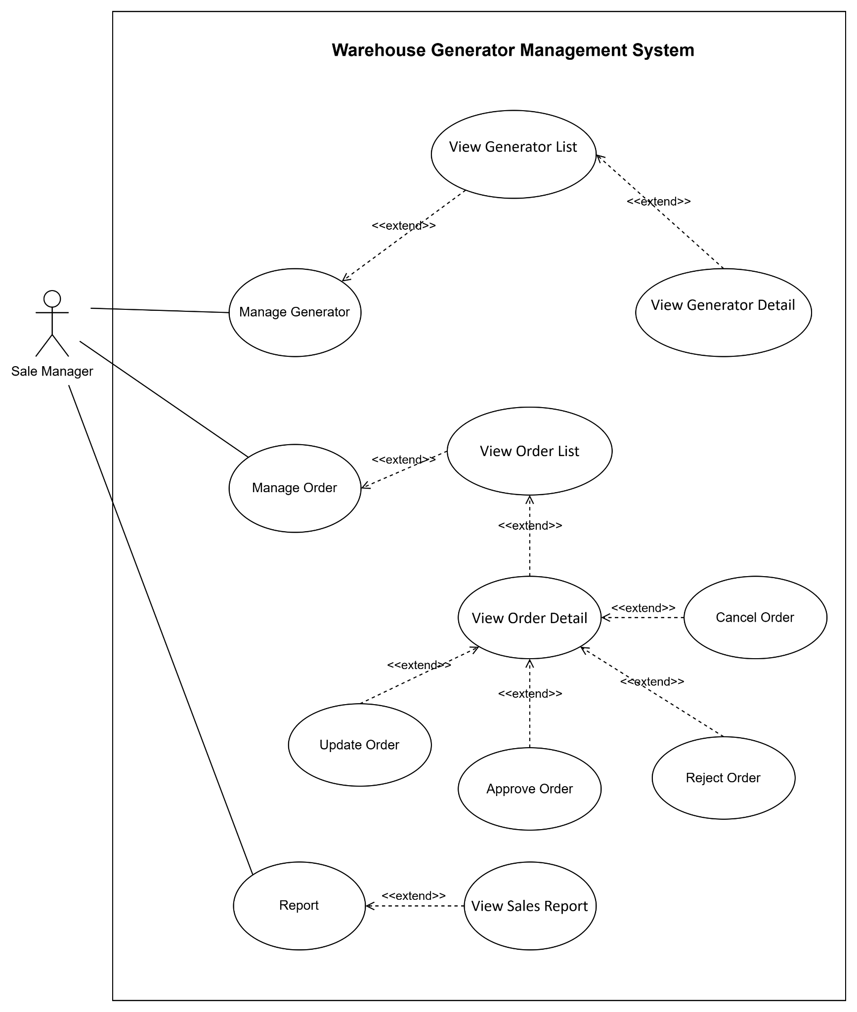

4.5 UCs for Warehouse Manager

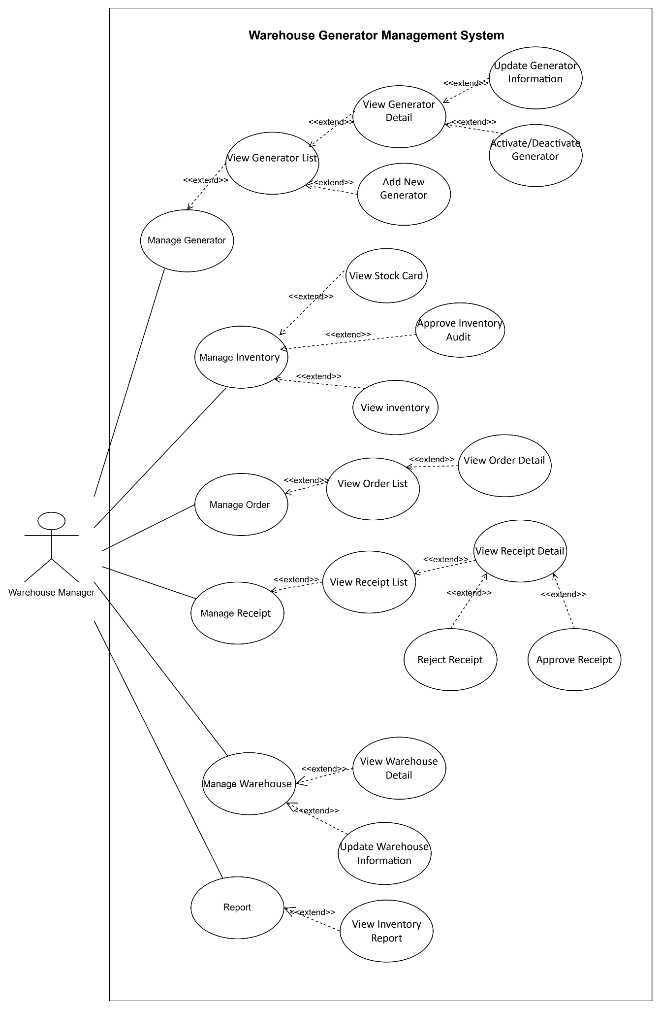

5. System Functionalities

5.1 Screens Flow

5.2 Screen Authorization

Screen | Admin | Warehouse Manager | Warehouse Staff | Sale Manager | Sale Staff
ADMIN MANAGEMENT
View system overview KPIs | X
Show system usage statistics charts | X
Refresh dashboard metrics | X
USER MANAGEMENT
View List Users | X
Edit Own Profile | X
View User Detail | X
Add New User | X
Update All Users | X
Assign roles to user | X
OverrideUserPermissions  (Grant/Deny) | X
Deactive/Activate User | X
Search/Filter Users | X
ROLE MANAGEMENT
View List All Roles | X
Add New Role | X
Update Role (Assign/Revoke  permissions) | X
Search Roles | X
FORGOT PASSWORD
View all reset requests | X
Generate new password | X
View processed request details | X
CHANGE PASSWORD
Change own password | X | X | X | X | X
PROFILE
View Own Profile | X | X | X | X | X
Update Own Profile (name, phone, address) | X | X | X | X | X
GENERATOR CATALOG
View All Generators |  | X | X | X | X
View Generators Detail |  | X | X | X | X
Add New Generators |  | X
Update Generator |  | X
Delete Generator |  | X
IMPORT RECEIPT
View All Import Receipt |  | X | X
View Own Import Receipt |  | X | X
Add New Import Receipt |  |  | X
Update All Import Receipt |  | X
Update Own Import Receipt |  |  | X
Approve/Reject |  | X
EXPORT RECEIPT
View All Export Receipt |  | X | X
View Own Export Receipt |  | X | X
Add New Export Receipt |  |  | X
Update All Export Receipt |  | X
Update Own Export Receipt |  |  | X
Approve/Reject |  | X
ORDER MANAGEMENT
View All Orders |  | X | X | X | X
View Own Orders |  |  |  |  | X
View Order Detail |  | X | X | X | X
Add New Order |  |  |  |  | X
Update Own Order |  |  |  |  | X
Update All Orders |  |  |  | X
Approve/Reject Order |  |  |  | X
INVENTORY & AUDIT
View Stock Balance |  | X | X | X | X
View Stock Card |  | X | X
Create Inventory Audit |  |  | X
Approve Audit |  | X

5.3 Non-UI Functions

# | Feature | System Function | Description
1 | User Authentication | Session authentication filter | Intercepts every request to /admin/*. Verified users are logged in with a valid session. If not authenticated, redirects to the login page. Configured in web.xml with 30-minute session timeout.
 |  | BCrypt password hashing | Hashes all passwords using BCrypt before storing them in the database.  When users login, verifies plaintext password into stored hash.  Detects legacy plaintext passwords and auto-upgrades them to BCrypt on successful authentication
 |  | Random Password Generator | When an admin approves a forgot-password request, generates a random 10-character password. Hashes it with BCrypt, updates the user's password, and returns the plaintext for UI.
2 | Authorization & Access Control | RBAC Authorization Service | Maps each requested URL to a required permission key  (/admin/users → users, view/admin/users → users.view)  Checks if the logged-in user's assigned roles include the required permission. Denies access with 403 error if missing.
 |  | ABAC Permission Override Service | After RBAC checks, evaluates individual permission overrides from user_permissions table.  A DENY override blocks access even if the role grants it. A GRANT override allows access even if the role lacks it.
 |  | Auto-Grant View Permission | When a non-view action permission is assigned to a role (e.g., users.create, users.update) the system automatically grants the corresponding view permission for that resource (users.view)
 |  | Permission Refresh | When roles or permissions are updated, the system sets a perm_refresh_{userId} flag. The SecurityFilter detects this on the next request to instantly reload the user's session permissions from the database.
 |  | Filter sidebar visibility | On every page render, evaluates the logged-in user's effective permissions and conditionally displays sidebar menu items. Menu items whose required permission the user lacks are hidden from the UI entirely.
 |  | Admin Deactivation Protection | Prevents deactivating any user account that holds the admin role. Checked at the DAO/service layer before executing the deactivation.
3 | Session Management | Session Timeout Handler | Automatically invalidates HTTP sessions after 30 minutes of inactivity. Users must re-authenticate to access any protected page.
4 | Order Processing | Order Status Transition Validator | Validates that order status changes follow the defined workflow: PENDING → APPROVED or PENDING → REJECTED.  Prevents invalid transitions (e.g., PENDING → COMPLETED, APPROVED → PENDING).  Logs each status change with timestamp and user ID for audit trail.
5 | Receipt Processing | Receipt Status Transition Validator | Validates receipt status transitions: PENDING_RECONCILED → COMPLETED or PENDING_RECONCILED → REJECTED.  On transition to COMPLETED, triggers inventory stock update in a single transactional context.
 |  | Order-Receipt Cross-Check Service | When a warehouse manager reviews a receipt, compares receipt line items against the linked order: validates product codes, quantities, and serial numbers match.
 |  | Serial Number Validation Service | When warehouse staff scans serial numbers during receipt creation, validates:  - Serial is not already assigned to another item in inventory,  - Serial matches the product type in the order  - Serial format is valid per product rules.
6 | Inventory Management | Inventory Stock Update | Automatically adjusts inventory quantities when a receipt reaches COMPLETED status.  Export receipts decrement stock; import receipts increment stock.  Updates the inventory table for each item in the receipt within a database transaction to ensure consistency.
 |  | Stock Card Logging Service | Automatically writes an entry for every stock movement: records item SKU, transaction date, receipt reference number, in/out quantity, running balance, and the user who triggered the change. Provides a full audit trail for inventory movements.
7 | Database Connection | Connection Pool Management | DBContext initializes JDBC connections on application startup via @WebListener. Provides getConnection() method for all DAO classes. Connections use MySQL Connector/J 8.0 with useUnicode=true&characterEncoding=utf8mb4 for Vietnamese text support.

II. Functional Requirements

1. User Authentication:

1.1 User Login:
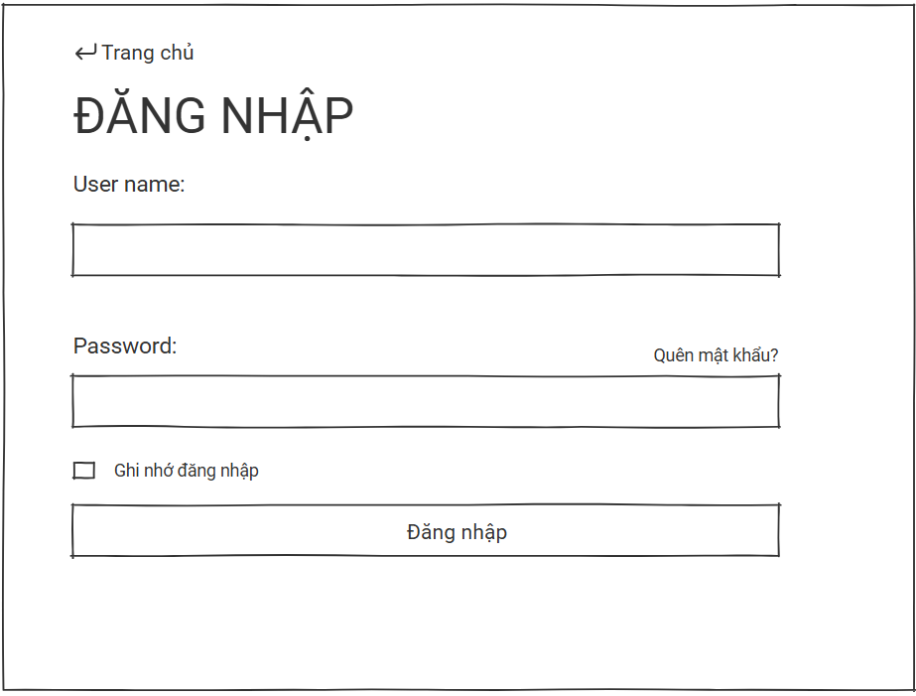

- This screen allows all internal users (Admin, Warehouse Manager, Warehouse Staff, Sales Staff) to log into the system using their registered accounts.
- Mapped UseCase:
Field Name | Description
UserName | Data type: alphanumeric string, length of 3 to 50 characters. Required field. Allows users to enter the unique system account name assigned by the Administrator.
Mật khẩu | Data type: string, min length of 6 characters. Required field. Must contain at least 1 uppercase letter, 1 lowercase letter, and 1 number. The input string will be verified against the BCrypt-hashed password stored in the database. Built-in eye icon allows toggling password visibility.
“Đăng nhập” Button | Action button. Validates user credentials against the database. If successful, redirects the user to their designated dashboard based on their role; otherwise, displays an authentication error message.
“Quên mật khẩu” Link | Navigation link. Redirects the user to the Password Recovery / Reset screen.
“Trang chủ” Link | Navigation link (located at the top-left). Redirects the user back to the system's public landing or landing homepage.
“Ghi nhớ đăng nhập” Checkbox | Input checkbox. Initial state: Unchecked. Selecting this option keeps the user session active on the local browser for subsequent visits.

1.2 User Change Password:
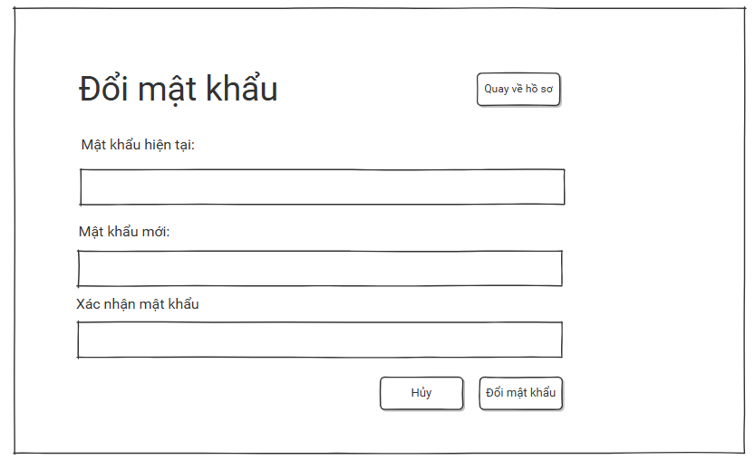

- This screen allows any currently logged-in system user to change their account password to maintain security. The system ensures the old password matches the database via BCrypt verification and enforces complexity rules for the new password before updating the encrypted record.
- Mapped Use Cases: UC_ChangePassword (Change account password).

Field Name | Description
“Mật khẩu hiện tại” Input | Data type: string. Required field. The user must input their current active password. The system validates this input against the BCrypt-hashed password stored in the database. Built-in eye icon allows toggling visibility.
“Mật khẩu mới” Input | Data type: string, password masked. Required field. The input must meet the following system validation rules:  • Minimum length of 6 characters.  • Must contain at least 1 uppercase letter (A–Z).  • Must contain at least 1 lowercase letter (a–z).  • Must contain at least 1 digit (0–9).  • Must be different from the current password.  Built-in eye icon allows toggling visibility.
“Xác nhận mật khẩu mới” Input | Data type: string, password masked. Required field. The user must re-enter the new password exactly as typed above. The system validates that this field matches the Mật khẩu mới field perfectly. Built-in eye icon allows toggling visibility.
“Đổi mật khẩu” Button | Action button. Validates all inputs and checks credentials. If all criteria are met, hashes the new password using BCrypt encryption, updates the database, clears current device sessions if necessary, and displays a success notification.
“Hủy” Button | Action button. Discards any entered inputs and returns the user to the previous screen or the main dashboard.
“Quay về hồ sơ” Link | Navigation button (located at the top-right). Redirects the user directly back to their personal profile view screen.

1.3 User Logout:

- This function allows any logged-in user to safely terminate their active session and exit the system from the global sidebar navigation panel.
- Mapped Use Cases: UC_Logout (Logout from the system).

Field Name | Description
“Dang xuat” Button | Action button located on the lower left sidebar. Clicking this button triggers the system to clear the current HttpSession session, remove authentication cookies, and instantly redirect the user back to the User Login screen.

1.4 User Forgot Password
This screen allows any user (Admin, Warehouse Manager, Warehouse Staff, Sales Staff) to submit a password reset request when they have forgotten their login credentials. The request is recorded in the system and forwarded to the Administrator for manual review. The Administrator processes the request via the Admin dashboard, generates a new password, and communicates it back to the user through an external channel.

Mapped Use Cases: UC-14 (Forgot Password)
Screen 1: Forgot Password Request
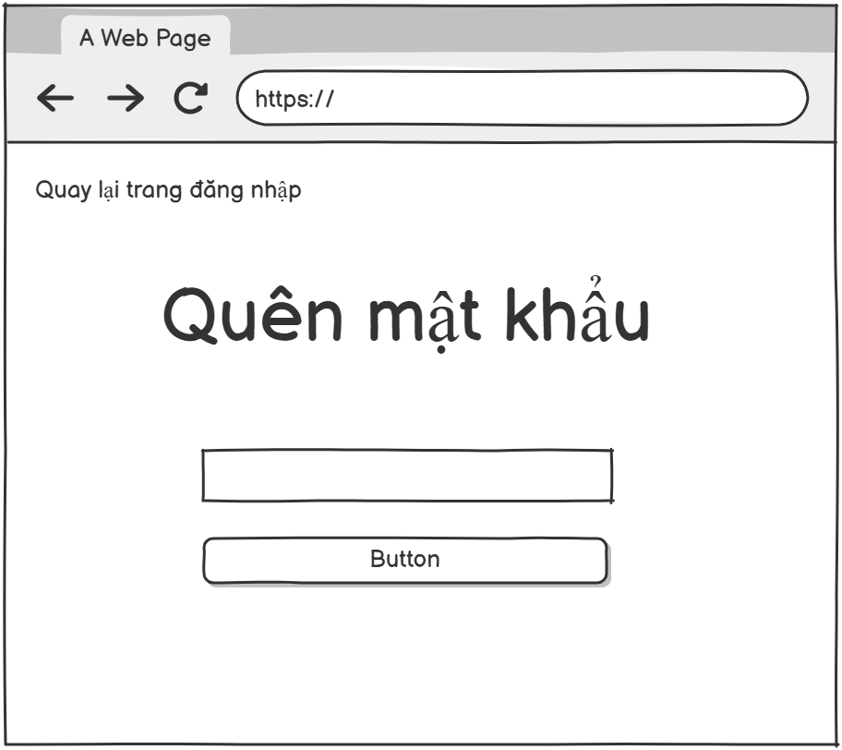

Field Name | Description
“Username” Input | Data type: alphanumeric string, length of 3 to 50 characters. Required field. User must enter the unique system account name assigned by the Administrator.
“Gửi yêu cầu” Button | Button Action button labeled "Gửi yêu cầu". Validates that the username exists in the system. If valid, creates a password reset request record with status "pending" and displays a success confirmation message. If the username does not exist, displays an error message.
“Quay lại đăng nhập” Link | Navigation link labeled "Quay lại đăng nhập". Redirects the user back to the Login screen

2. User Profile:

2.1 User view and change profile:
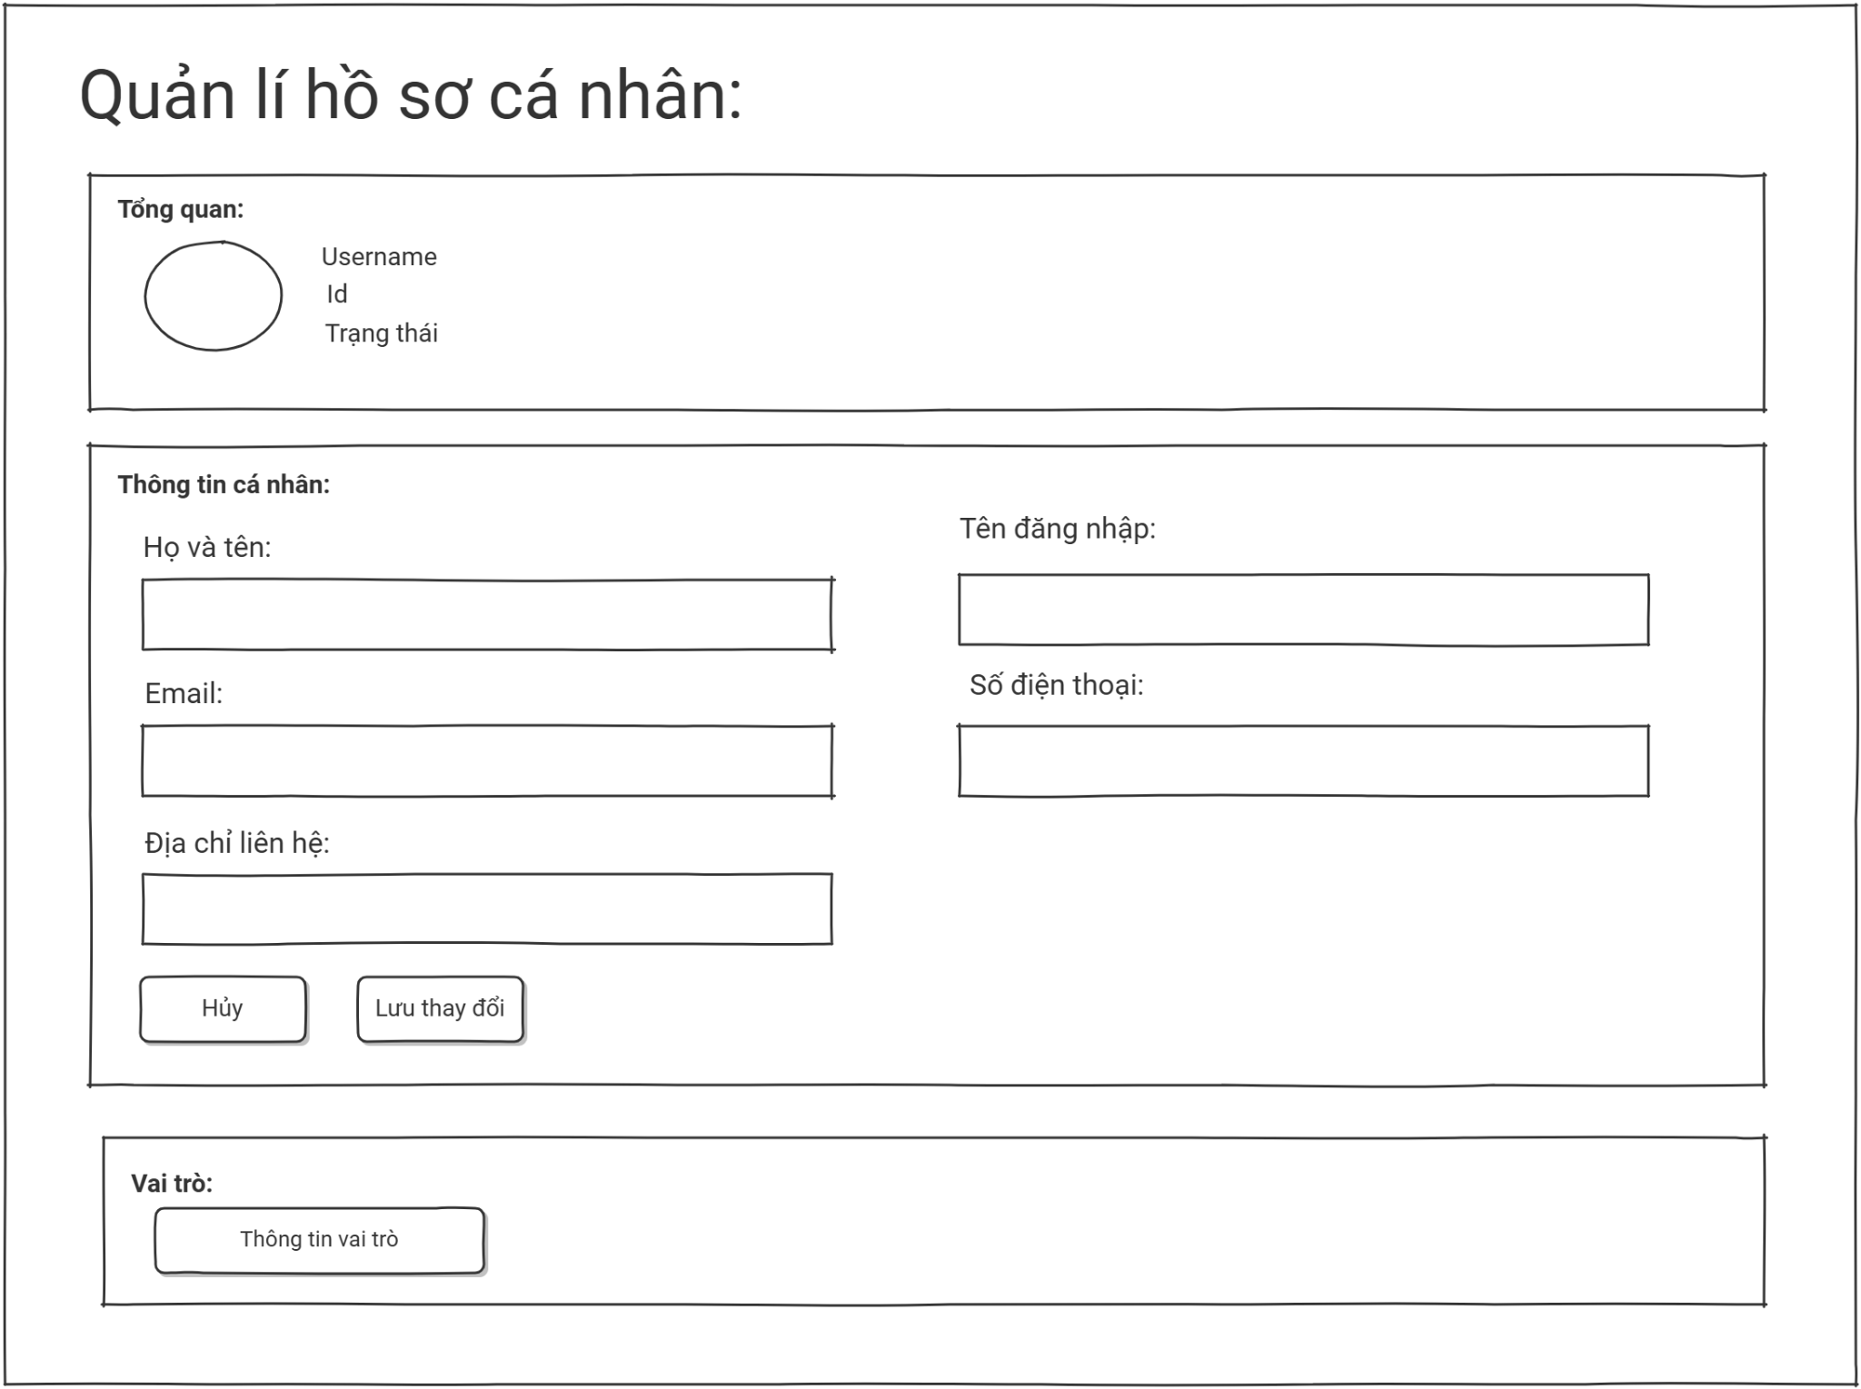

- This screen allows any authenticated system user to view their personal profile information, organizational roles, and modify eligible contact fields directly. Core identity attributes (such as Username, Email, and Roles) are strictly locked to maintain system security and data authenticity, while contact updates can be committed after successfully passing input validation rules.
- Mapped Use Cases: UC_ViewProfile (View account details), UC_EditProfile (Update personal information).
Field Name | Description
Field Group: 01 | Section containing overview metrics and account status identifiers.
ID | Data type: string, read-only system generated ID
Ngày tham gia | Data type: date formatted as dd/MM/yyyy. Read-only metadata.
Cập nhật | Data type: date formatted as dd/MM/yyyy. Tracks the latest modification date.
“Trạng thái” Badge | Visual component indicating current account validity (e.g., Đang hoạt động / active).
“Ảnh đại diện” | Graphical badge showing user's initial letters (e.g., AD).
Field Group: 02 | Section containing personal fields and data modification tools.
“Họ và tên” Input | Data type: alphabet string, length up to 50 characters. Required field (*). Must not contain special characters or numbers. Loaded from DB initially.
“Tên đăng nhập” Input | Data type: alphanumeric string. Status: Read-only / Locked (indicated by lock icon). Users cannot alter their account handle.
“Số điện thoại” Input | Data type: numeric string. Required field (*). Validation rules: Must be exactly 10 digits and must start with a leading '0' prefix.
“Email” Input | Data type: valid email string format. Status: Read-only / Locked (indicated by lock icon). Profile changes to core email require Admin intervention.
“Địa chỉ” Input | Data type: string text, length up to 255 characters. Optional text box for address inputs
“Lưu” Button | Action button. Validates modified fields against strict regex models. On success, persists updates to the database and raises a confirmation; on error, yields validation alerts.
“Hủy” Button | Action button. Discards pending text changes and restores inputs back to the last stored DB snapshot.
Field Group: 03 | Section presenting assigned platform operational roles.
(Roles) Badge | Display token showing assigned permissions (e.g., admin). Status: Read-only. Controlled strictly by security mapping files to prevent privilege elevation.

3. System Administration

3.1 Role & Permission Management

3.1.1 Role List
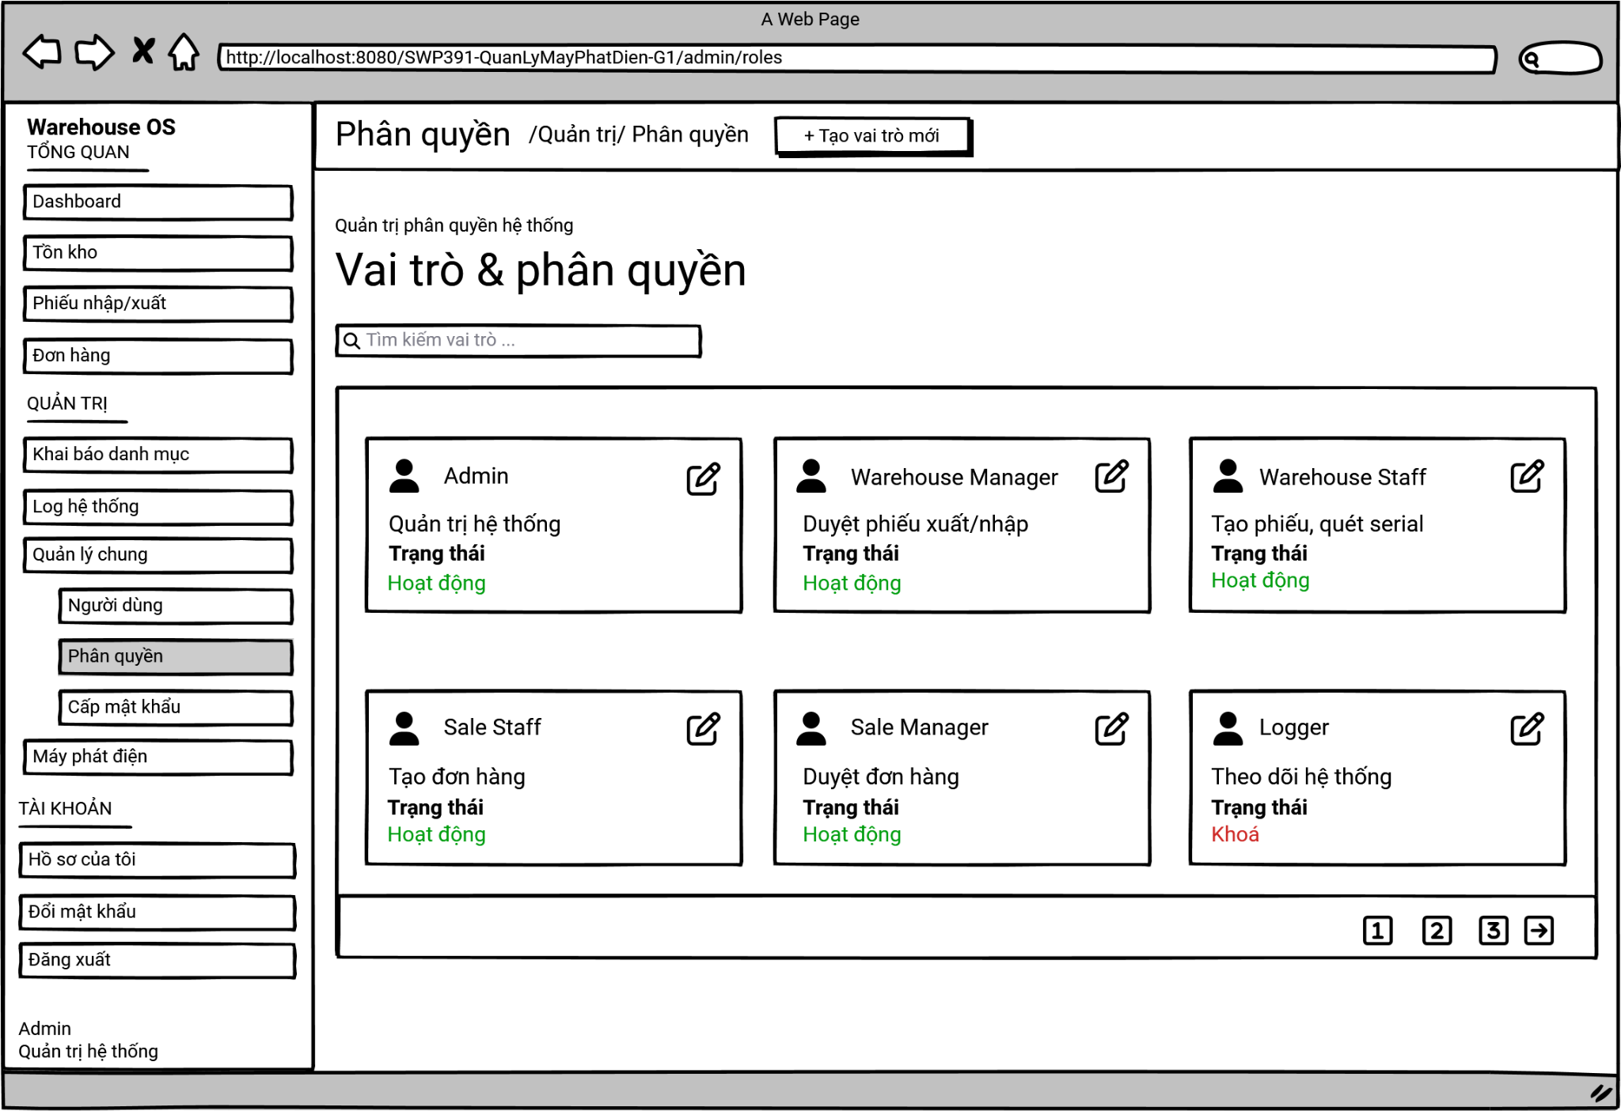
This screen allows the Administrator to:
- View Role List: view the list of current roles in the system, displayed as a grid of cards. Each card presents the role name, description, and current status (Active / Inactive).
- Search Roles: enter keyword(s) into the search bar to find specific roles by their names or descriptions.
On the screen, s/he can also
- Add New Role: navigate to the role creation screen by clicking the "+ Tạo vai trò mới" (Create new role) button.
- Update Role: choose to go to the Role Details screen to modify a role's information and its assigned permissions by clicking the Edit icon (pencil) on the corresponding role card.
Field Description
Field Name | Description
Search role | Search Role Bar: "Tìm kiếm vai trò"  - Initial value: blank.  - Placeholder text: "Tìm kiếm vai trò theo tên hoặc mô tả..." (Search role by name or description).
Edit button | The Edit icon button available on each role card.  Clicking this icon redirects the Administrator to the Role & Permission Assignment screen for that specific role.
Add new role button | Add New Role Button: "+ Tạo vai trò mới"  - The button to trigger the creation of a new role.  - Hover the mouse to show tooltip (if any).
Pagination | Pagination Component:  - Used to paginate and navigate through long data lists.  - Page numbers (1, 2, 3...): Click to jump directly to the respective page.  - Arrow buttons: Click to go to the previous or next page.

3.1.2 Add Role & Permission Assignment
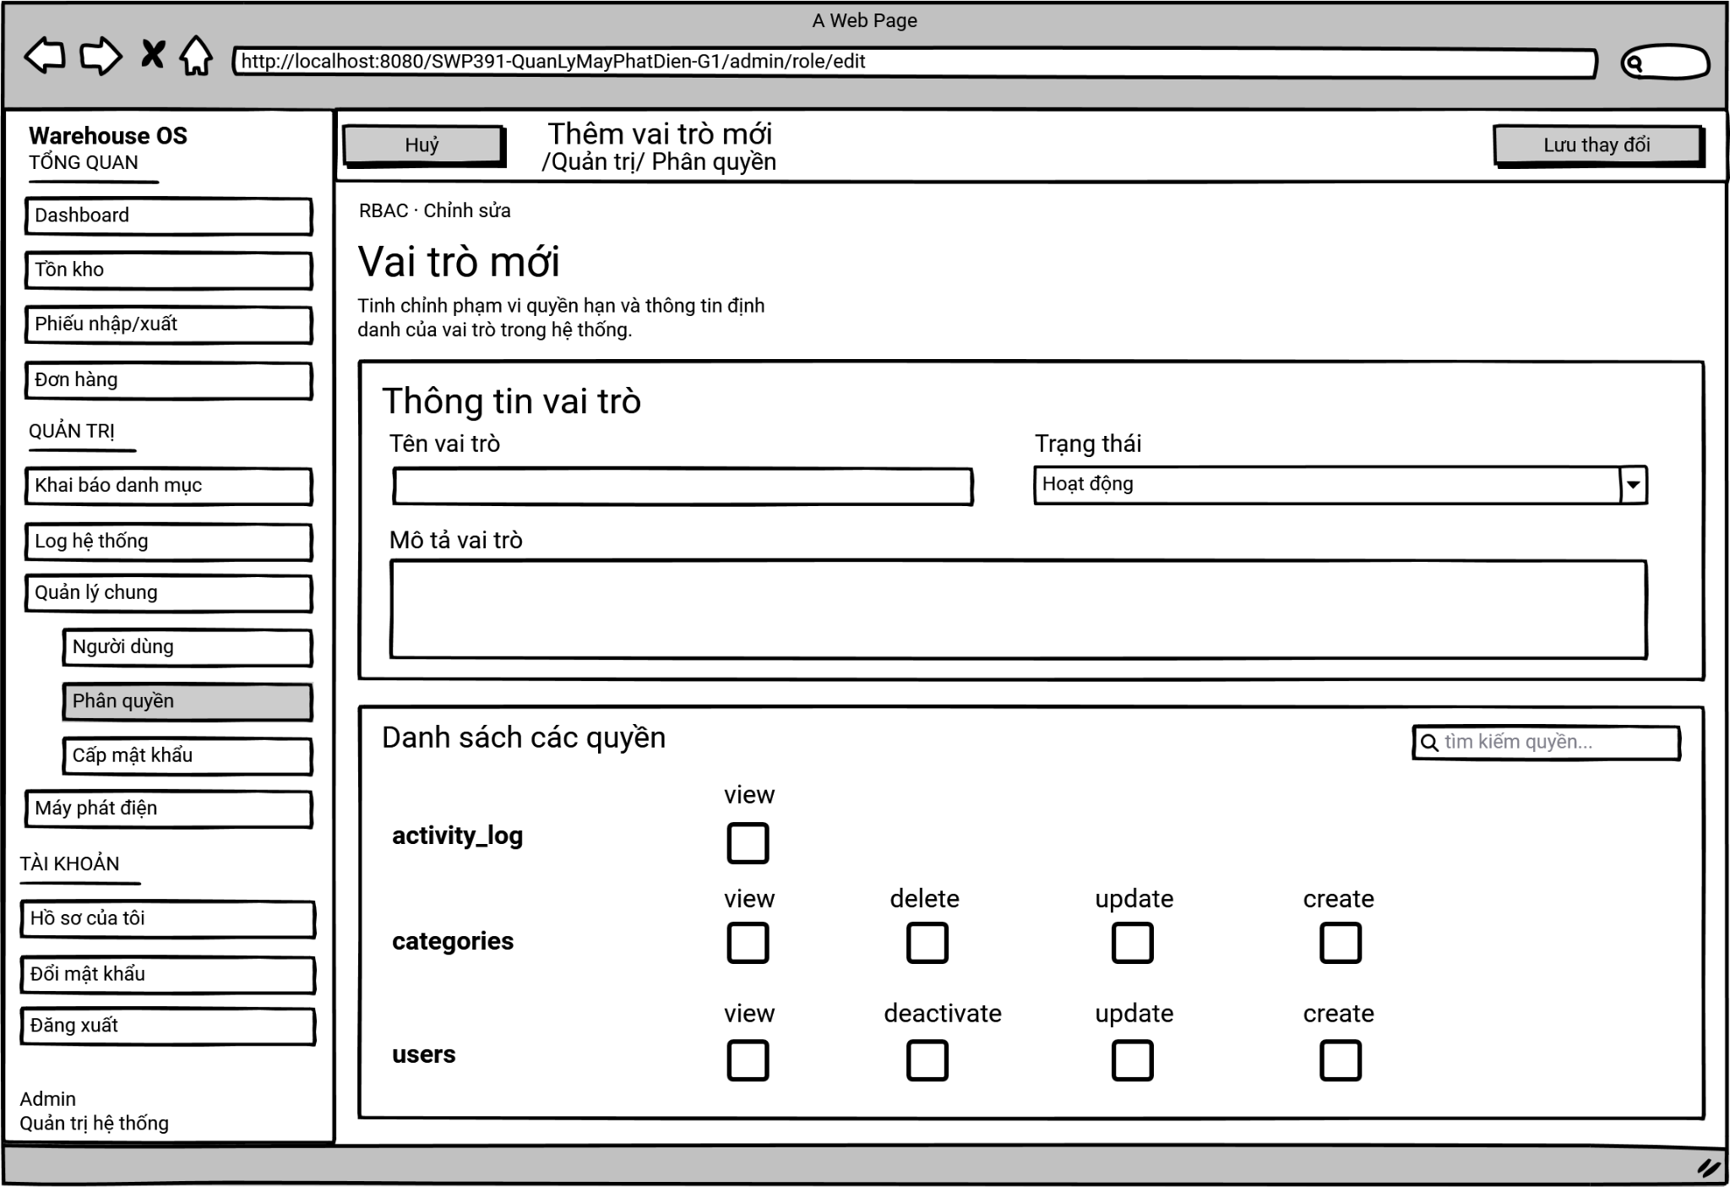
On this screen, the Administrator can:
- Input Role Information: define the fundamental attributes of the role, including its unique name, operational status, and a detailed description.
- Search Permissions: quickly find specific modules or actions within the RBAC matrix using the search bar.
- Assign/Revoke Permissions (RBAC): grant or remove specific system capabilities (e.g., view, create, update, cancel) for various modules (e.g., audit_logs, customers, contracts) by toggling the respective checkboxes.
- Save/Cancel: commit the changes to the database or discard them and return to the Role List screen.
Field Description
Field Name | Description
Role Input Information | Role Information Area:  - Role Name “Tên vai trò”: Text input (Required). Must be unique.  - Status “Trạng thái”: Dropdown list (Active / Inactive). Default is Active.  - Role Description “Mô tả vai trò”: Text area for explaining the role's purpose.
Search | Permission Search Bar: “Tìm kiếm quyền”  Initial value: blank.  Allows filtering the RBAC matrix below by module name or specific action keyword.
Permission List | “Danh sách các quyền”: A structured grid displaying available modules and their associated granular actions.  - Checking a box grants the permission (e.g., customers.create).  - Unchecking revokes it.
Save button | Save Changes Button: "Lưu thay đổi"  Submits the form data to the backend. Validates required fields before saving and redirects back to the Role List upon success.
Cancel button | Cancel Button: "Hủy"  Back to the role list page without creating new roles

3.1.3 Edit Role & Permission Assignment
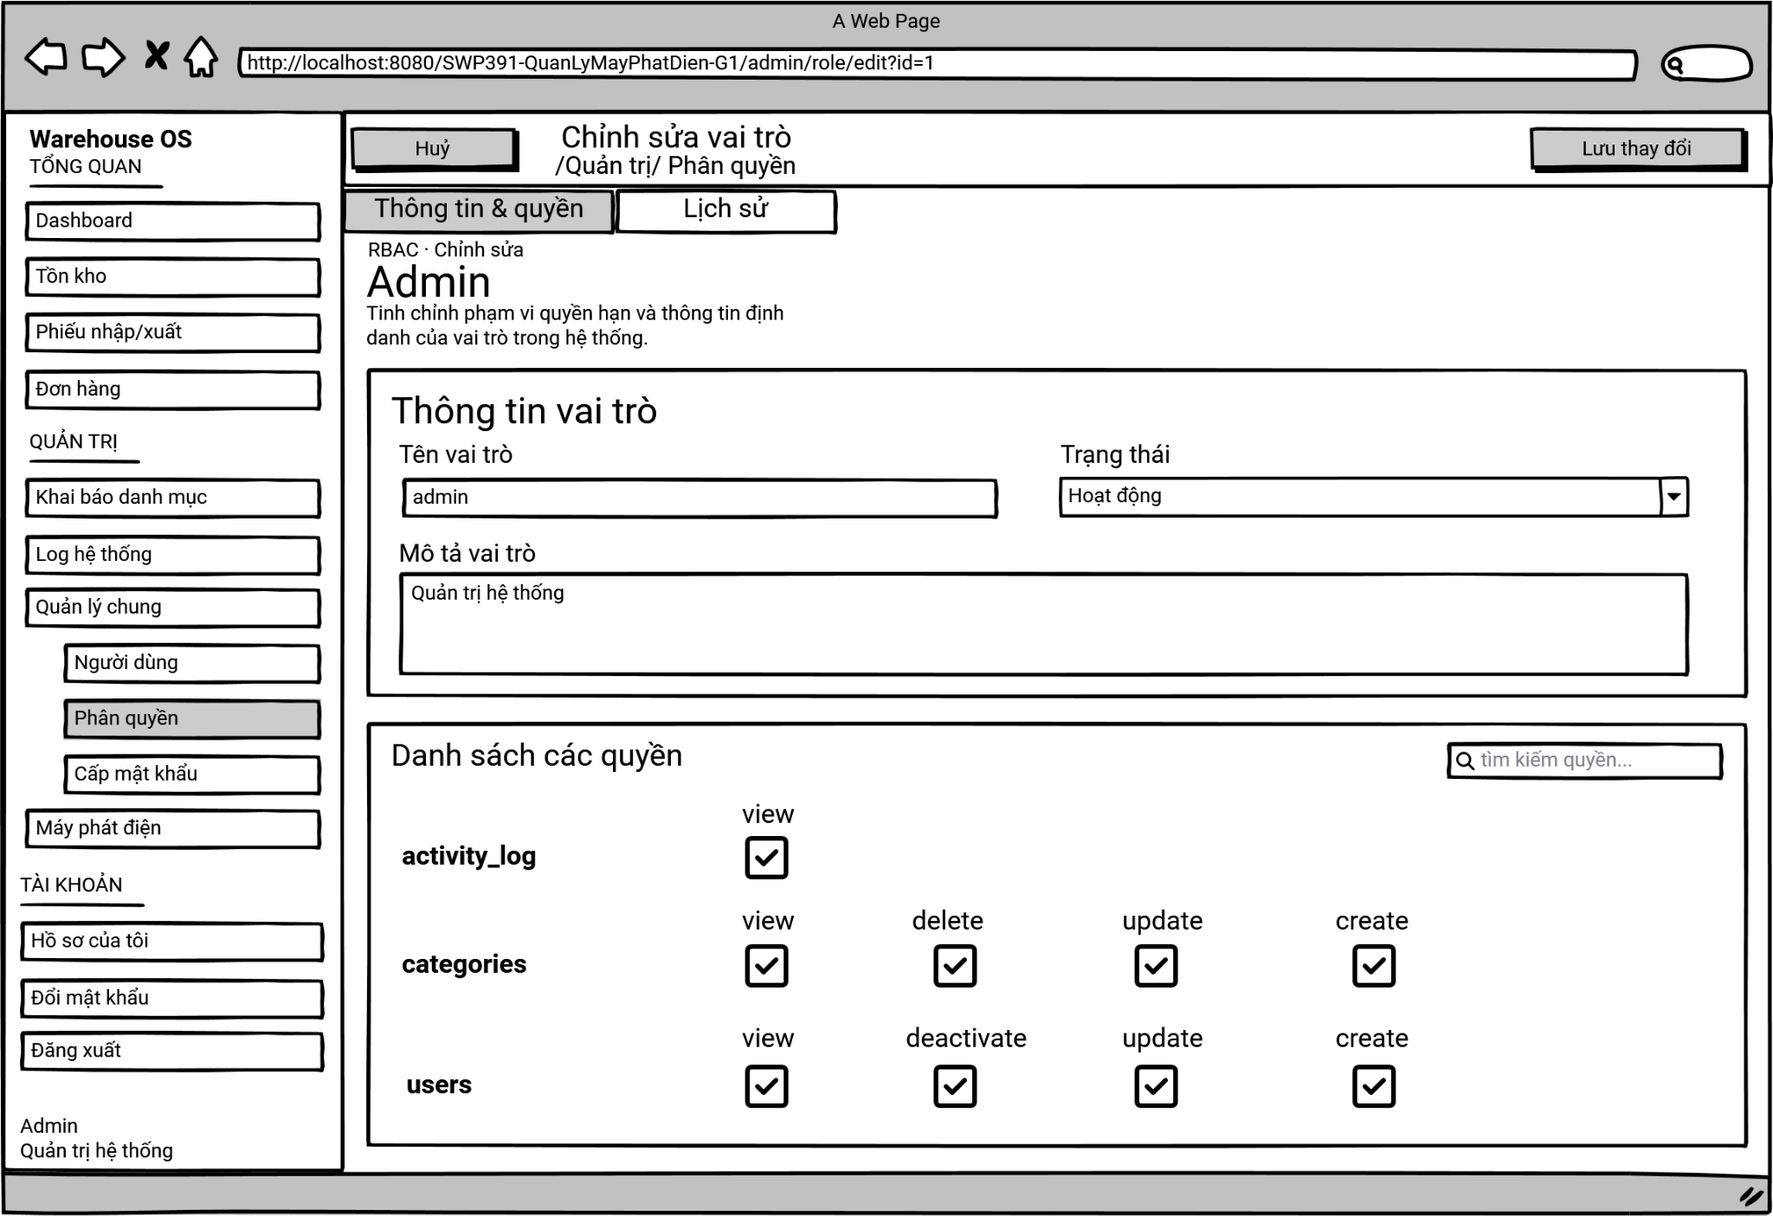
This screen allows the Administrator to view and modify the configuration and access rights of an existing system role.
On this screen, the Administrator can:
- Modify Role Information: update the role's name, description, or change its operational status (e.g., from "Active" to "Locked"/Inactive).
- Review Role Overview: view read-only metadata about the role (e.g., Role Type, Warehouse Scope).
- Search Permissions: filter the permission list by typing keywords.
- Adjust Permissions (RBAC): grant new permissions by checking empty boxes or revoke existing permissions by unchecking the currently active boxes.
- Save/Cancel: apply the modifications to the database or cancel to discard changes.
Field Description
Field Name | Description
Navigation Tabs | Tabs: "Thông tin & quyền" / "Lịch sử"  - Allows the user to switch between modifying role details/permissions and viewing the audit log.  - The "Thông tin & quyền" tab is currently active.
Search permissions | Permission Search Bar: "Tìm kiếm quyền..."  - Initial value: blank.  - A search box with a magnifying glass icon that allows filtering the RBAC matrix below by module name or specific action keyword.
Role Input Information | Role Information Area: "Thông tin vai trò"  - Role Name "Tên vai trò": Text input for the role's identifier (e.g., admin).  - Status "Trạng thái": Dropdown list to set the operational status (e.g., Hoạt động).  - Role Description "Mô tả vai trò": Text area for explaining the role's purpose and scope.
Permission List | Permission Grid: "Danh sách các quyền"  - A structured grid displaying available modules (e.g., activity_log, categories, users) and their associated granular actions (view, delete, update, create, deactivate).  - Checking a box grants the corresponding permission.  - Unchecking a box revokes it.
Save Button | Save Changes Button: "Lưu thay đổi"  Submits the form data to the backend. Validates required fields before saving and redirects back to the Role List upon success.
Cancel Button | Cancel Button: "Hủy"  Back to the role list page without updating roles

3.1.3 Role & Permission History
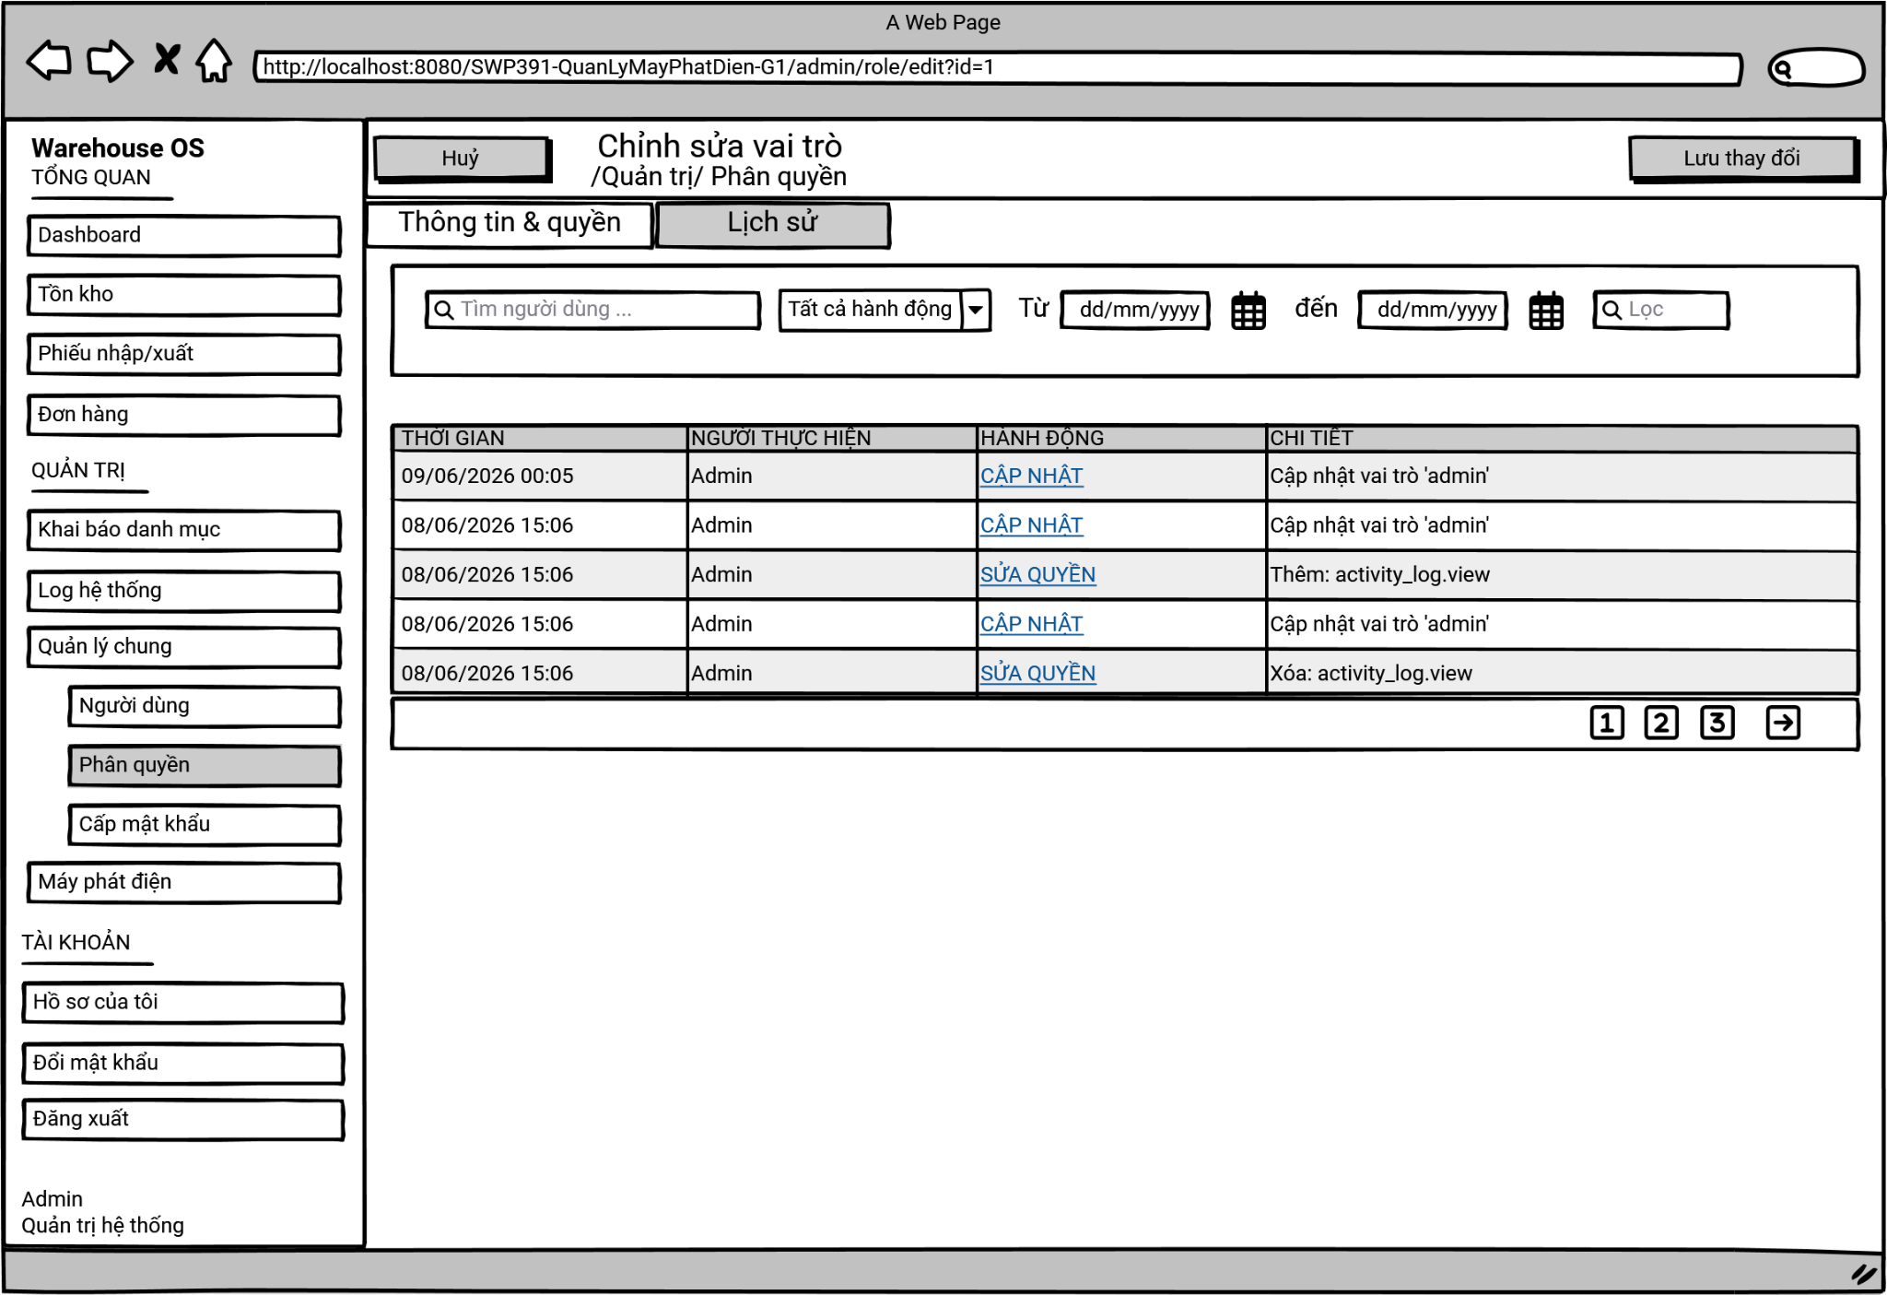

This screen allows the Administrator to view the audit log and historical modifications made to an existing system role.
On this screen, the Administrator can:
- View Role History: review a detailed log of past modifications, including the exact time, the user who made the changes, the type of action performed, and specific details of the change.
- Filter by User: search the audit log for actions performed by a specific user or administrator.
- Filter by Action Type: narrow down the history records by selecting specific types of actions from a dropdown menu (e.g., viewing all permission updates).
- Filter by Date Range: specify a start and end date to view only the changes that occurred within a defined timeframe.
- Navigate Settings: switch back to the "Thông tin & quyền" tab to make further adjustments to the role's configuration.

Field Name | Description
Cancel button | Cancel Button: "Huỷ"  - Click to discard any unsaved changes and return to the previous screen.
Save button | Save Changes Button: "Lưu thay đổi"  - Submits and applies any pending modifications made to the role.
Navigation Tabs | Tabs: "Thông tin & quyền" / "Lịch sử"  - Allows the user to switch between modifying role details and viewing the audit log.  - The "Lịch sử" (History) tab is currently active.
User Search | User Search Input: "Tìm người dùng ..."  - A text input field with a magnifying glass icon used to filter the history log by the name of the user who performed the action.
Action Filter | Action Dropdown: "Tất cả hành động"  - A dropdown menu allowing the Administrator to filter the log by specific action categories (e.g., CẬP NHẬT, SỬA QUYỀN).
Date Range | Date Pickers: "Từ" [dd/mm/yyyy] "đến" [dd/mm/yyyy]  - Input fields with calendar icons to specify a start date and an end date to filter the history records within a specific time frame.
Filter Button | Filter Button: "Lọc"  - A button with a magnifying glass icon used to execute the search and apply the selected filters to the history table below.
History Table | Audit Log Table:  - A structured grid displaying the history of modifications made to the role.  - Columns include: "THỜI GIAN" (Timestamp), "NGƯỜI THỰC HIỆN" (User who executed the action), "HÀNH ĐỘNG" (Type of Action), and "CHI TIẾT" (Specific details of what was changed).
Pagination | Pagination Component:  - Used to paginate and navigate through long data lists.  - Page numbers (1, 2, 3...): Click to jump directly to the respective page.  - Arrow buttons: Click to go to the previous or next page.

3.2 User Management

3.2.1 User List
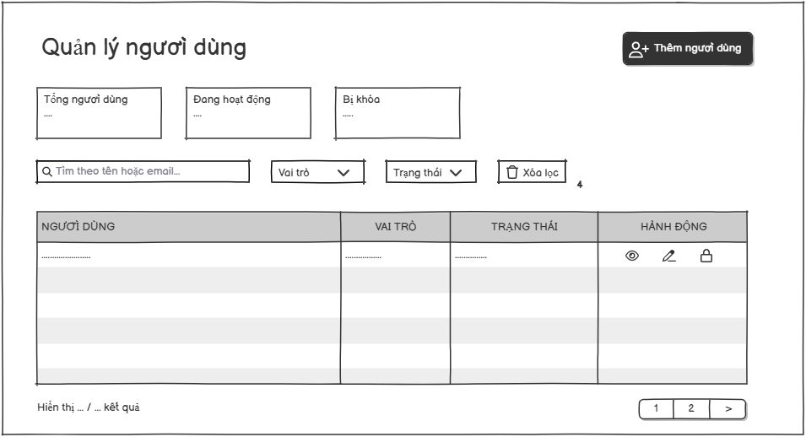

Screen Description:
- Screen Name: User Management
- Access Role: Admin
- Main Functionality: This screen allows the high-level administrator to monitor the list of all accounts in the system, view statistical cards of account statuses (Total Users, Active, Locked), perform searches, filter by roles/status, and execute administrative actions (View Details, Edit, Lock/Unlock accounts).

Field Name | Description
Add User | Action button labeled "Thêm người dùng". Clicking this button redirects the Administrator to the "Thêm người dùng" screen.
Total Users | Information block displaying the total number of user accounts registered in the system. Data type: Integer.
Active | Information block displaying the count of accounts that are currently active. Data type: Integer.
Lock | Information block displaying the count of accounts that are currently locked/disabled. Data type: Integer.
Search | Text input field with placeholder "Tìm theo tên hoặc email...". Allows the Administrator to dynamically filter the user list by typing a user's full name or email address.
Role | Filter dropdown list labeled "Vai trò: Tất cả". Allows filtering the user list by system roles.
Status | Filter dropdown list labeled "Trạng thái: Tất cả". Allows filtering the user list by account status.
Clear Filter | Action button labeled "Xoá lọc" with a reset icon. Resets all active search inputs and dropdown selections back to their default states.
User List | Data grid displaying user records with the following columns:  • USER (NGƯỜI DÙNG): Displays the user's Full Name (with initial avatar) and Email.  • ROLE (VAI TRÒ): Displays the assigned role badge (e.g., Customer, Admin).  • STATUS (TRẠNG THÁI): Displays status indicators (e.g., Active with a green dot).  • ACTION (HÀNH ĐỘNG): Interactive operational icons.
View Details | Action icon (Eye shape) under the Action column. Opens a detailed profile view or modal of the selected user.
Edit | Action icon (Pencil shape) under the Action column. Redirects to the update screen or opens a form to edit the selected user's details.
Lock Account | Action icon (Padlock shape) under the Action column. Toggles the account state between active and locked, updating the status accordingly.
Pagination | Navigation element at the bottom right displaying row ranges and page numbers to navigate through multiple pages of records.

3.2.2 User Detail

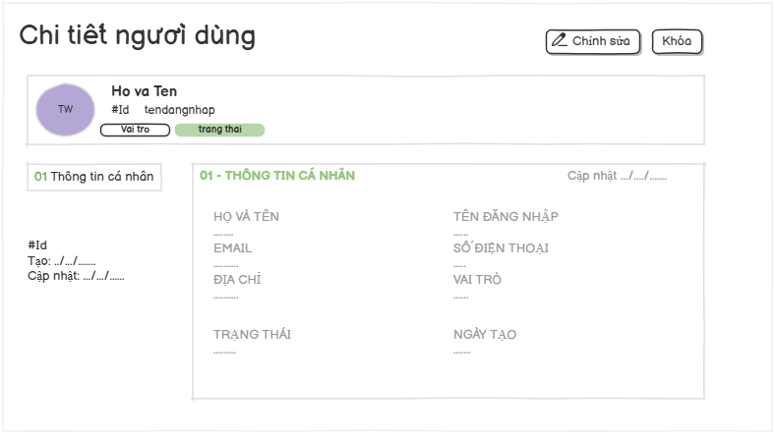
Screen Description:
- Screen Name: User Details
- Access Role: Admin
- Main Functionality: This screen displays comprehensive read-only profile information for a specific user account (in this case, an Admin account). It allows administrators to verify registration details, check account verification and activity status, navigate back to the user list, or initiate actions like profile modifications or account deactivation.

Field Name | Description
Edit Header | Action button labeled "Chỉnh sửa" located in the top-right header toolbar. Clicking it opens the account modification mode or screen.
Activate/Deactivate | Action button labeled "Kích hoạt" with green styling. Clicking it changes the user's status to active. Action button labeled "Vô hiệu hoá" with red styling. Clicking it changes the user's status to locked.
User Profile Summary | Highlighted summary block at the top displaying the user's avatar, username, login ID, ID number, registration date, verification status badge, role badge, activity status badge.
Personal Information Card | Main data block labeled "01 - THÔNG TIN CÁ NHÂN" displaying read-only fields including: Full Name, Email, Address, Status, Phone Number, Created Date, and Last Updated timestamp.

3.2.3 Create User
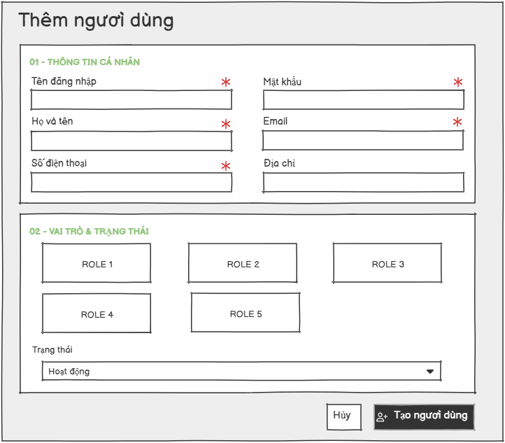
Screen Description:
- Screen Name: Create New User
- Access Role: Admin
- Main Functionality: This screen provides a multi-section form that allows administrators to create and register a new user account within the system. It captures basic personal contact details, authentication rules, role-based authorization levels, initial status configurations, and options to finalize or discard the creation process.

Field Name | Description
Username | Text input field labeled "Tên đăng nhập". Marked as a required field (*). It accepts an alphanumeric string as the system unique login identifier. Placeholder text: "VD: nguyenvana".
Password | Password character entry field labeled "Mật khẩu". Marked as a required field (*). Requires a secure string with a validation rule constraint of at least 6 characters. Placeholder text: "Ít nhất 6 ký tự".
Full Name | Text input field labeled "Họ và tên". Marked as a required field (*). Captures the user's formal name representation. Placeholder text: "Nguyễn Văn A".
Email | Text input field labeled "Email". Marked as a required field (*). Validates standard formatting structures for systemic communications. Placeholder text: "ten@example.com".
Phone Number | Text input field labeled "Số điện thoại". Marked as a required field (*). Accepts numerical input for mobile contact info. Placeholder text: "VD: 0912345678".
Address | Text input field labeled "Địa chỉ". Optional data field to document geographic residential or office coordinates. Placeholder text: "VD: Hà Nội".
Role | Grid grouping component labeled "Vai trò". Marked as a required field (*). Contains selectable system permission cards enabling assignment of default authorizations.
Status | Configuration dropdown element labeled "Trạng thái". Sets the starting operational access state of the account. Defaults to "Hoạt động" (Active).
Cancel | Action button labeled "Huỷ". Discards all current temporary text edits and structural selections without applying changes.
Create User | Primary action button labeled "+ Tạo người dùng". Validates the required form parameters and triggers backend database record generation for the new user profile.

3.2.3 Edit User
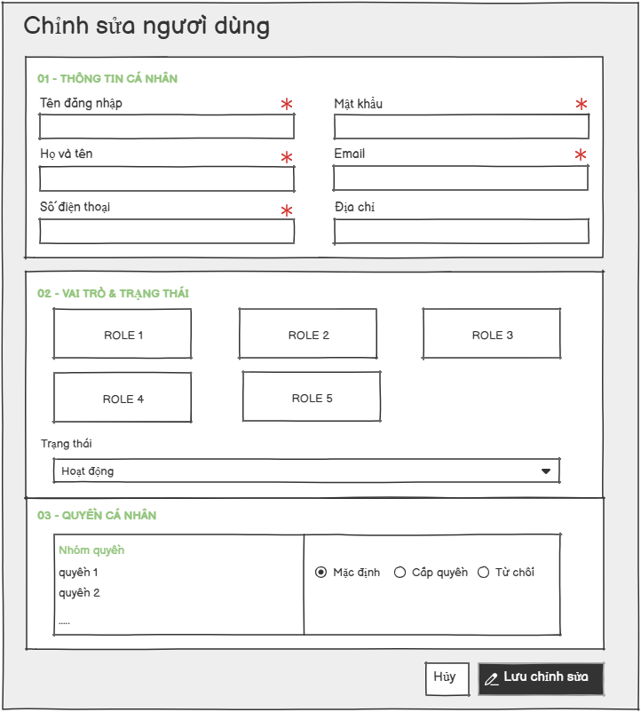
Section 01 — Basic Information
Field Name | Description
“Full Name” Input | Data type: alphabet string, length up to 60 characters. Required field (*). Must contain at least 2 characters. Displays current value from database. Input is visually marked when modified (dirty state).
“Email” Input | Data type: valid email string format. Status: Read-only / Locked (indicated by lock icon and grayed background). Email is the login key and cannot be changed after account creation.
“Phone”Input | Data type: numeric string. Required field (*). Must match the pattern: starts with "0", contains exactly 10 digits. Displays current value from database. Input is visually marked when modified.
“Address” Input | Data type: string text, length up to 255 characters. Optional field. Displays current value from database. Input is visually marked when modified.

Section 02 — Roles & Warehouse Assignment
Field Name | Description
“Role Cards” | Grid of selectable role cards displaying all active system roles. Each card shows the role name and description. The currently assigned role is highlighted with a selected state (accent border and background). Clicking a card selects/deselects it. The roleIds parameter is submitted as a request parameter.
“Status”Segmented Control | Segmented button group allowing the Admin to switch the account status. Options: "Hoạt động" (active), "Chưa kích hoạt" (inactive). The current status is pre-selected. Selection is submitted as a hidden status field.

Section 03 — Permission

Field Name | Description
“Permission Groups” | Permissions are organized by resource groups (e.g., users, roles, generators, import_orders, inventory, etc.). Each group is displayed in a bordered card with the resource name as heading.
“Override Toggles” | For each individual permission within a group, three radio options are available: "Mặc định" (default — inherits role permissions), "GRANT" (explicitly grants the permission regardless of role), "DENY" (explicitly denies the permission, overriding role grants, with higher priority). The current override value is pre-selected. Submitting "DENY" on a non-view action automatically applies the same override to the corresponding "view" action of the same resource.
“Permission Description” | Each permission row displays a human-readable description (e.g., "Xem danh sách người dùng", "Tạo phiếu nhập kho", etc.).

3.3 Password Reset Management
This screen allows the Administrator to view and process password reset requests submitted by users who have forgotten their credentials. The Administrator can review pending requests and generate new passwords for affected users.

Mapped Use Cases: UC-14 (Forgot Password – Admin processing)
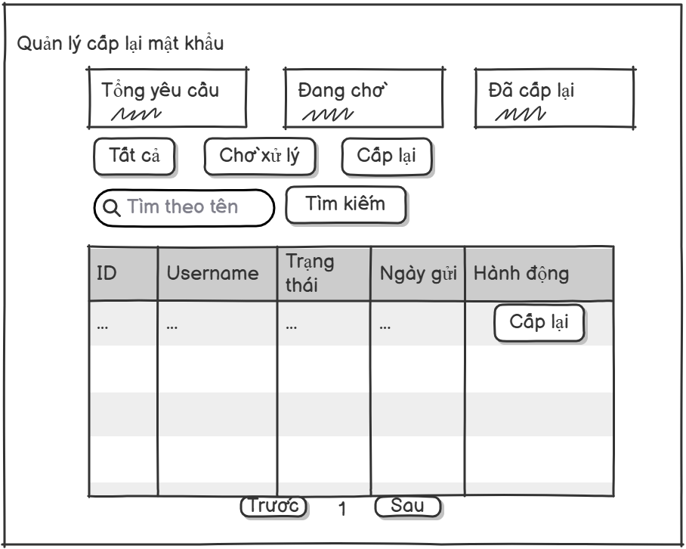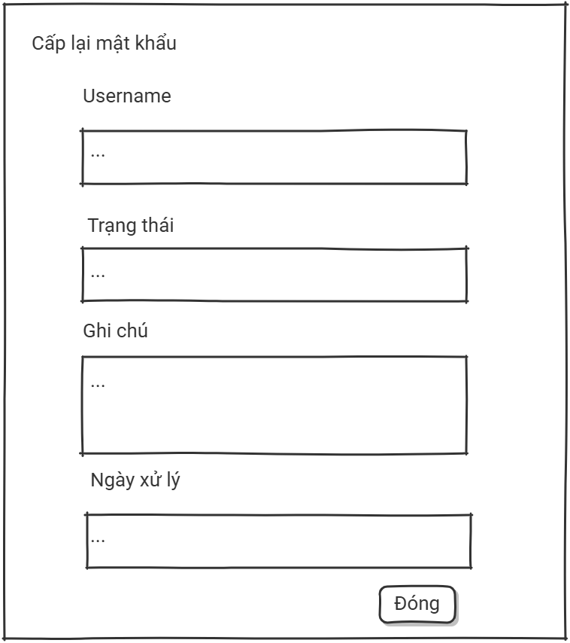
Stats Cards
Field Name | Description
“Stats Cards” | Displays the total number of password reset requests in the system. Labeled "Tổng yêu cầu".
“Pending” | Displays the number of requests currently awaiting processing (status "pending"). Labeled "Đang chờ".
“Approved” | Displays the number of requests that have been processed (status "approved"). Labeled "Đã cấp lại".

Filter Tabs

Field Name | Description
“All Tab” | Filter tab labeled "Tất cả". Active by default when no status filter is applied. Displays all requests regardless of status.
“Pending Tab” | Filter tab labeled "Chờ xử lý". Filters the list to show only requests with status "pending".
“Approved Tab” | Filter tab labeled "Đã cấp lại". Filters the list to show only requests with status "approved".

Request Table

Field Name | Description
“Table Columns” | Table displays 5 columns: ID (prefixed "#", monospace), Username, Status (colored pill badge: "Chờ xử lý" warn/yellow for pending, "Đã cấp lại" accent/green for approved), Submitted Date (createdAt), Actions.
“Process Button” | Labeled "Cấp lại" (primary accent style). Visible only for pending requests. Opens a modal with readonly Username and optional Note field. On confirm: generates a random password, hashes with BCrypt, updates the user's password, marks the request "approved". The plain-text password is shown in a session success message.
“Detail Button” | Labeled "Chi tiết" (default style). Visible only for approved requests. Opens a read-only modal showing: Username, Status ("Đã cấp lại"), Note, and Processing Date (processedAt).
“Pagination” | Always visible below the table. Includes "← Trước" (disabled on first page), numbered page buttons (current highlighted), and "Sau →" (disabled on last page). All links preserve the active status filter.

3.4 Order Management

3.4.1. Create Order
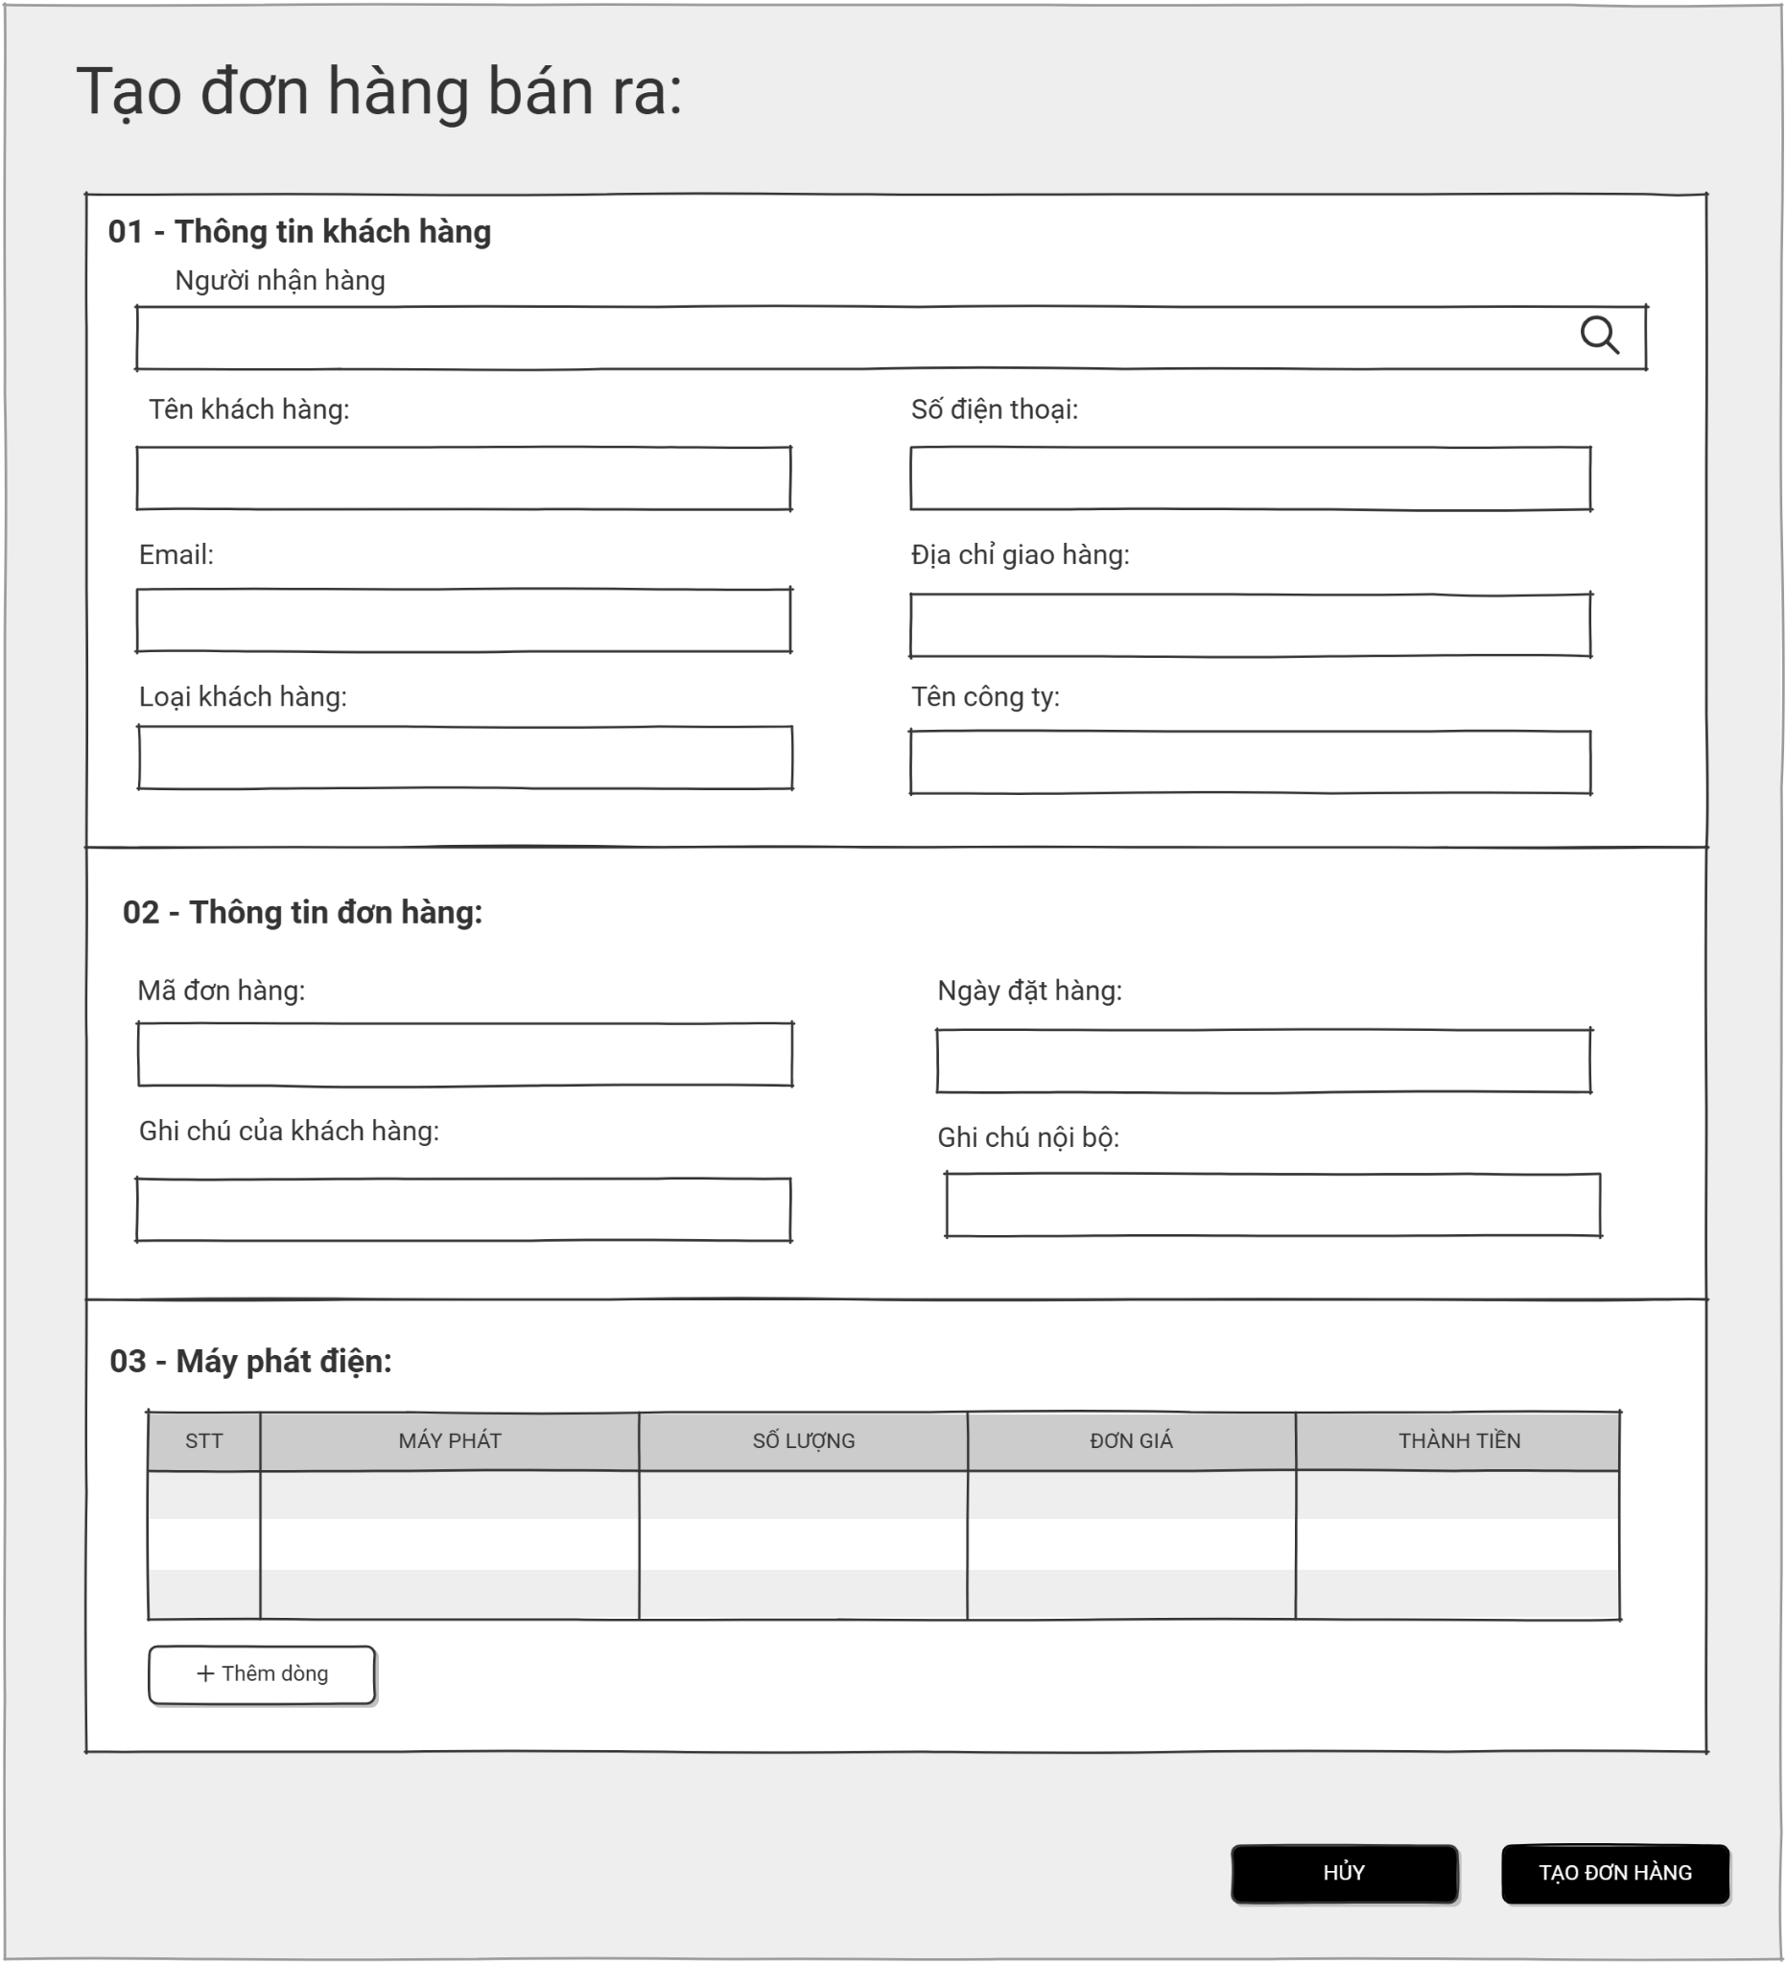

Field Name | Description
“Tên khách hàng” | Text input field labeled "Tên khách hàng". Marked as a required field (*). It accepts a string representing the full name of the buyer or corporate contact. Placeholder text: "VD: Nguyễn Văn A".
“Số điện thoại” | Numerical text input field labeled "Số điện thoại". Marked as a required field (*). It accepts a numeric string for the customer's primary contact number. Placeholder text: "VD: 0912345678".
“Email” | Text input field labeled "Email". Optional configuration to capture the customer's electronic mail address for invoicing or communication. Placeholder text: "email@example.com".
“Địa chỉ giao hàng” | Text input field labeled "Địa chỉ giao hàng". Marked as a required field (*). Documents the formal physical address where the generator will be delivered. Placeholder text: "VD: Số 1, Đường ABC, Quận 1, TP.HCM".
“Loại khách hàng” | Dropdown selection field labeled "Loại khách hàng". Marked as a required field (*). Allows the user to select the customer category from a predefined list (e.g., Retail, Wholesale, Enterprise). Placeholder text: "-- Chọn loại khách hàng --".
“Tên công ty” | Text input field labeled "Tên công ty". Optional field to document the formal corporate or legal entity name if the customer is a business. Placeholder text: "VD: Công ty TNHH ABC".
“Mã số thuế” | Text input field labeled "Mã số thuế". Optional alphanumeric text field to record the customer's official business tax identification number. Placeholder text: "VD: 0123456789".
“Mã đơn hàng” | Text input field labeled "Mã đơn hàng". Optional field to manually input a specific identification string, or it will be automatically generated by the system if left blank. Placeholder text: "VD: ORD-20260526-001".
“Ngày đặt hàng” | Date picker selection field labeled "Ngày đặt hàng". Marked as a required field (*). Allows the user to select the official execution date of the transaction. Placeholder text: "mm/dd/yyyy".
“Ghi chú khách hàng” | Multiline text area component labeled "Ghi chú của khách hàng". Provides optional space to record specific delivery instructions or public remarks requested by the buyer. Placeholder text: "VD: Giao giờ hành chính, gọi trước khi giao...".
“Ghi chú nội bộ” | Multiline text area component labeled "Ghi chú nội bộ". Provides optional space for staff-only remarks, internal tracking details, or private comments regarding the order. Placeholder text: "VD: Khách quen, giảm giá 5%...".
“Máy phát” | Dropdown selection field labeled "Chọn máy". Marked as a required field (*). Allows the user to dynamically select a specific generator model from the active inventory list. Placeholder text: "-- Chọn máy --".
“Đơn giá” | Numerical text input field labeled "Số lượng". Marked as a required field (*). Captures the total number of units ordered for the selected generator model. Default value: "1".
“Số lượng” | Read-only numerical field labeled "Đơn giá". Automatically populated and updated based on the standard commercial price of the selected generator model. Displays currency in Vietnamese Đồng (đ).
“Thành tiền” | Read-only calculated text component labeled "Thành tiền". Displays the product of the "Unit Price" and "Quantity" for that specific item line. Displays currency in Vietnamese Đồng (đ).
“Thêm dòng” | Interactive action component labeled "+ Thêm dòng". Allows the user to dynamically append a new item row to the product grid for adding multiple generator models within the same order.
“Hủy” | Navigation action component labeled "Hủy". Aborts the current creation process and redirects the user back to the order management dashboard.
“Tạo đơn hàng” | Action component labeled "+ Tạo đơn hàng". Validates all mandatory inputs and submits the entire order form data to the server for creation.

3.4.2. Manage Order:
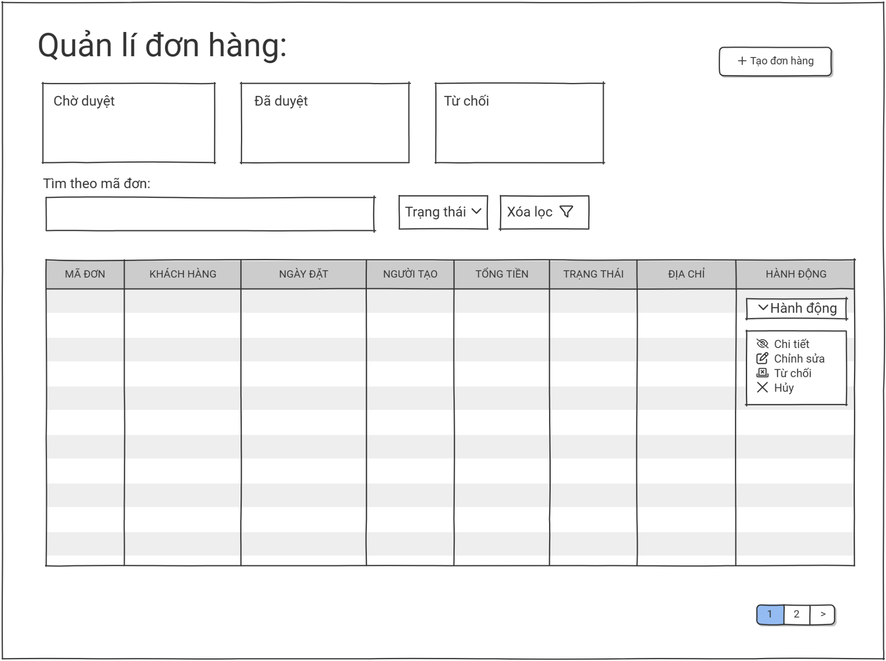

Field Name | Description
“Chờ duyệt” | Read-only statistics card component labeled "Chờ duyệt". Dynamically displays the current total number of orders awaiting manager approval (Value: "4").
“Đã duyệt” | Read-only statistics card component labeled "Đã duyệt". Dynamically displays the total number of successfully processed and approved orders (Value: "5").
“Từ chối” | Read-only statistics card component labeled "Từ chối". Dynamically displays the total number of orders that have been rejected by managers (Value: "2").
“Đã hủy” | Read-only statistics card component labeled "Đã hủy". Dynamically displays the total number of orders canceled by sale staff before completion (Value: "4").
“Tìm kiếm” | Text input field with a search magnifying glass icon labeled "Tìm theo mã đơn hoặc tên khác". Accepts an alphanumeric string or text string to filter the list instantly by Order ID or Customer Name.
“Trạng thái” | Dropdown selection component labeled "Trạng thái: Tất cả". Allows users to filter the visible table rows by specific states (e.g., Tất cả, Chờ duyệt, Đã duyệt, Từ chối, Đã hủy). Select options trigger automatic page reload.
“Xóa lọc” | Interactive action component button labeled "Xóa lọc". Resets all active search strings and status filters, returning the order table view to its baseline state.
Icon “Xem chi tiết” | Inline actionable icon element (Eye symbol) under the "Hành động" column. Triggers navigation to review comprehensive details of that specific row.
Icon “Hủy đơn hàng” | Inline actionable icon element (Exclamation/Warning symbol) under the "Hành động" column. Triggers the input box for Sale Managers to log rejection reasons.
Icon “Chấp nhận đơn hàng” | Inline actionable icon element (Checkmark symbol) under the "Hành động" column. Authorized for Sale Managers to quickly transition state to Approved.
Icon “Từ chối đơn ” | Multiline text area component labeled "Ghi chú nội bộ". Provides optional space for staff-only remarks, internal tracking details, or private comments regarding the order. Placeholder text: "VD: Khách quen, giảm giá 5%...".
Icon “Chỉnh sửa đơn hàng” | Inline actionable icon element (Pencil symbol) under the "Hành động" column. Allows authorized staff to modify editable order values.
Phân trang | Footer navigation structure indicating active pagination states (e.g., "Hiển thị 1–10 / 15 kết quả"). Includes interactive number buttons ("1", "2") and next arrow elements to handle large datasets.

3.5 Generator Management

3.5.1 Create Generator

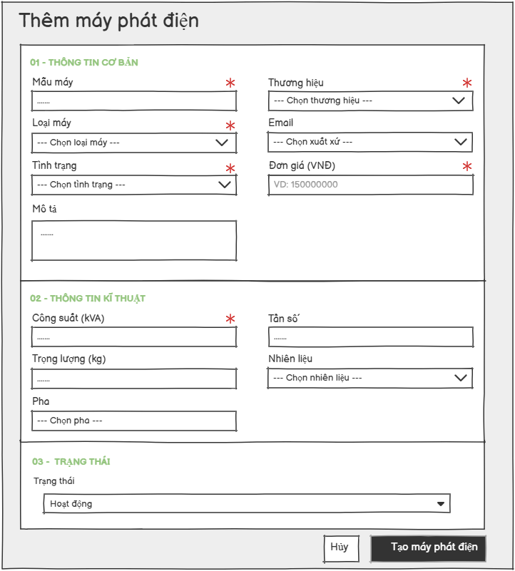
Screen Description:
- Screen Name: Create New Generator
- Access Role: Warehouse Manager
- Main Functionality: This screen provides a multi-section form that allows administrators to modify and update an existing generator asset entry in the system. It fetches existing data properties, models operational metrics, and allows status alterations.

Field Name | Description
Model | Text input field labeled "Mẫu máy". Marked as a required field (*). It accepts an alphanumeric string representing the specific model code of the generator. Placeholder text: "VD: GX-5000".
Brand | Dropdown selection field labeled "Thương hiệu". Marked as a required field (*). Allows the user to select the manufacturer or brand from a predefined structural list. Placeholder text: "-- Chọn thương hiệu --".
Generator Type | Dropdown selection field labeled "Loại máy". Optional configuration to categorize the structural type or application category of the generator. Placeholder text: "-- Chọn loại máy --".
Origin | Dropdown selection field labeled "Xuất xứ". Captures the geographic or manufacturing country of origin. Placeholder text: "-- Chọn xuất xứ --".
Condition | Dropdown selection field labeled "Tình trạng". Documents the current physical state or quality level of the hardware (e.g., New, Used). Placeholder text: "-- Chọn tình trạng --".
Unit Price | Numerical text input field labeled "Đơn giá (VNĐ)". Marked as a required field (*). Captures the formal commercial unit price representation in Vietnamese Đồng. Placeholder text: "VD: 15000000".
Description | Multiline text area component labeled "Mô tả". Provides optional space to document comprehensive details, features, or notes regarding the generator. Placeholder text: "Mô tả chi tiết về máy phát điện...".
Capacity | Numerical text input field labeled "Công suất (kVA)". Marked as a required field (*). Validates standard numerical metrics representing the total power capacity rating. Placeholder text: "VD: 5.0".
Frequency | Text input field labeled "Tần số". Captures the operational alternating current frequency constraints of the engine. Placeholder text: "VD: 50Hz".
Weight | Numerical text input field labeled "Trọng lượng (kg)". Optional field to document the geographic net weight coordinates of the physical unit. Placeholder text: "VD: 85.5".
Fuel Type | Dropdown selection field labeled "Nhiên liệu". Maps out the corresponding primary energy source type required to run the machine (e.g., Diesel, Petrol). Placeholder text: "-- Chọn nhiên liệu --".
Phase | Dropdown selection field labeled "Pha". Configures the phase configuration details (e.g., 1-Phase, 3-Phase). Placeholder text: "-- Chọn pha --".
Status | Configuration dropdown element labeled "Trạng thái". Sets the starting operational access or availability state of the asset in the inventory system. Defaults to "Hoạt động" (Active).
Cancel | Action button labeled "Huỷ". Discards all current temporary text edits and structural selections within the layout without applying changes.
Create Generator | Primary action button labeled "+ Tạo máy phát điện". Validates the required form parameters across sections and triggers backend database record generation for the new generator asset profile.

3.5.2 Edit Generator

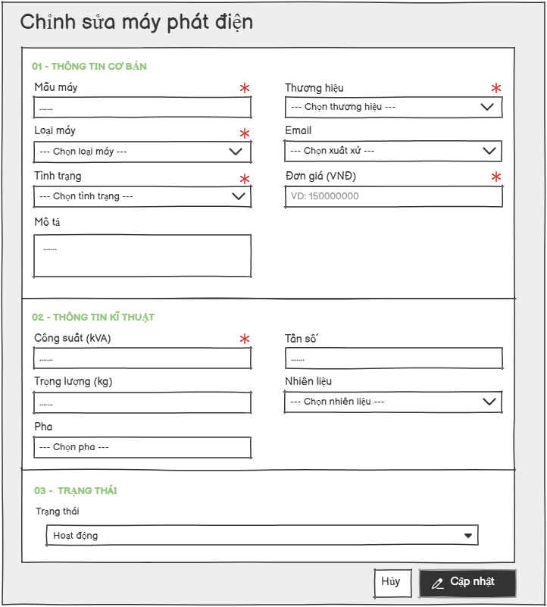
Screen Description:
- Screen Name: Edit Generator
- Access Role: Warehouse Manager
- Main Functionality: This screen provides a multi-section form that allows administrators to modify and update an existing generator asset entry in the system. It fetches existing data properties, models operational metrics, and allows status alterations.

Field Name | Description
Model | Text input field labeled "Mẫu máy". Marked as a required field (*). It accepts an alphanumeric string representing the specific model code of the generator. Placeholder text: "VD: GX-5000".
Brand | Dropdown selection field labeled "Thương hiệu". Marked as a required field (*). Allows the user to select the manufacturer or brand from a predefined structural list. Placeholder text: "-- Chọn thương hiệu --".
Generator Type | Dropdown selection field labeled "Loại máy". Optional configuration to categorize the structural type or application category of the generator. Placeholder text: "-- Chọn loại máy --".
Origin | Dropdown selection field labeled "Xuất xứ". Captures the geographic or manufacturing country of origin. Placeholder text: "-- Chọn xuất xứ --".
Condition | Dropdown selection field labeled "Tình trạng". Documents the current physical state or quality level of the hardware (e.g., New, Used). Placeholder text: "-- Chọn tình trạng --".
Unit Price | Numerical text input field labeled "Đơn giá (VNĐ)". Marked as a required field (*). Captures the formal commercial unit price representation in Vietnamese Đồng. Placeholder text: "VD: 15000000".
Description | Multiline text area component labeled "Mô tả". Provides optional space to document comprehensive details, features, or notes regarding the generator. Placeholder text: "Mô tả chi tiết về máy phát điện...".
Capacity | Numerical text input field labeled "Công suất (kVA)". Marked as a required field (*). Validates standard numerical metrics representing the total power capacity rating. Placeholder text: "VD: 5.0".
Frequency | Text input field labeled "Tần số". Captures the operational alternating current frequency constraints of the engine. Placeholder text: "VD: 50Hz".
Weight | Numerical text input field labeled "Trọng lượng (kg)". Optional field to document the geographic net weight coordinates of the physical unit. Placeholder text: "VD: 85.5".
Fuel Type | Dropdown selection field labeled "Nhiên liệu". Maps out the corresponding primary energy source type required to run the machine (e.g., Diesel, Petrol). Placeholder text: "-- Chọn nhiên liệu --".
Phase | Dropdown selection field labeled "Pha". Configures the phase configuration details (e.g., 1-Phase, 3-Phase). Placeholder text: "-- Chọn pha --".
Status | Configuration dropdown element labeled "Trạng thái". Sets the starting operational access or availability state of the asset in the inventory system. Defaults to "Hoạt động" (Active).
Cancel | Action button labeled "Huỷ". Discards all current temporary text edits and structural selections within the layout without applying changes.
Create  Generator | Primary action button labeled "Cập nhật". Performs structural validation on required parameters and updates backend database record attributes with the modified variables.

3.5.3 Generator List
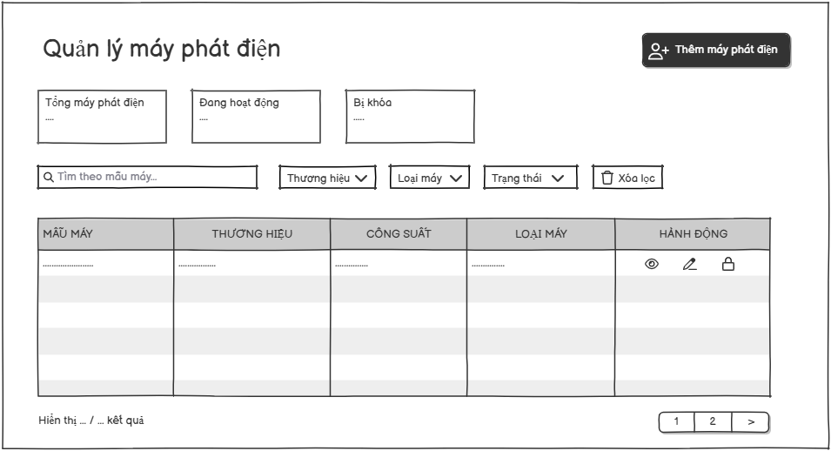
Screen Description:
- Screen Name: Generator List
- Access Role: Warehouse Manager
- Main Functionality: This screen displays a comprehensive, paginated table of all generator assets currently registered in the system. It allows users to view overview statistics, search, filter, and manage generators. From this screen, authorized users can also navigate to create a new asset or perform actions on existing entries.

Field Name | Description
Add Generator | Action button labeled "Thêm máy phát điện". Clicking this button redirects the User/Administrator to the creation screen to add a new asset.
Total Generators | Information block displaying the total number of generator assets registered in the system (e.g., 11). Data type: Integer.
Search | Text input field with placeholder "Tìm theo mẫu máy...". Allows the user to dynamically filter the list by typing the generator model name.
Role | Filter dropdown list labeled "Vai trò: Tất cả". Allows filtering the user list by system roles.
Brand Filter | Filter dropdown list labeled "Thương hiệu: Tất cả". Allows filtering the list by manufacturers (e.g., Cummins, Hyundai, Honda, Yamaha).
Machine Type Filter | Filter dropdown list labeled "Loại máy: Tất cả". Allows filtering the generator list by its application type (e.g., Công nghiệp, Dân dụng, Inverter).
Status Filter | Filter dropdown list labeled "Trạng thái: Tất cả". Allows filtering the list by operational status (e.g., Hoạt động, Bị khóa).
Clear Filter | Action button labeled "Xóa lọc" with a reset icon. Resets all active search inputs and dropdown selections back to their default states.
Generator List | Data grid displaying generator records with the following columns:  • MẪU MÁY (MODEL): Displays the technical model name of the generator.  • THƯƠNG HIỆU (BRAND): Displays the manufacturer's name.  • CÔNG SUẤT (CAPACITY): Displays the power capacity formatted with units (e.g., 25.00 kVA).  • ĐƠN GIÁ (UNIT PRICE): Displays the rental or asset price formatted in VND (e.g., 85,000,000 đ).  • LOẠI MÁY (TYPE): Displays the classification category.  • TRẠNG THÁI (STATUS): Displays status indicators (e.g., "Hoạt động" with a green dot or "Bị khóa" with a red dot).  • HÀNH ĐỘNG (ACTION): Placeholder column for interactive operational tools.
View Details | Action icon (Eye shape)* under the Action column. Opens a detailed technical specifications sheet or modal for the selected generator.
Edit | Action icon (Pencil shape)* under the Action column. Redirects the user to the "Edit Generator" screen to modify asset details.
Lock | Action icon (Trash bin or Lock shape)* under the Action column. Allows the user to remove or change the status of the selected generator entry.
Pagination | Navigation element at the bottom right displaying row ranges (e.g., "Hiển thị 1–10 / 11 kết quả") and page numbers to navigate through multiple pages of records.

3.5.4 Generator Detail
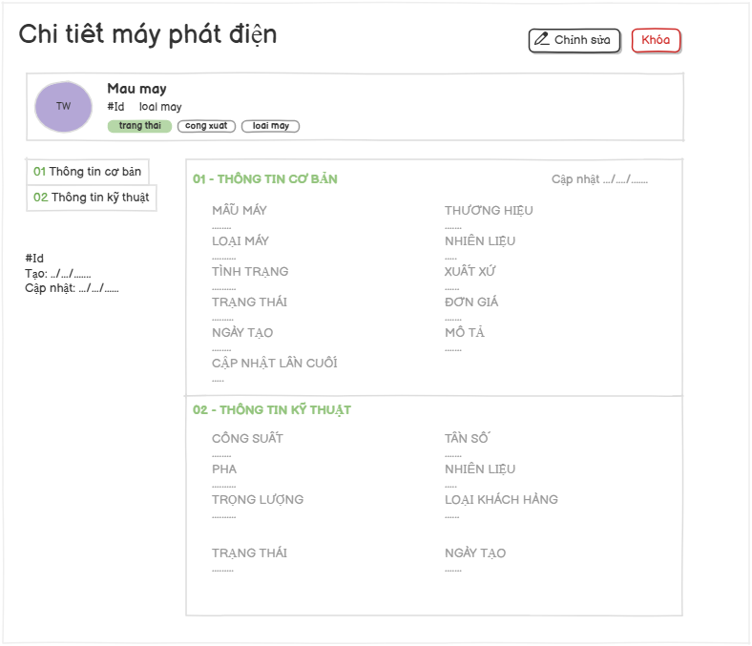
Screen Description:
- Screen Name: Generator Details
- Access Role: Warehouse Manager
- Main Functionality: This screen displays comprehensive, read-only profile and technical specifications for a specific generator asset. It allows users to review general management information, technical performance metrics, operational status, and system tracking timestamps. From this screen, authorized users can initiate management actions such as profile modifications, asset locking/unlocking, or navigating through structured information tabs.

Field Name | Description
Edit | Action button labeled "Chỉnh sửa" located in the top-right header toolbar. Clicking it opens the generator modification mode or screen.
Activate/Deactivate | Action button labeled "Kích hoạt" with green styling. Clicking it changes the generator status to active. Action button labeled "Vô hiệu hoá" with red styling. Clicking it changes the generator status to locked.
Generator Profile Summary | Highlighted summary block at the top displaying the generator's initial avatar, Model Name ("Mau may"), Generator ID ("#Id"), Category ("loai may"), and three descriptive status/specification badges ("trang thai", "cong xuat", "loai may").
Basic Information Card | Main data block labeled "01 - THÔNG TIN CƠ BẢN" displaying read-only general management fields including: Model, Machine Type, Condition, Status, Created Date, Last Updated, Brand, Fuel Type, Origin, Unit Price, Description, and a top-right modification timestamp ("Cập nhật .../.../......").
Technical Specification Card | Secondary data block labeled "02 - THÔNG TIN KỸ THUẬT" displaying read-only technical performance fields including: Capacity, Phase, Weight, Status, Frequency, Fuel Type, Customer Type, and Created Date.

3.6. Category Management

3.6.1 View category management list

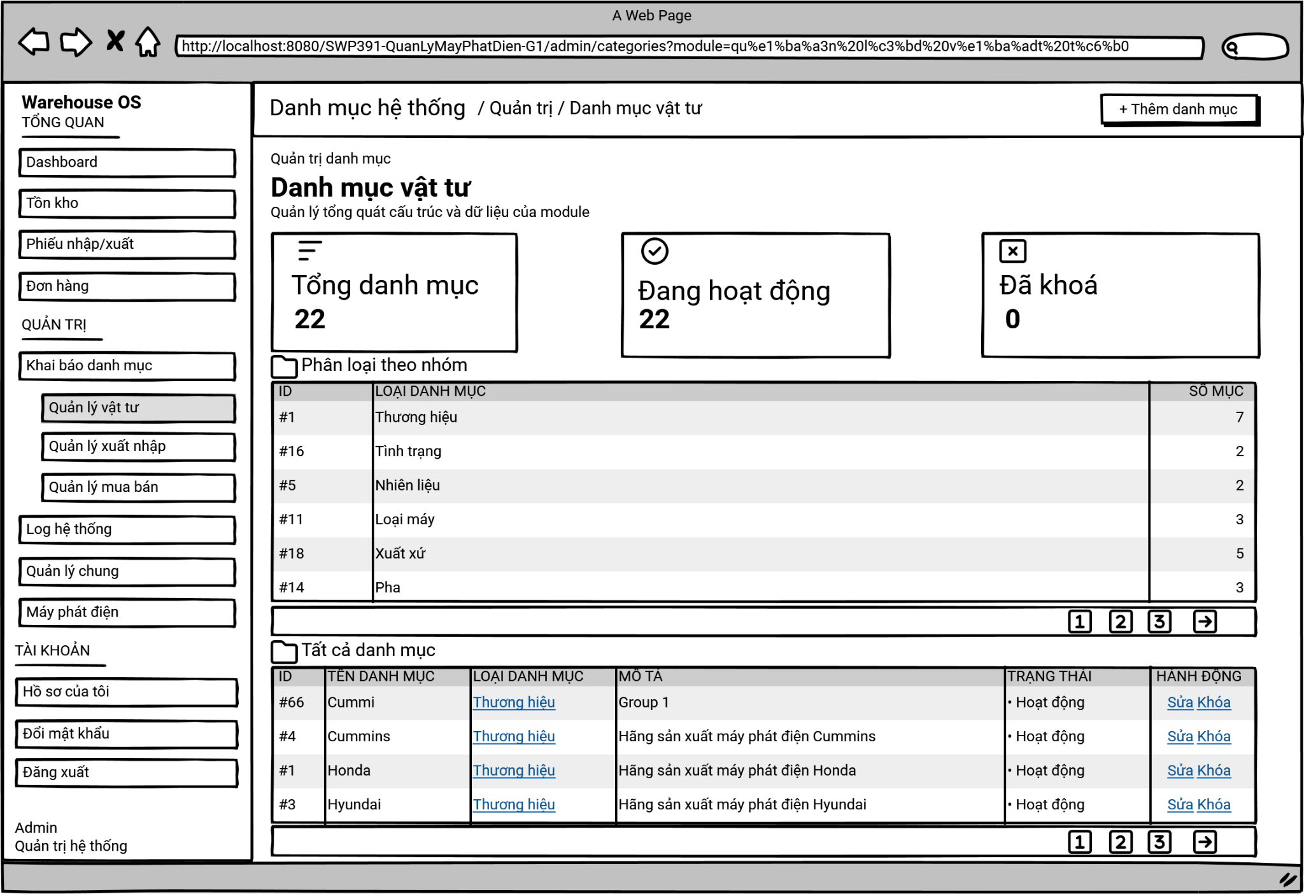
On this screen, the Administrator can:
- View Category Statistics: quickly review the overall metrics through KPI cards showing the total number of categories, active categories, and locked categories.
- Review Category Groups: view a summarized table of categories aggregated by their type (e.g., Brand, Status, Fuel) along with the item count for each.
- Manage All Categories: view a detailed, comprehensive list of all individual categories, including their specific name, type, description, and operational status.
- Add New Category: initiate the creation of a new category entry into the system.
- Modify/Delete Entries: perform row-level actions to edit existing category details or remove them entirely.

Field Name | Description
Add Category Button | Add Category Button: "+ Thêm danh mục"  - A button located at the top right to trigger the creation of a new category entry.
Summary Dashboard | KPI Cards: "Tổng danh mục", "Đang hoạt động", "Đã khoá"  - Read-only metric cards displaying the total count, active count, and inactive/locked count of categories currently in the module.
Category Groups Table | Grouped Table: "Phân loại theo nhóm"  - A summary table displaying category classifications.  - Columns include: "ID", "LOẠI DANH MỤC" (Category Type), and "SỐ MỤC" (Number of items belonging to that type).
All Categories Table | Detailed List Table: "Tất cả danh mục"  - A structured grid displaying all individual categories in the system.  - Columns include: "ID", "TÊN DANH MỤC" (Category Name), "LOẠI DANH MỤC" (Category Type - acts as a clickable link), "MÔ TẢ" (Description), "TRẠNG THÁI" (Status), and "HÀNH ĐỘNG" (Action).
Action Links | Action Links: "Sửa" / "Khóa"  - Clickable text links located in the "HÀNH ĐỘNG" column of the All Categories Table.  - Allows the Administrator to either edit ("Sửa") the specific category details or soft delete ("Khoá") the record from the database.
Pagination | Pagination Component:  - Used to paginate and navigate through long data lists.  - Page numbers (1, 2, 3...): Click to jump directly to the respective page.  - Arrow buttons: Click to go to the previous or next page.

3.6.2 View category list in detail
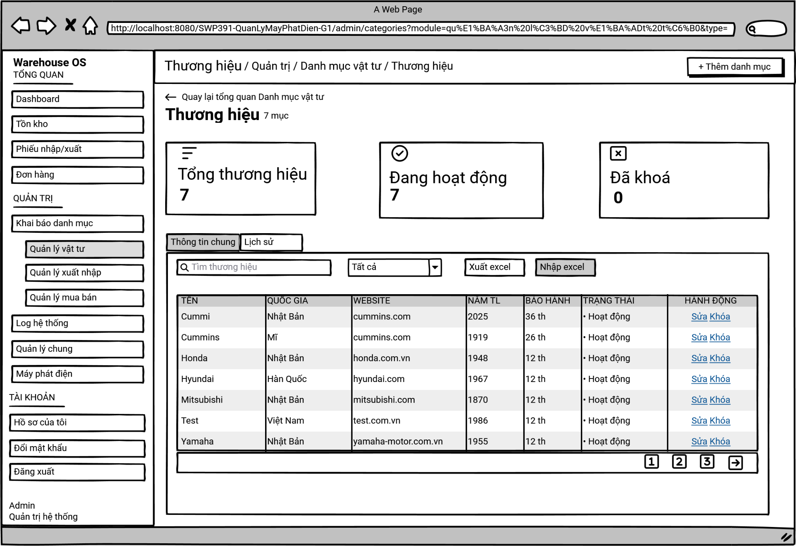
This screen allows the Administrator to view and manage specific entries within a selected category classification (in this case, "Thương hiệu" - Brands).
On this screen, the Administrator can:
- Navigate: easily return to the main Category Overview screen using the back link.
- View Specific Statistics: review KPI cards that display the total, active, and locked count of items specifically for the selected category.
- Search and Filter: locate specific items using a text search bar or filter them by their status using a dropdown menu.
- Bulk Data Operations: export the current list to an Excel file or import new data from an Excel file to update the database efficiently.
- Manage Entries: view a detailed data table of all items, add new entries, or perform row-level actions to edit or delete existing records.
- Switch Views: toggle between the general information list ("Thông tin chung") and the audit log/history ("Lịch sử") of the category.

Field Name | Description
Back Link | Back Navigation Link: "<- Quay lại tổng quan Danh mục vật tư"  - A clickable text link that redirects the user back to the main Category Overview page.
Add Button | Add Item Button: "+ Thêm danh mục"  - A button located at the top right to trigger the creation of a new entry within this specific category.
Summary Dashboard | KPI Cards: "Tổng thương hiệu", "Đang hoạt động", "Đã khoá"  - Read-only metric cards displaying the total count, active count, and inactive/locked count of items within this specific category.
Navigation Tabs | Tabs: "Thông tin chung" / "Lịch sử"  - Allows the user to switch between viewing the data table ("Thông tin chung") and the audit history ("Lịch sử").  - The "Thông tin chung" tab is currently active.
Search Input | Search Bar: "Tìm thương hiệu"  - A text input field with a magnifying glass icon to search for specific items by name or other text attributes.
Filter Dropdown | Status Dropdown: "Tất cả"  - A dropdown menu allowing the user to filter the table by operational status (e.g., All, Active, Locked).
Data Action Buttons | Export/Import Buttons: "Xuất excel" / "Nhập excel"  - Buttons to download the current data grid into an Excel spreadsheet ("Xuất excel") or upload an Excel file to bulk-insert/update records ("Nhập excel").
Data Table | Category Details Table:  - A structured grid displaying the specific items.  - Columns include: "TÊN" (Name), "QUỐC GIA" (Country), "WEBSITE", "NĂM TL" (Year Founded), "BẢO HÀNH" (Warranty), "TRẠNG THÁI" (Status), and "HÀNH ĐỘNG" (Action).
Action Links | Search input field featuring a magnifying glass icon. Allows users to type text strings to filter the table data instantly by brand name.
Dropdown "Tất cả" | Action Links: "Sửa" / "Khóa"  - Clickable text links located in the "HÀNH ĐỘNG" column.  - Allows the Administrator to either edit ("Sửa") the specific item's details or delete ("Khóa") it from the system.
Pagination | Pagination Component:  - Used to paginate and navigate through long data lists.  - Page numbers (1, 2, 3...): Click to jump directly to the respective page.  - Arrow buttons: Click to go to the previous or next page.

3.6.3 Add new category
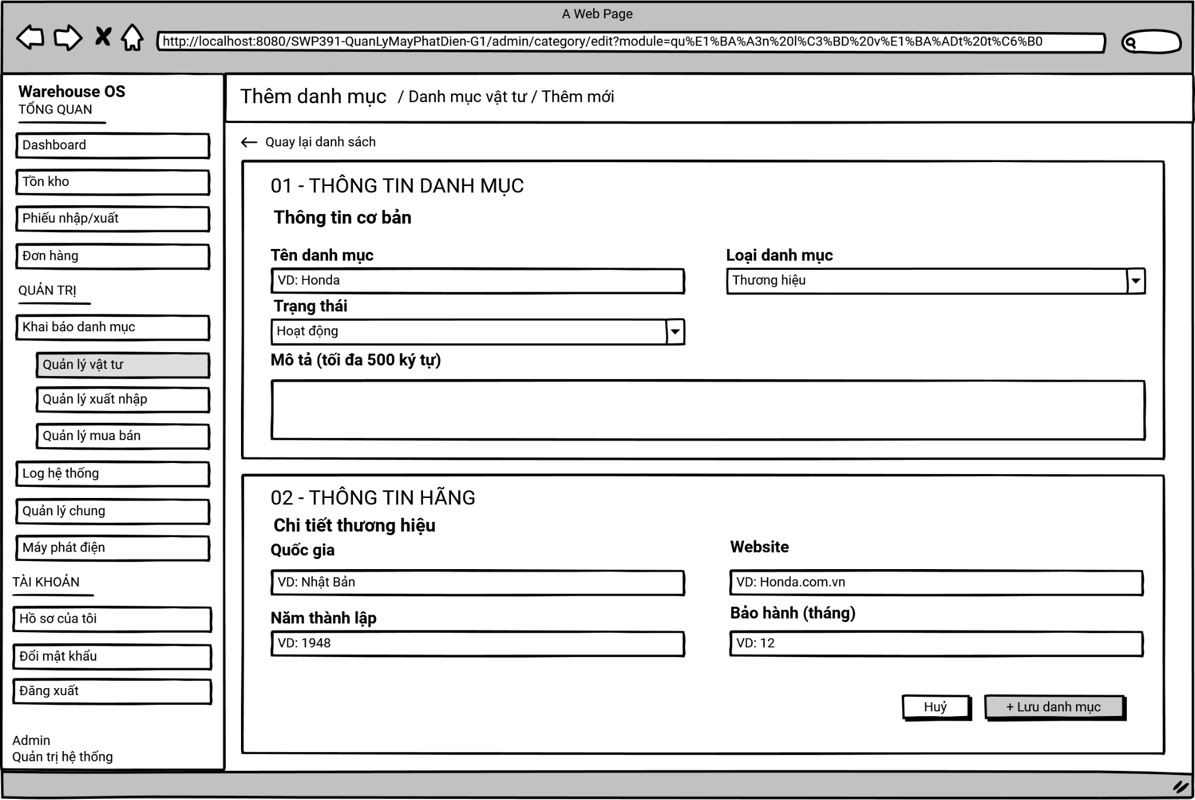
This screen allows the Administrator to create and configure a new category entry within the system through a structured, multi-section form. The form dynamically adapts based on the selected category type (in this case, displaying fields specific to a "Thương hiệu" - Brand).
On this screen, the Administrator can:
- Navigate: return safely to the previous category list without saving changes using the back link.
- Enter Basic Information: define core attributes of the new category, including its name, classification type, operational status, and a general description.
- Enter Specific Details: input specialized data corresponding to the chosen category type (e.g., for a Brand, adding details like origin country, website, founding year, and warranty period).
- Save/Cancel: submit the form to create the new category in the database or cancel the operation to discard all entered inputs.

Field Name | Description
Back Link | Back Navigation Link: "<- Quay lại danh sách"  - A clickable text link that discards current progress and redirects the user back to the category list page.
Basic Info Section | Basic Information Area: "01 - THÔNG TIN DANH MỤC" / "Thông tin cơ bản"  - A designated section for inputting the general attributes required for any category type.
Category Name | Category Name Input: "Tên danh mục"  - A text input field for the name of the new category.  - Placeholder text: "VD: Honda".
Category Type | Category Type Dropdown: "Loại danh mục"  - A dropdown menu to select the classification of the category.  - The current selection is "Thương hiệu", which dictates the fields shown in Section 02.
Status | Status Dropdown: "Trạng thái"  - A dropdown menu to set the initial operational status of the category.  - Default/Current selection is "Hoạt động".
Description | Description Text Area: "Mô tả (tối đa 500 ký tự)"  - A larger text box for providing a detailed explanation or notes about the category, with a limit of 500 characters.
Specific Info Section | Specific Details Area: "02 - THÔNG TIN HÃNG" / "Chi tiết thương hiệu"  - A dynamic section that appears based on the "Loại danh mục" selected above, containing the following specific fields for brands:  + Origin Input: "Quốc gia". Text input, placeholder: "VD: Nhật Bản".  + Website Input: "Website". Text input, placeholder: "VD: Honda.com.vn".  + Year Founded Input: "Năm thành lập". Numeric/text input, placeholder: "VD: 1948".  + Warranty Input: "Bảo hành (tháng)". Numeric input, placeholder: "VD: 12".
Cancel Button | Cancel Button: "Huỷ"  - A secondary button to discard all filled information and close the form without saving.
Save Button | Save Button: "+ Lưu danh mục"  - A primary button that validates the form data and submits it to the backend to create the new category record.

3.6.4 Edit category
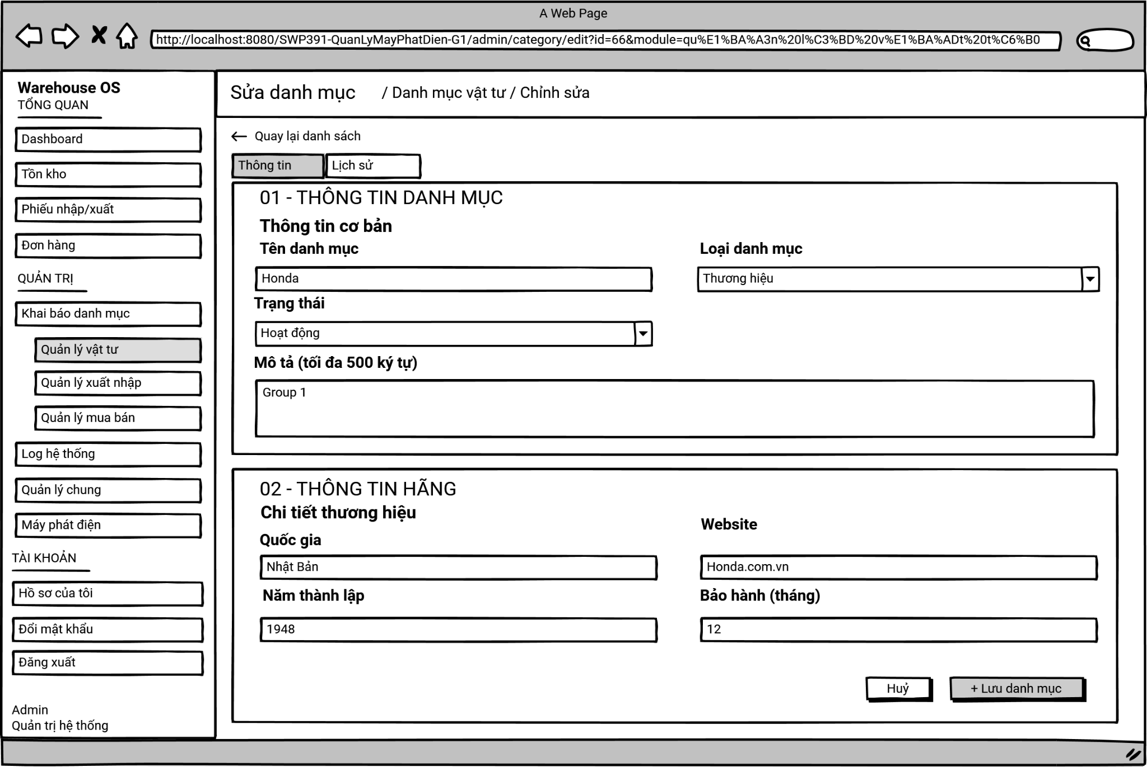
This screen allows the Administrator to view and modify the details and configuration of an existing category entry within the system. The form is pre-populated with the current data of the selected category.
On this screen, the Administrator can:
- Navigate: return to the previous category list without saving any modifications using the back link.
- Switch Views: toggle between editing the category details ("Thông tin") and viewing the audit history of changes made to this category ("Lịch sử").
- Update Basic Information: modify core attributes such as the category name, operational status, and description.
- Update Specific Details: modify specialized data corresponding to the category type (e.g., for a Brand, updating the country, website, founding year, or warranty period).
- Save/Cancel: submit the updated form data to the database or cancel the operation to discard all changes.

Field Name | Description
Back Link | Back Navigation Link: "<- Quay lại danh sách"  - A clickable text link that discards current progress and redirects the user back to the category list page.
Navigation Tabs | Tabs: "Thông tin" / "Lịch sử"  - Allows the user to switch between the editing form ("Thông tin") and the audit log ("Lịch sử").  - The "Thông tin" tab is currently active.
Basic Info Section | Basic Information Area: "01 - THÔNG TIN DANH MỤC" / "Thông tin cơ bản"  - A designated section displaying the general attributes of the category.
Category Name | Category Name Input: "Tên danh mục"  - A text input field pre-filled with the current category name (e.g., "Honda").
Category Type | Category Type Dropdown: "Loại danh mục"  - A dropdown menu indicating the classification of the category (e.g., "Thương hiệu").
Status | Status Dropdown: "Trạng thái"  - A dropdown menu to set the initial operational status of the category.  - Default/Current selection is "Hoạt động".
Description | Description Text Area: "Mô tả (tối đa 500 ký tự)"  - A text box pre-filled with the current description (e.g., "Group 1"), allowing up to 500 characters.
Specific Info Section | Specific Details Area: "02 - THÔNG TIN HÃNG" / "Chi tiết thương hiệu"  - A section containing the specific fields for the "Thương hiệu" type, pre-filled with existing data:  + Country Input: "Quốc gia" (Lưu ý: Lỗi UI ở màn hình Thêm mới đã được sửa lại đúng tên nhãn ở màn hình này). Text input, pre-filled with current data (e.g., "Nhật Bản").  + Website Input: "Website". Text input, pre-filled (e.g., "Honda.com.vn").  + Year Founded Input: "Năm thành lập". Numeric/text input, pre-filled (e.g., "1948").  + Warranty Input: "Bảo hành (tháng)". Numeric input, pre-filled (e.g., "12").
Cancel Button | Cancel Button: "Huỷ"  - A secondary button to discard all filled information and close the form without saving.
Save Button | Save Button: "+ Lưu danh mục"  - A primary button that validates the form data and submits it to the backend to create the new category record.

3.6.5 View detail list history
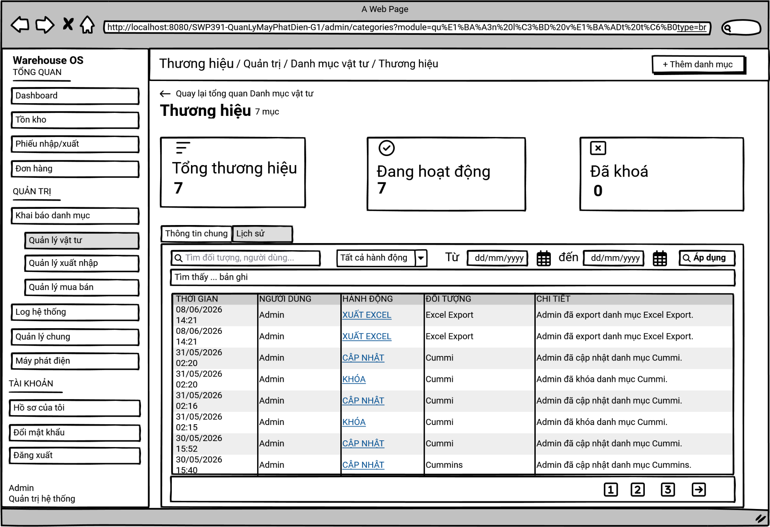
This screen allows the Administrator to view the audit log and historical tracking of all actions performed within a specific category classification (in this case, "Thương hiệu" - Brands).
On this screen, the Administrator can:
- Navigate: return to the main Category Overview screen using the back link.
- View Specific Statistics: review KPI cards that display the total, active, and locked count of items specifically for the selected category.
- Filter History by Keyword: search the audit log for specific objects (e.g., a specific brand name) or specific users who performed the actions.
- Filter by Action Type: narrow down the history records by selecting specific action categories from a dropdown menu (e.g., updates, locks, exports).
- Filter by Date Range: specify a start and end date to view only the changes that occurred within a defined timeframe.
- Review Audit Trail: view a detailed data table of all recorded events, including timestamps, users, actions, target objects, and descriptive details.
- Switch Views: toggle between the general information list ("Thông tin chung") and this audit log/history ("Lịch sử").

Field Name | Description
Back Link | Back Navigation Link: "<- Quay lại tổng quan Danh mục vật tư"  - A clickable text link that redirects the user back to the main Category Overview page.
Navigation Tabs | Tabs: "Thông tin chung" / "Lịch sử"  - Allows the user to switch between viewing the data table ("Thông tin chung") and the audit history ("Lịch sử").  - The "Lịch sử" tab is currently active.
Add Button | Add Item Button: "+ Thêm danh mục"  - A button located at the top right to trigger the creation of a new entry within this specific category.
Summary Dashboard | KPI Cards: "Tổng thương hiệu", "Đang hoạt động", "Đã khoá"  - Read-only metric cards displaying the total count, active count, and inactive/locked count of items within this specific category.
Search Input | Search Bar: "Tìm đối tượng, người dùng..."  - A text input field with a magnifying glass icon to search the log by specific target objects or user names.
Action Filter | Action Dropdown: "Tất cả hành động"  - A dropdown menu allowing the user to filter the log by specific action types (e.g., XUẤT EXCEL, CẬP NHẬT, KHÓA).
Date Range | Date Pickers: "Từ" [dd/mm/yyyy] "đến" [dd/mm/yyyy]  - Input fields with calendar icons to specify a start date and an end date to filter the history records within a specific time frame.
Apply Button | Filter Apply Button: "Áp dụng"  - A button with a magnifying glass icon used to execute the search and apply the selected filters to the history table below.
Record Count | Result Summary: "Tìm thấy [X] bản ghi"  - A text label indicating the total number of history records found based on the applied filters (e.g., "Tìm thấy 9 bản ghi").
History Table | Audit Log Table:  - A structured grid displaying the history of actions made within the category.  - Columns include: "THỜI GIAN" (Timestamp), "NGƯỜI DÙNG" (User who executed the action), "HÀNH ĐỘNG" (Type of Action - often displayed as a clickable link), "ĐỐI TƯỢNG" (Target object affected), and "CHI TIẾT" (Specific description of the event).
Pagination | Pagination Component:  - Used to paginate and navigate through long data lists.  - Page numbers (1, 2, 3...): Click to jump directly to the respective page.  - Arrow buttons: Click to go to the previous or next page.

3.6.6 View a detail category history
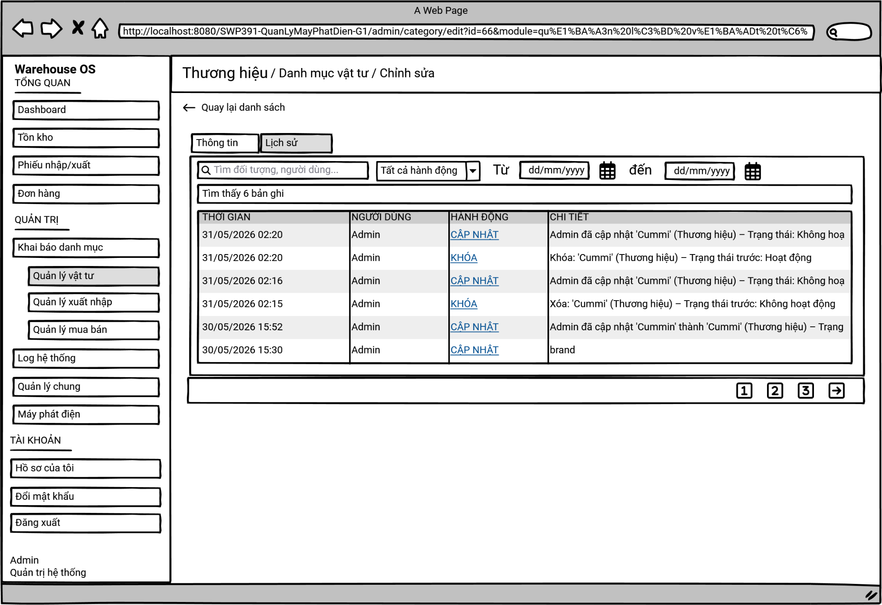
This screen allows the Administrator to view the specific audit log and historical tracking of modifications made to a single, specific category entry (in this case, a specific brand being edited).
On this screen, the Administrator can:
- Navigate: return safely to the previous category list without saving any pending modifications using the back link.
- Switch Views: toggle between editing the category's details ("Thông tin") and viewing its audit history ("Lịch sử").
- Filter History by Keyword: search the specific item's log for particular users or keywords.
- Filter by Action Type: narrow down the history records by selecting specific action categories from a dropdown menu (e.g., updates, locks).
- Filter by Date Range: specify a start and end date to view only the changes that occurred to this item within a defined timeframe.
- Review Audit Trail: view a detailed data table of all recorded events for this specific item, including timestamps, the user who made the change, the action taken, and descriptive details of what was altered.

Field Name | Description
Back Link | Back Navigation Link: "<- Quay lại danh sách"  - A clickable text link that redirects the user back to the category list page.
Navigation Tabs | Tabs: "Thông tin" / "Lịch sử"  - Allows the user to switch between the editing form ("Thông tin") and the audit log ("Lịch sử").  - The "Lịch sử" tab is currently active.
Search Input | Search Bar: "Tìm đối tượng, người dùng..."  - A text input field with a magnifying glass icon to search the specific item's log by keywords or user names.
Action Filter | Action Dropdown: "Tất cả hành động"  - A dropdown menu allowing the user to filter the log by specific action types (e.g., CẬP NHẬT, KHÓA).
Date Range | Date Pickers: "Từ" [dd/mm/yyyy] "đến" [dd/mm/yyyy]  - Input fields with calendar icons to specify a start date and an end date to filter the history records within a specific time frame.
Record Count | Result Summary: "Tìm thấy [X] bản ghi"  - A text label indicating the total number of history records found for this item based on the applied filters (e.g., "Tìm thấy 6 bản ghi").
History Table | Audit Log Table:  - A structured grid displaying the history of actions made to this specific category item.  - Columns include: "THỜI GIAN" (Timestamp), "NGƯỜI DÙNG" (User who executed the action), "HÀNH ĐỘNG" (Type of Action - displayed as a clickable link), and "CHI TIẾT" (Specific description of the changes made, such as previous vs. new status).
Pagination | Pagination Component:  - Used to paginate and navigate through long data lists.  - Page numbers (1, 2, 3...): Click to jump directly to the respective page.  - Arrow buttons: Click to go to the previous or next page.

3.6.7 Import From Excel
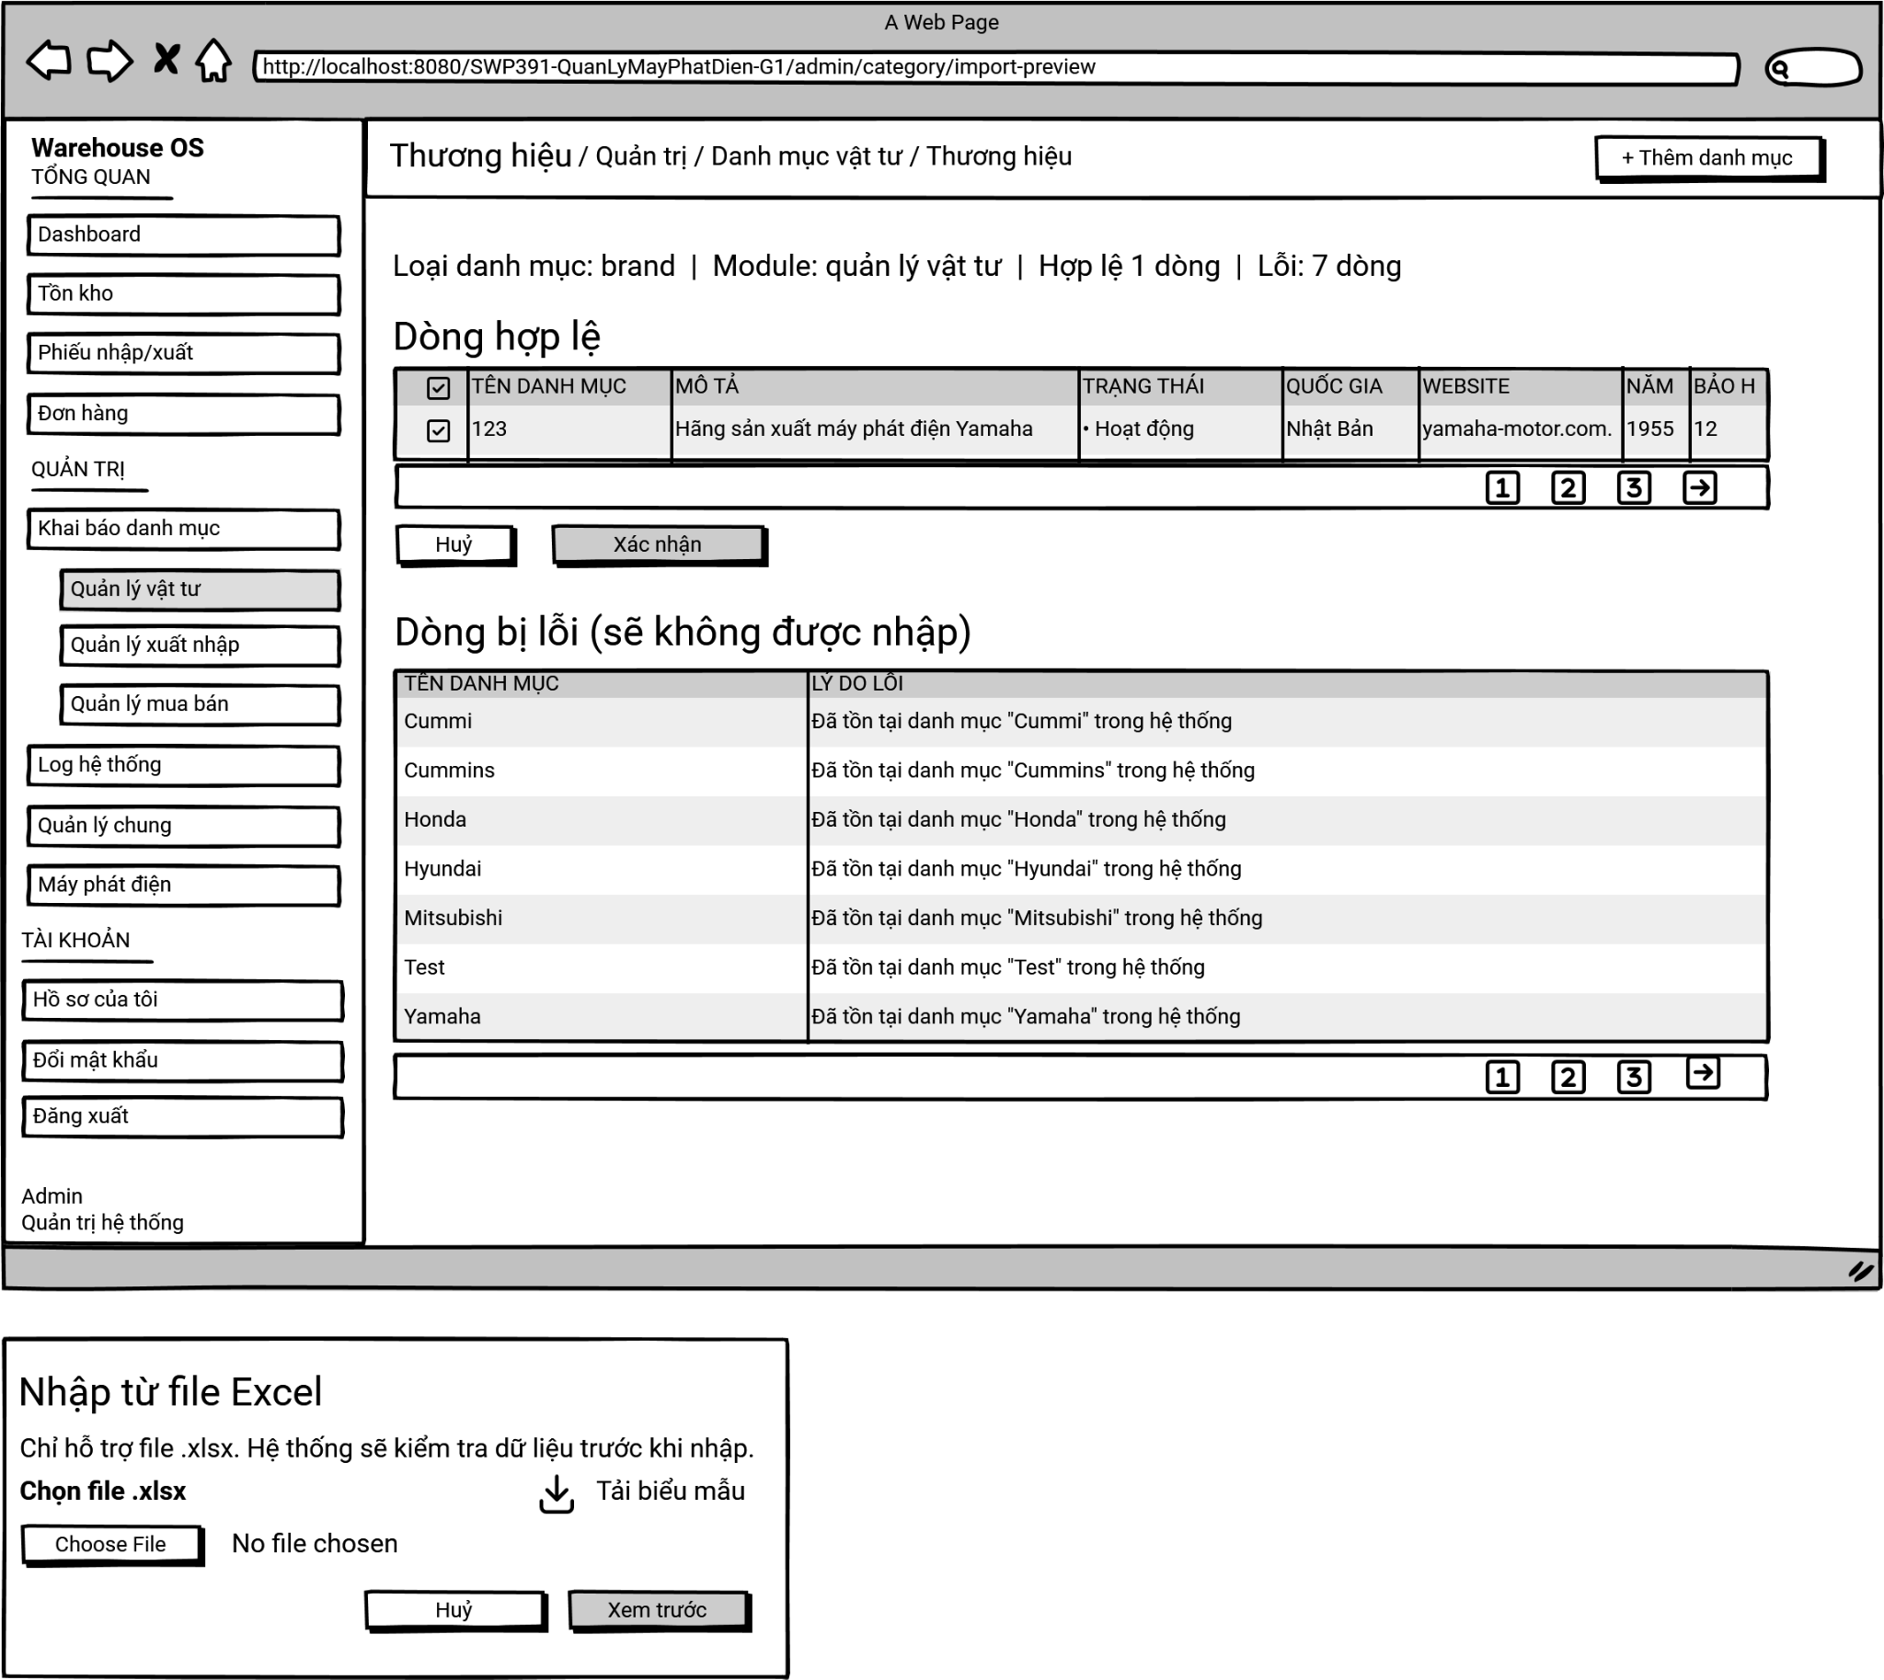

On this screen, the Administrator can:
- Download Template: download a predefined .xlsx template to ensure the data is formatted correctly before uploading.
- Upload Data: select and submit an Excel file from their local device for system processing.
- Preview Validation Results: review a summary of the system's automatic data validation (e.g., how many rows are valid vs. invalid) before committing any changes to the database.
- Manage Valid Rows: review the data that passed validation. The Administrator can selectively check or uncheck individual rows to decide exactly what gets imported.
- Review Errors: examine the rows that failed validation (e.g., due to duplicate names already existing in the system) along with their specific error messages. These rows are strictly read-only and will be automatically skipped during import.
- Confirm or Cancel: execute the final import for the selected valid data or abort the entire process to return to the category list.

Field Name | Description
Import Modal Title & Info | Modal Header: "Nhập từ file Excel"  - Instructional text indicating that only .xlsx files are supported and that the system will pre-validate the data ("Chỉ hỗ trợ file .xlsx. Hệ thống sẽ kiểm tra dữ liệu trước khi nhập.").
Download Template | Download Link: "Tải biểu mẫu"  - A clickable link with a download icon used to retrieve the standard Excel template required for a successful import.
File Input | File Uploader: "Choose File" / "No file chosen"  - A standard file selection input allowing the user to browse their computer and attach the data file.
Modal Buttons | Dialog Buttons: "Huỷ" / "Xem trước"  - "Huỷ": Closes the upload dialog without submitting.  - "Xem trước": Uploads the file to the server for validation and transitions to the Preview Screen.
Import Summary | Validation Summary: "Loại danh mục: brand | Module: quản lý vật tư | Hợp lệ 1 dòng | Lỗi: 7 dòng"  - A read-only text line displaying the context of the import and the numerical results of the validation check (valid row count vs. error row count).
Valid Rows Table | Valid Data Grid: "Dòng hợp lệ"  - A structured table displaying the rows from the Excel file that passed all validation rules.  - Includes a checkbox column at the far left allowing the Administrator to select/deselect specific rows for import.
Action Buttons | Preview Action Buttons: "Huỷ" / "Xác nhận"  - Located between the two tables.  - "Huỷ": Discards the uploaded data and cancels the import process.  - "Xác nhận": Submits the checked rows from the "Dòng hợp lệ" table to be saved into the database.
Invalid Rows Table | Error Data Grid: "Dòng bị lỗi (sẽ không được nhập)"  - A read-only table displaying rows that failed validation.  - Columns include: "TÊN DANH MỤC" (The extracted name causing the issue) and "LÝ DO LỖI" (The specific error message, e.g., "Đã tồn tại danh mục 'Cummi' trong hệ thống" - Duplicate entry).  - These rows are locked and cannot be selected for import.
Pagination | Pagination Component:  - Used to paginate and navigate through long data lists.  - Page numbers (1, 2, 3...): Click to jump directly to the respective page.  - Arrow buttons: Click to go to the previous or next page.

3.7 Inventory Management

3.7.1 Inventory list
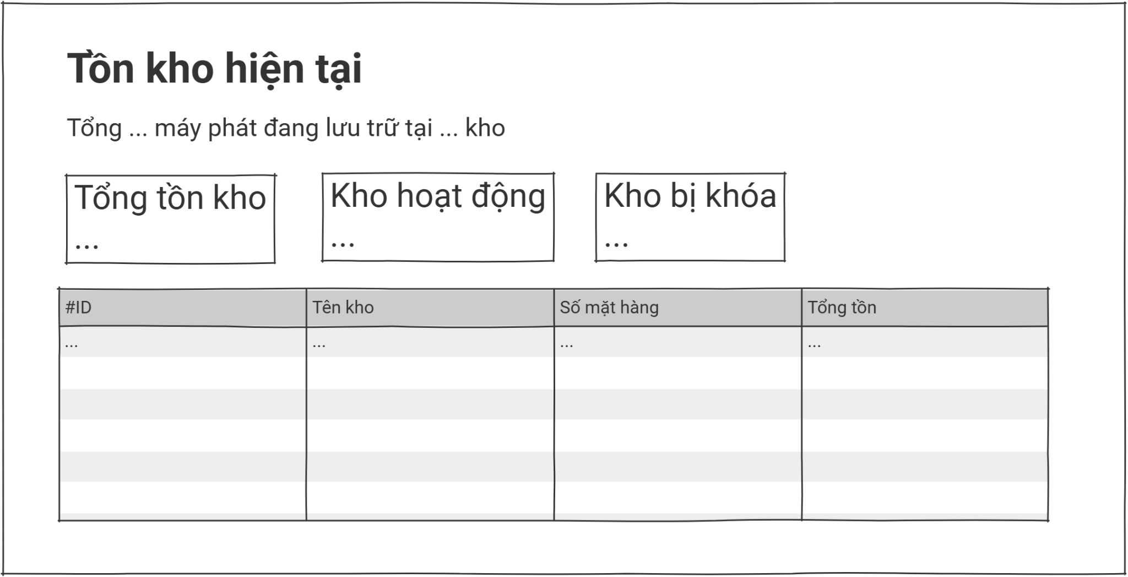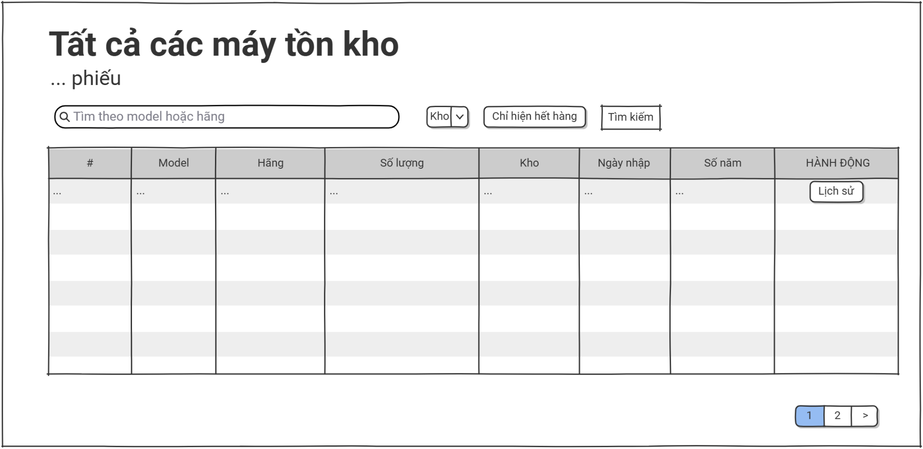
Screen Description:
Screen Name: Inventory List
Access Role: Warehouse Manager and Warehouse Staff
Main Functionality: This screen displays a comprehensive, paginated table of all inventory records currently stored in the system. It allows users to view stock levels per part across all warehouses, search by part code or name, filter by warehouse or category, and perform action shortcuts on existing entries. From this screen, authorized users can navigate to view detailed inventory information or access history views.

Field Name | Description
Search | Text input field with placeholder 'Search by code or name...'. Allows the user to dynamically filter the inventory list by typing a part code, part name, or warehouse name.
Warehouse Filter | Filter dropdown list labeled 'Warehouse'. Allows filtering the inventory list by a specific warehouse or selecting 'All warehouses' to view every record.
Category Filter | Filter dropdown list labeled 'Category'. Allows filtering the inventory list by the part category (e.g., Engine, Alternator, Filter, Battery).
Stock Status Filter | Filter dropdown list labeled 'Stock Status'. Allows filtering records by stock availability such as 'In stock', 'Low stock', or 'Out of stock'.
Clear Filter | Action button labeled 'Clear' with a refresh icon. Resets all active search inputs and dropdown selections back to their default states.
Inventory List Table | Data grid displaying inventory records with the following columns: Part Code, Part Name, Warehouse, Category, Quantity On Hand, Reorder Level, Stock Status, Last Updated, and Action.
View Details | Action icon (Eye shape) under the Action column. Opens a detailed, read-only profile view of the selected inventory record.
Stock Card History | Action icon (Clipboard shape) under the Action column. Redirects the user to the Stock Card History screen for the selected part.
Generator History | Action icon (Bolt shape) under the Action column. Redirects the user to the Generator History screen to view which generator units the selected part is installed on.
Pagination | Bottom-bar pagination control showing total record count, current page number, total pages, and Previous/Next navigation buttons.

3.7.2 Inventory detail
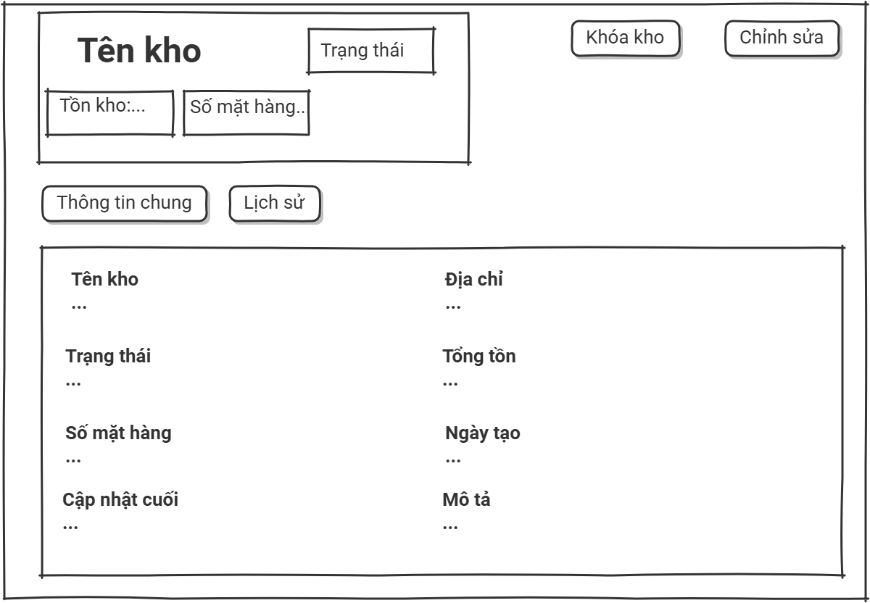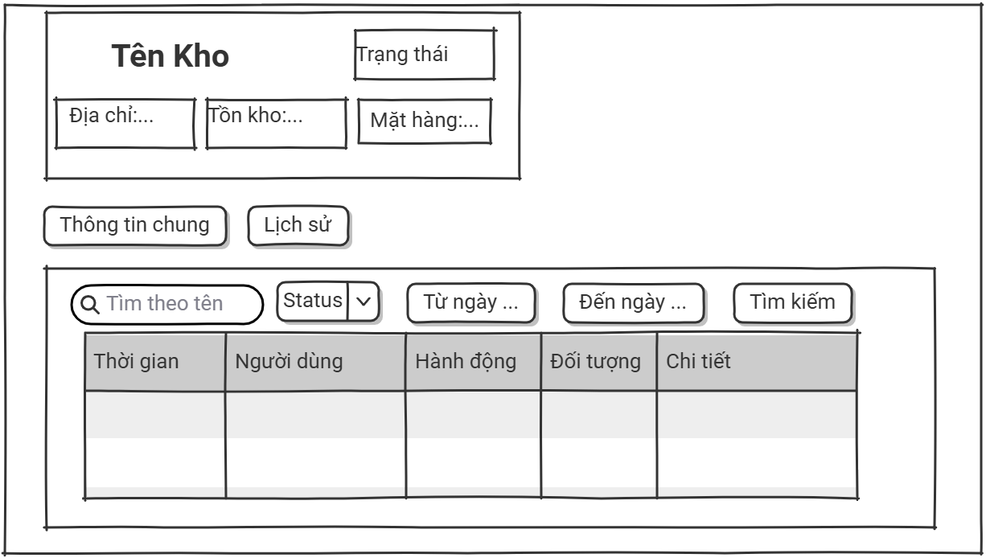Screen Description:
Screen Name: Inventory Details
Access Role: Warehouse Manager and Warehouse Staff
Main Functionality: This screen displays comprehensive, read-only profile information for a specific inventory record, including part identity, classification, current stock quantity, warehouse assignment, reorder threshold, and system timestamps. Authorized users can initiate management actions such as editing the record, viewing stock movement history, or returning to the inventory list.

Field Name | Description
Edit | Action button labeled 'Edit' located in the top-right header toolbar. Clicking it opens the inventory modification mode or screen.
Back Link | Navigation link labeled '<- Back to Inventory List' located at the top of the page. Returns the user to the previous inventory list view.
Inventory Summary Card | Highlighted summary block at the top displaying the part code, part name, avatar/icon, warehouse name, and current stock status badge.
Stock Information Card | Main data block labeled '01 - STOCK INFORMATION' displaying read-only fields including: Part Code, Part Name, Category, Warehouse, Quantity On Hand, Reorder Level, Unit of Measure, and Stock Status.
System Information Card | Data block labeled '02 - SYSTEM INFORMATION' showing the Created Date, Last Updated Date, and the name of the user who last modified the record.

3.7.3 Edit inventory
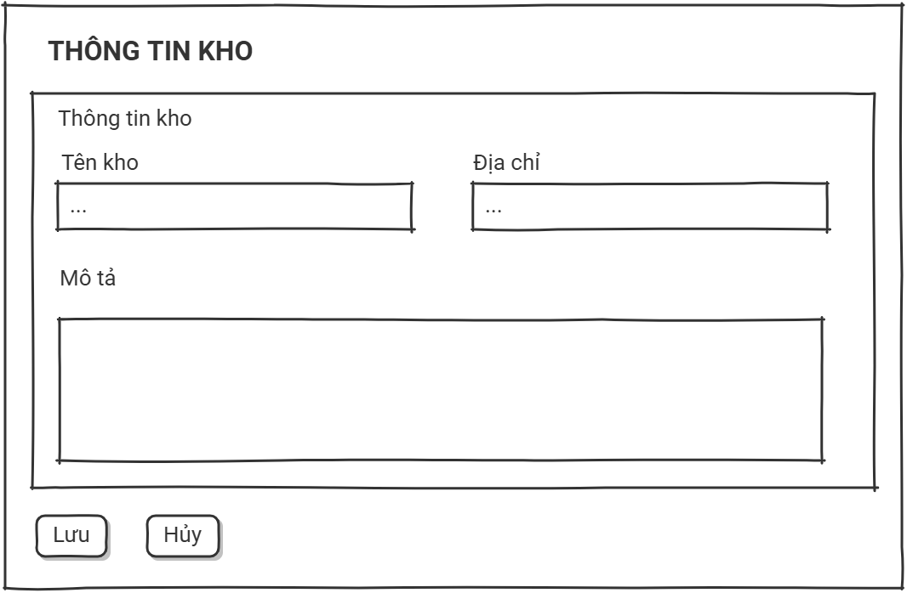Screen Description:
Screen Name: Edit Inventory
Access Role: Warehouse Manager and Warehouse Staff
Main Functionality: This screen provides an input form pre-populated with existing data for a specific inventory record, allowing authorized users to update stock information, warehouse assignment, reorder levels, and other attributes. The form enforces field-level validation rules and supports either committing the changes or discarding them to return to the detail view.

Field Name | Description
Save | Action button labeled 'Save' located in the top-right header toolbar. Clicking it validates the form and commits the updated inventory record to the database.
Cancel | Action button labeled 'Cancel' located next to the Save button. Discards any unsaved changes and returns the user to the inventory detail screen.
Part Code | Read-only text input displaying the part's unique code. Marked as a required field (*) but cannot be modified after creation.
Part Name | Text input field labeled 'Part Name'. Marked as a required field (*). It accepts alphabet characters, numbers, spaces, and standard punctuation, up to a maximum of 100 characters.
Category | Dropdown selection labeled 'Category'. Marked as a required field (*). The user must select one of the predefined part categories registered in the system (e.g., Engine, Alternator, Filter, Battery).
Warehouse | Dropdown selection labeled 'Warehouse'. Marked as a required field (*). The user must select one of the active warehouses from which the inventory is managed.
Quantity On Hand | Numeric input field labeled 'Quantity On Hand'. Marked as a required field (*). Accepts only non-negative integers. The system recalculates the stock status badge based on this value relative to the reorder level.
Reorder Level | Numeric input field labeled 'Reorder Level'. Accepts only non-negative integers. When Quantity On Hand falls below this value, the system flags the record as 'Low stock'.
Unit of Measure | Dropdown selection labeled 'Unit of Measure'. Marked as a required field (*). The user must select a unit (e.g., Piece, Set, Liter) consistent with the chosen category.

3.7.4 Stock card history
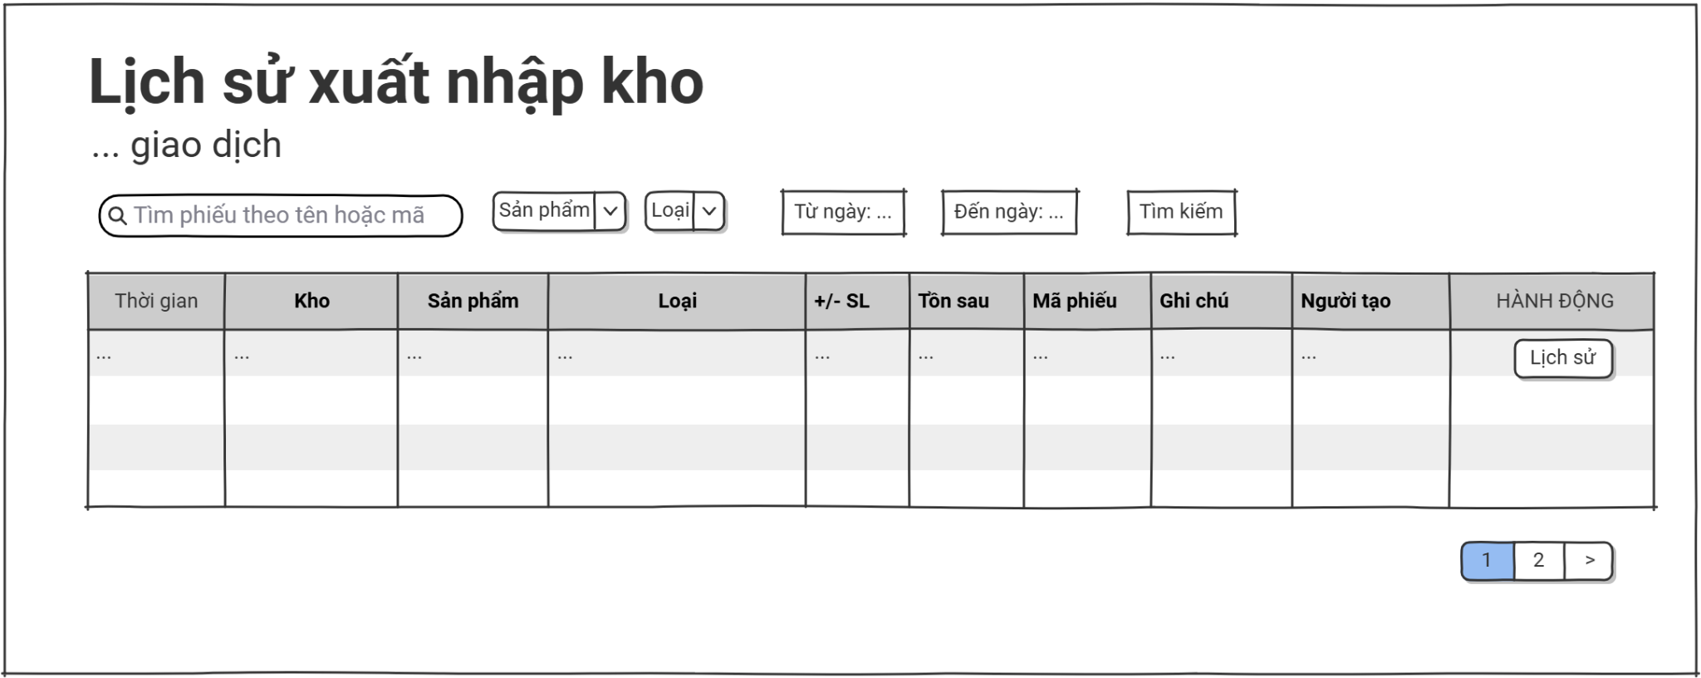Screen Description:
Screen Name: Stock Card History
Access Role: Warehouse Manager and Warehouse Staff
Main Functionality: This screen displays a chronological, paginated log of all stock movements (import, export, transfer, adjustment) for a specific part within a specific warehouse. It allows users to filter movements by transaction type, date range, and reference document (e.g., receipt code), providing full traceability of inventory changes over time.

Field Name | Description
Back Link | Navigation link labeled '<- Back to Inventory Detail' located at the top of the page. Returns the user to the previous inventory detail screen.
Part Information Banner | Highlighted summary banner at the top displaying the part code, part name, warehouse name, and the current quantity on hand for context.
Transaction Type Filter | Filter dropdown list labeled 'Transaction Type'. Allows filtering the movement log by entry type: Import, Export, Transfer In, Transfer Out, or Adjustment.
Date Range Filter | Date range picker labeled 'Date Range'. Allows filtering the movement log to show only entries recorded between a specified start date and end date.
Search by Reference | Text input field with placeholder 'Search by receipt code...'. Allows the user to filter the movement log by referencing a specific receipt or document code.
Clear Filter | Action button labeled 'Clear' with a refresh icon. Resets all active filters back to their default states.
Stock Movement Table | Data grid displaying stock movement entries with the following columns: Transaction Date, Transaction Type, Reference Code, Quantity In, Quantity Out, Balance After, Performed By, and Remarks.
Pagination | Bottom-bar pagination control showing total record count, current page number, total pages, and Previous/Next navigation buttons.

3.7.5 Generator history
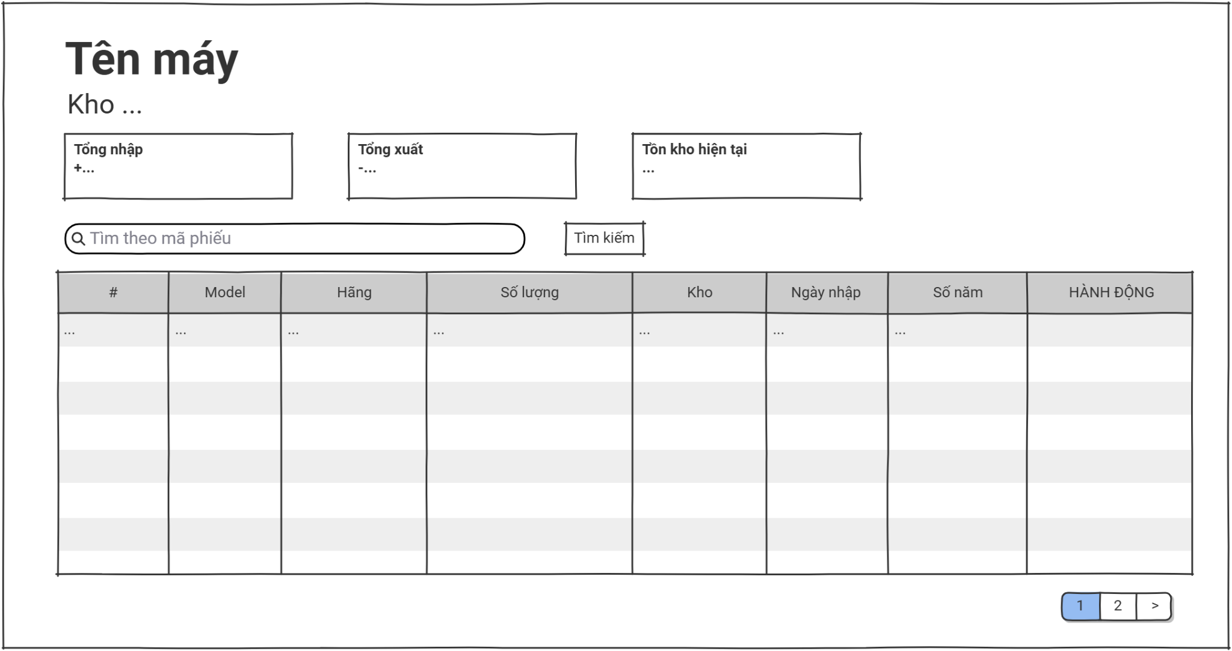
Screen Description:
Screen Name: Generator History
Access Role: Warehouse Manager and Warehouse Staff
Main Functionality: This screen displays a paginated list of generator units on which a specific part is currently installed or has been historically installed. It allows users to track part usage across the generator fleet, view installation timestamps, and identify which generators are associated with each part record.

Field Name | Description
Back Link | Navigation link labeled '<- Back to Inventory Detail' located at the top of the page. Returns the user to the previous inventory detail screen.
Part Information Banner | Highlighted summary banner at the top displaying the part code, part name, warehouse name, and a short description of the part for context.
Search by Serial | Text input field with placeholder 'Search by generator serial...'. Allows the user to filter the list of associated generators by entering a generator serial number.
Status Filter | Filter dropdown list labeled 'Installation Status'. Allows filtering the list by whether the part is currently 'Installed' or 'Removed' on each generator.
Clear Filter | Action button labeled 'Clear' with a refresh icon. Resets all active filters back to their default states.
Generator History Table | Data grid displaying generator association records with the following columns: Generator Serial, Model, Capacity (kVA), Installation Date, Removal Date, Status, and Last Maintenance Date.
View Generator | Action icon (Eye shape) under the Action column. Opens a read-only detailed view of the selected generator unit.
Pagination | Bottom-bar pagination control showing total record count, current page number, total pages, and Previous/Next navigation buttons.

3.8 Receipt Management

3.8.1 Receipt list
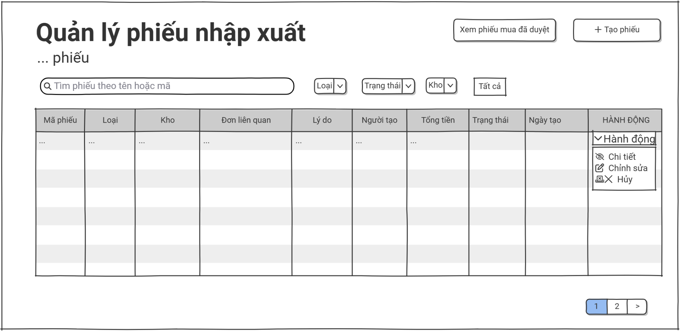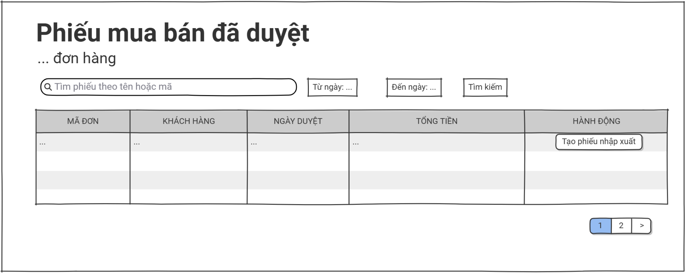Screen Description:
Screen Name: Receipt List
Access Role: Warehouse Manager, Warehouse Staff, Sale Manager, and Sale Staff
Main Functionality: This screen displays a comprehensive, paginated table of all import and export receipts currently registered in the system. It allows users to search, filter by receipt type, status, and date range, and perform action shortcuts on existing entries. Authorized users can also create a new receipt or navigate to a detailed view of a specific receipt.

Field Name | Description
Create Receipt | Action button labeled '+ Create Receipt' with a plus icon. Clicking this button opens a dropdown allowing the user to choose between creating an Import Receipt or an Export Receipt.
Search | Text input field with placeholder 'Search by receipt code...'. Allows the user to dynamically filter the receipt list by entering a receipt code, supplier, or customer name.
Receipt Type Filter | Filter dropdown list labeled 'Receipt Type'. Allows filtering the receipt list by Import, Export, or showing all receipt types.
Status Filter | Filter dropdown list labeled 'Status'. Allows filtering the receipt list by operational status such as Pending, Approved, Rejected, or Cancelled.
Date Range Filter | Date range picker labeled 'Date Range'. Allows filtering the receipt list to show only receipts created within a specific date range.
Clear Filter | Action button labeled 'Clear' with a refresh icon. Resets all active search inputs and dropdown selections back to their default states.
Receipt List Table | Data grid displaying receipt records with the following columns: Receipt Code, Type, Partner (Supplier/Customer), Warehouse, Total Items, Status, Created Date, Created By, and Action.
View Details | Action icon (Eye shape) under the Action column. Opens a detailed, read-only profile view of the selected receipt.
Edit | Action icon (Pencil shape) under the Action column. Redirects the user to the receipt editing screen. Only enabled for receipts in Pending or Rejected status.
Approve | Action icon (Check shape) under the Action column. Allows authorized managers to approve the selected receipt. Only available for Pending receipts.
Reject | Action icon (Cross shape) under the Action column. Allows authorized managers to reject the selected receipt with a reason. Only available for Pending receipts.
Pagination | Bottom-bar pagination control showing total record count, current page number, total pages, and Previous/Next navigation buttons.

3.8.2 Receipt detail
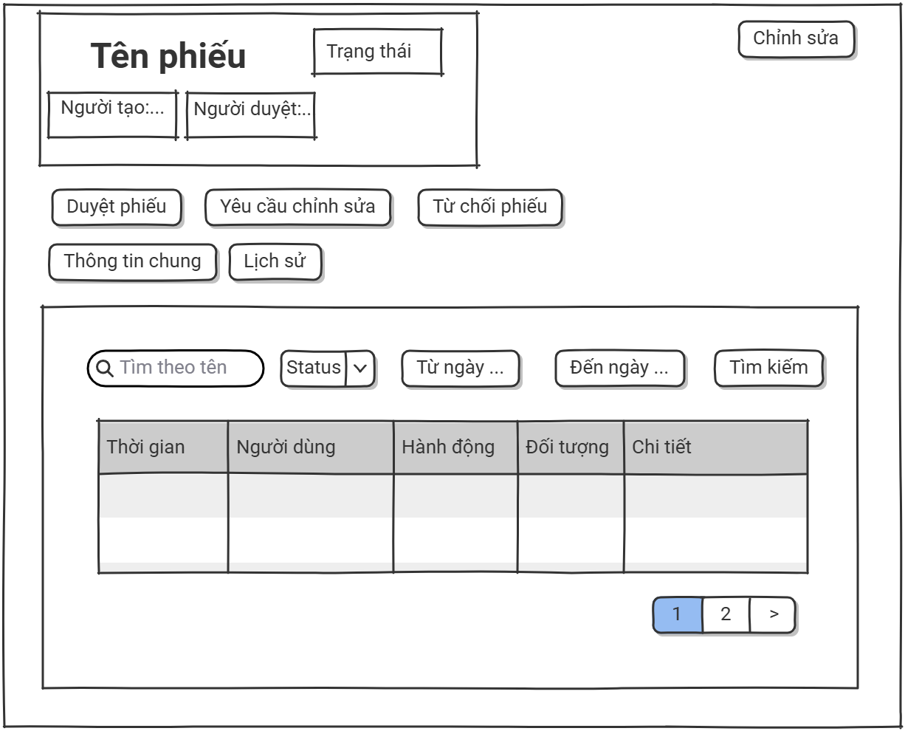Screen Description:
Screen Name: Receipt Details
Access Role: Warehouse Manager, Warehouse Staff, Sale Manager, and Sale Staff
Main Functionality: This screen displays comprehensive, read-only profile information for a specific receipt, including receipt identity, transaction type, partner details, warehouse, status, line items, and system timestamps. Authorized users can initiate management actions such as editing, approving, rejecting, or printing the receipt.

Field Name | Description
Edit | Action button labeled 'Edit' located in the top-right header toolbar. Clicking it redirects the user to the receipt editing screen. Only enabled for receipts in Pending or Rejected status.
Approve | Action button labeled 'Approve' with a check icon. Clicking it approves the selected receipt. Only available for Pending receipts and visible to authorized managers.
Reject | Action button labeled 'Reject' with a cross icon. Clicking it opens a confirmation dialog requiring a reason before rejecting the receipt. Only available for Pending receipts.
Print | Action button labeled 'Print' with a printer icon. Opens a printable version of the receipt in a new browser tab.
Back Link | Navigation link labeled '<- Back to Receipt List' located at the top of the page. Returns the user to the previous receipt list view.
Receipt Summary Card | Highlighted summary block at the top displaying the receipt code, receipt type badge (Import/Export), partner name, warehouse, and current status badge.
General Information Card | Main data block labeled '01 - GENERAL INFORMATION' displaying read-only fields including: Receipt Code, Receipt Type, Reference Document, Partner Name, Warehouse, Created Date, Created By, Approved By, and Approved Date.
Receipt Line Items Table | Data grid displaying the line items included in the receipt with the following columns: Line No., Part Code, Part Name, Unit, Quantity, Unit Price, and Line Total.
Receipt Notes Card | Data block labeled '02 - NOTES' displaying any additional notes or remarks attached to the receipt by the creator or approver.

3.8.3 Create receipt
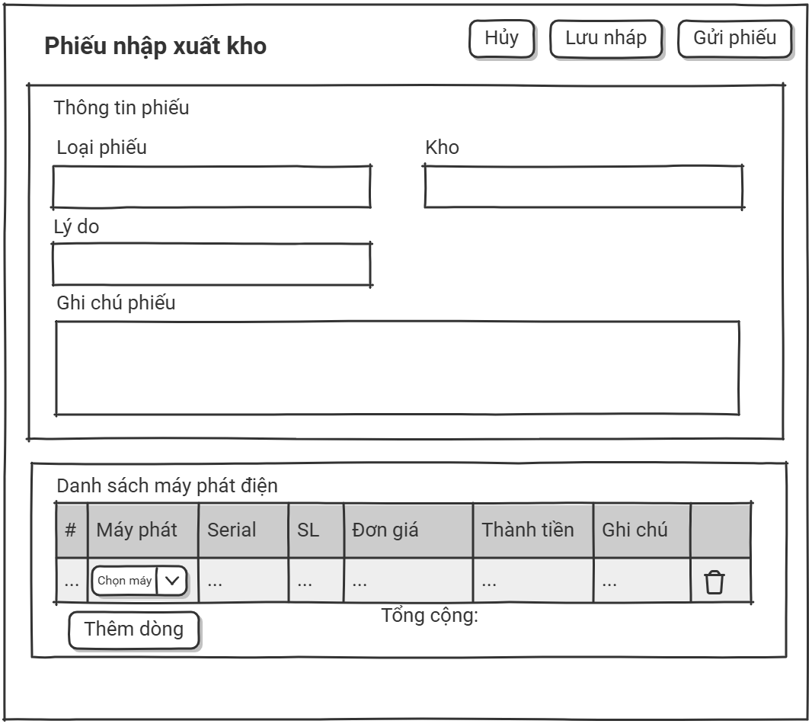Screen Description:
Screen Name: Create Receipt
Access Role: Warehouse Manager, Warehouse Staff, Sale Manager, and Sale Staff
Main Functionality: This screen provides a blank input form that allows authorized users to create a new import or export receipt. The user can select the receipt type, partner, warehouse, add line items by selecting parts and entering quantities, and submit the receipt for approval. The form enforces field-level validation rules and supports either saving the receipt as Pending or discarding it to return to the receipt list.

Field Name | Description
Save as Pending | Action button labeled 'Save' located in the top-right header toolbar. Clicking it validates the form and saves the new receipt in Pending status for later approval.
Cancel | Action button labeled 'Cancel' located next to the Save button. Discards any unsaved data and returns the user to the receipt list screen.
Receipt Type | Dropdown selection labeled 'Receipt Type'. Marked as a required field (*). The user must select either 'Import' or 'Export'. Once selected, the available partner list and warehouse options update accordingly.
Partner | Searchable dropdown selection labeled 'Partner'. Marked as a required field (*). For Import receipts, the user must select a Supplier; for Export receipts, the user must select a Customer.
Warehouse | Dropdown selection labeled 'Warehouse'. Marked as a required field (*). The user must select the destination (for Import) or source (for Export) warehouse.
Receipt Date | Date picker labeled 'Receipt Date'. Marked as a required field (*). Defaults to the current system date. Accepts any valid date not in the future.
Reference Document | Text input field labeled 'Reference Document'. Optional. Allows the user to attach a reference number such as a Purchase Order code or Sales Order code.
Add Line Item | Action button labeled '+ Add Line Item'. Clicking it appends a new empty row to the line items table, where the user can select a part and enter the quantity.
Line Items Table | Editable data grid for receipt line items with the following columns: Part Code, Part Name, Unit, Quantity, Unit Price, Line Total, and Action (Remove). At least one line item is required to save the receipt.
Receipt Notes | Multi-line text area labeled 'Notes'. Optional. Allows the user to enter additional remarks or instructions related to the receipt.

3.8.4 Edit receipt
Screen Description:
Screen Name: Edit Receipt
Access Role: Warehouse Manager, Warehouse Staff, Sale Manager, and Sale Staff
Main Functionality: This screen provides an input form pre-populated with existing data for a specific receipt, allowing authorized users to update receipt type, partner, warehouse, line items, and notes. The form enforces field-level validation rules and supports either committing the changes or discarding them to return to the detail view. Only receipts in Pending or Rejected status can be edited.

Field Name | Description
Save Changes | Action button labeled 'Save' located in the top-right header toolbar. Clicking it validates the form and commits the updated receipt data to the database.
Cancel | Action button labeled 'Cancel' located next to the Save button. Discards any unsaved changes and returns the user to the receipt detail screen.
Receipt Code | Read-only text input displaying the unique receipt code. Marked as a required field (*) but cannot be modified after creation.
Receipt Type | Dropdown selection labeled 'Receipt Type'. Marked as a required field (*). The user can change between 'Import' and 'Export'. The available partner list and warehouse options update accordingly.
Partner | Searchable dropdown selection labeled 'Partner'. Marked as a required field (*). For Import receipts, the user must select a Supplier; for Export receipts, the user must select a Customer.
Warehouse | Dropdown selection labeled 'Warehouse'. Marked as a required field (*). The user must select the destination or source warehouse depending on the receipt type.
Receipt Date | Date picker labeled 'Receipt Date'. Marked as a required field (*). Allows the user to modify the transaction date.
Reference Document | Text input field labeled 'Reference Document'. Optional. Allows the user to update the reference document number.
Add Line Item | Action button labeled '+ Add Line Item'. Clicking it appends a new empty row to the line items table.
Line Items Table | Editable data grid for receipt line items with the following columns: Part Code, Part Name, Unit, Quantity, Unit Price, Line Total, and Action (Remove). At least one line item is required to save the receipt.
Receipt Notes | Multi-line text area labeled 'Notes'. Optional. Allows the user to update the additional remarks or instructions related to the receipt.

3.9 Customer Management

3.9.1 Customer list
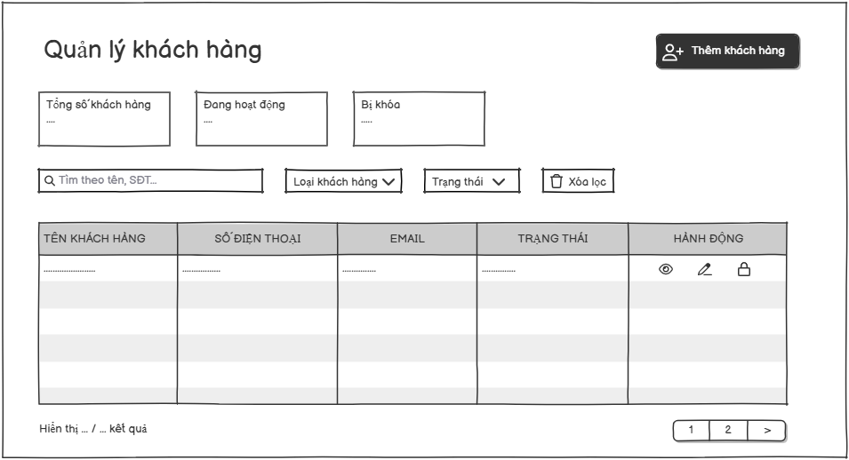
Screen Description:
- Screen Name: Customer List
- Access Role: Sales Staff and Sales Manager
- Main Functionality: This screen displays a comprehensive, paginated table of all customers currently registered in the system. It allows users to view overview statistics, search, filter, and manage customers. From this screen, authorized users can also navigate to create a new customer profile or perform action shortcuts on existing entries.

Field Name | Description
Add Customer | Action button labeled "Thêm khách hàng" with a user-plus icon. Clicking this button redirects the user to the customer creation screen.
Search | Text input field with placeholder "Tìm theo tên, SĐT... ". Allows the user to dynamically filter the list by typing the customer's name or phone number.
Customer Type Filter | Filter dropdown list labeled "Loại khách hàng". Allows filtering the customer list by specific categories or customer segments.
Status Filter | Filter dropdown list labeled "Trạng thái". Allows filtering the list by operational status (e.g., Active, Locked).
Clear Filter | Action button labeled "Xóa lọc" with a trash/reset icon. Resets all active search inputs and dropdown selections back to their default states.
Customer List Table | Data grid displaying customer records with the following columns:  • TÊN KHÁCH HÀNG (CUSTOMER NAME): Displays the full name of the customer.  • SỐ ĐIỆN THOẠI (PHONE NUMBER): Displays the customer's registered phone number.  • EMAIL: Displays the customer's email address.  • TRẠNG THÁI (STATUS): Displays status indicators (e.g., "Đang hoạt động" or "Bị khóa").  • HÀNH ĐỘNG (ACTION): Placeholder column for interactive operational shortcuts.
View Details | Action icon (Eye shape) under the Action column. Opens a detailed profile view or modal for the selected customer.
Edit | Action icon (Pencil shape) under the Action column. Redirects the user to the customer profile editing screen to update their information.
Lock | Action icon (Lock shape) under the Action column. Allows authorized users to toggle the account status, locking or unlocking the selected customer's access.
Pagination | Navigation element at the bottom displaying row ranges (e.g., "Hiển thị ... / ... kết quả") and page numbers to navigate through multiple pages of records.

3.9.2 Customer Detail
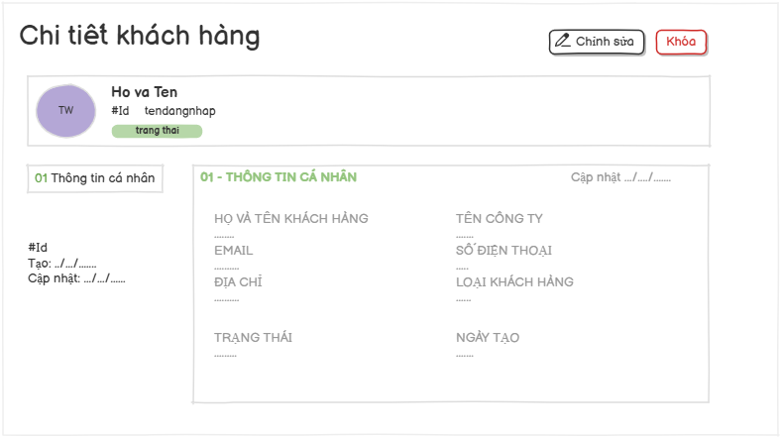
Screen Description:
- Screen Name: Customer Details
- Access Role: Sales Staff and Sales Manager
- Main Functionality: This screen displays comprehensive, read-only profile information for a specific customer account. It allows administrators to review personal/company identity records, contact data, account classification, and system timestamps. From this screen, authorized users can initiate management actions such as profile modifications, account locking/unlocking, or navigating through structured information tabs.

Field Name | Description
Edit | Action button labeled "Chỉnh sửa" located in the top-right header toolbar. Clicking it opens the customer modification mode or screen.
Activate/Deactivate | Action button labeled "Kích hoạt" with green styling. Clicking it changes the customer status to active. Action button labeled "Vô hiệu hoá" with red styling. Clicking it changes the customer status to locked.
Customer Profile Summary | Highlighted summary block at the top displaying the customer's initial avatar, Full Name, Username, login ID, and account status badge.
Personal Information Card | Main data block labeled "01 - THÔNG TIN CÁ NHÂN" displaying read-only fields including: Full Name, Email, Address, Status, Company Name, Phone Number, Customer Type, Created Date, and Last Updated timestamp.

3.9.3 Create customer
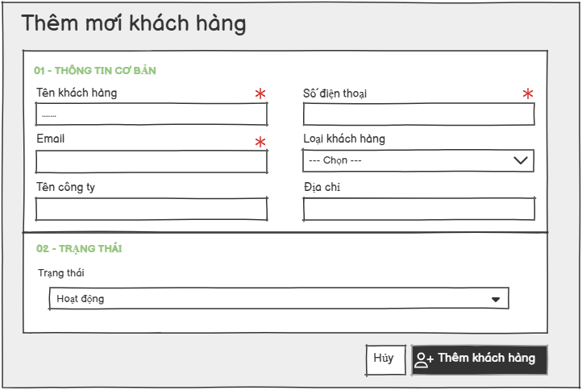
Screen Description:
- Screen Name: Create customer
- Access Role: Sales Staff and Sales Manager
- Main Functionality: This screen provides a blank input form that allows authorized users to register a new customer profile into the system. It contains mandatory and optional fields divided into logical sections. Users can either submit the form to save the new entry or cancel the action to discard inputs.

Field Name | Description
Customer Name | Text input field labeled "Tên khách hàng". Marked as a required field (*). It accepts an alphanumeric string representing the official name of the customer.
Phone Number | Text input field labeled "Số điện thoại". Marked as a required field (*). It validates standard numerical sequences representing the contact number of the customer.
Email | Text input field labeled "Email". Marked as a required field (*). It validates standard email format constraints for customer correspondence.
Customer Type | Dropdown selection field labeled "Loại khách hàng". Optional field to categorize the type or classification of the customer. Placeholder text: "--- Chọn ---".
Company Name | Text input field labeled "Tên công ty". Optional field to record the registered or legal corporate entity name of the customer.
Address | Text input field labeled "Địa chỉ". Optional field to document the physical or operating address location of the customer.
Status | Dropdown selection field labeled "Trạng thái". Sets the current operational or partnership availability state of the customer. Defaults to "Hoạt động" (Active).
Cancel | Action button labeled "Hủy". Discards all current temporary text edits and structural selections within the layout without applying changes, returning the user to the previous screen.
Add Customer Button | Primary action button labeled "Thêm khách hàng" with a user-plus icon. Performs form validation on required fields and creates a new backend database record for the customer.

3.9.4 Update customer
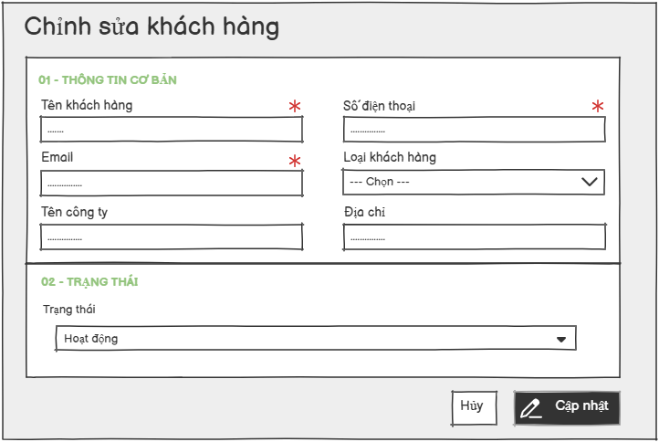
Screen Description:
- Screen Name: Update customer
- Access Role: Sales Staff and Sales Manager
- Main Functionality: This screen provides an input form pre-populated with existing data that allows authorized users to modify and update an established customer profile. It contains mandatory and optional fields divided into logical sections (Basic Information and Status). Users can either submit the updated form to save changes or cancel the action to keep original records.

Field Name | Description
Customer Name | Text input field labeled "Tên khách hàng". Marked as a required field (*). It accepts an alphanumeric string representing the official name of the customer.
Phone Number | Text input field labeled "Số điện thoại". Marked as a required field (*). It validates standard numerical sequences representing the contact number of the customer.
Email | Text input field labeled "Email". Marked as a required field (*). It validates standard email format constraints for customer correspondence.
Customer Type | Dropdown selection field labeled "Loại khách hàng". Optional field to categorize the type or classification of the customer. Placeholder text: "--- Chọn ---".
Company Name | Text input field labeled "Tên công ty". Optional field to record the registered or legal corporate entity name of the customer.
Address | Text input field labeled "Địa chỉ". Optional field to document the physical or operating address location of the customer.
Status | Dropdown selection field labeled "Trạng thái". Sets the current operational or partnership availability state of the customer. Defaults to "Hoạt động" (Active).
Cancel | Action button labeled "Hủy". Discards all current temporary text edits and structural selections within the layout without applying changes, returning the user to the previous screen.
Update | Primary action button labeled "Cập nhật" with a pencil icon. Performs structural validation on required parameters and updates backend database record attributes with the modified customer variables.

4.0 Supplier Management

4.0.1 Supplier list
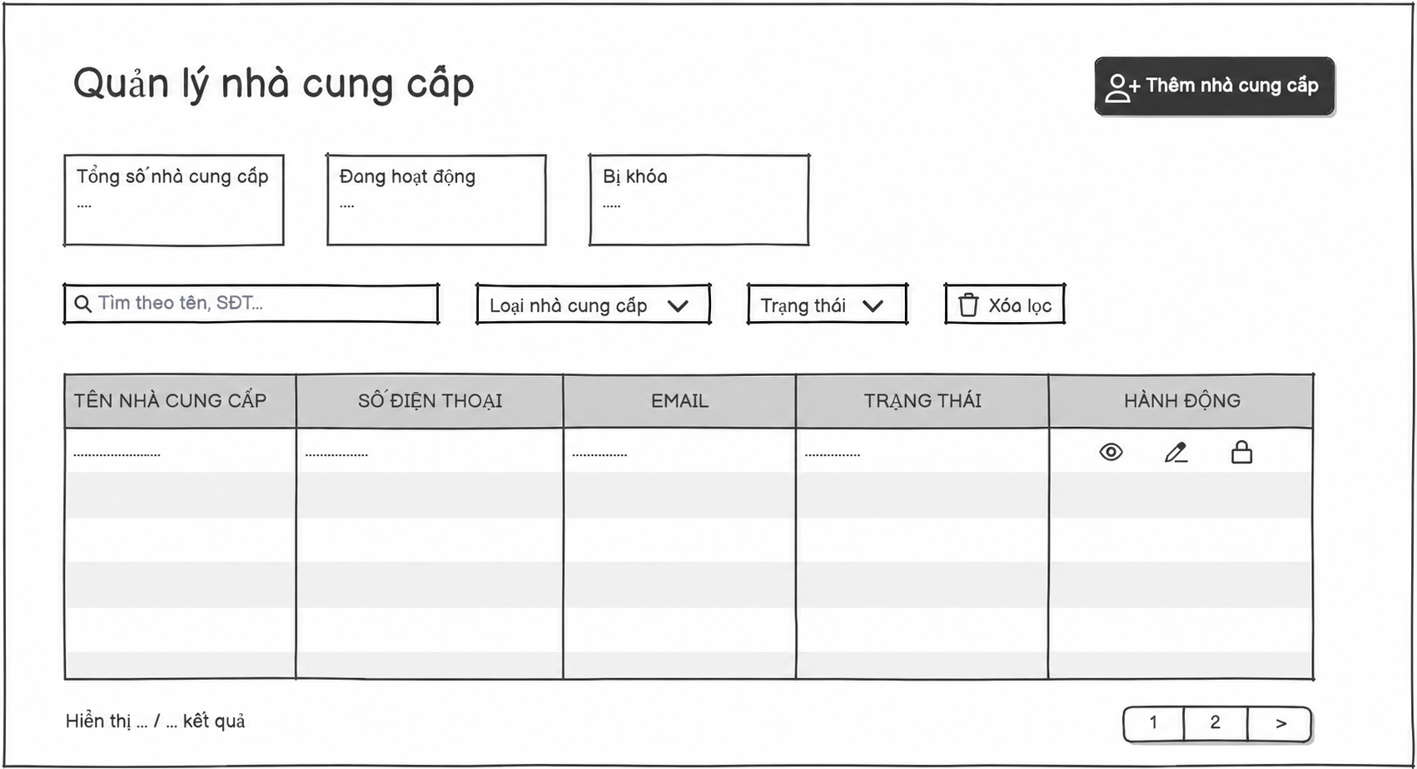
Screen Description:
- Screen Name: Supplier List
- Access Role: Warehouse Manager
- Main Functionality: This screen displays a comprehensive, paginated table of all suppliers currently registered in the system. It allows users to view overview statistics, search, filter, and manage suppliers . From this screen, authorized users can also navigate to create a new supplier profile or perform action shortcuts on existing entries.

Field Name | Description
Add Supplier | Action button labeled "Thêm nhà cung cấp " with a user-plus icon. Clicking this button redirects the user to the supplier creation screen.
Search | Text input field with placeholder "Tìm theo tên, SĐT... ". Allows the user to dynamically filter the list by typing the supplier's name or phone number.
Supplier Type Filter | Filter dropdown list labeled "Loại nhà cung cấp ". Allows filtering the supplier list by specific categories or customer segments.
Status Filter | Filter dropdown list labeled "Trạng thái". Allows filtering the list by operational status (e.g., Active, Locked).
Clear Filter | Action button labeled "Xóa lọc" with a trash/reset icon. Resets all active search inputs and dropdown selections back to their default states.
Customer List Table | Data grid displaying supplier records with the following columns:  • TÊN NHÀ CUNG CẤP (SUPPLIER NAME): Displays the commercial name of the supplier  • SỐ ĐIỆN THOẠI (PHONE NUMBER): Displays the supplier's contact phone number.  • EMAIL: Displays the supplier's primary email address.  • TRẠNG THÁI (STATUS): Displays status indicators (e.g., "Đang hoạt động" or "Bị khóa").  • HÀNH ĐỘNG (ACTION): Placeholder column for interactive operational shortcuts.
View Details | Action icon (Eye shape) under the Action column. Opens a detailed profile view or modal for the selected supplier .
Edit | Action icon (Pencil shape) under the Action column. Redirects the user to the customer profile editing screen to update their information.
Lock | Action icon (Lock shape) under the Action column. Allows authorized users to toggle the account status, locking or unlocking the selected customer's access.
Pagination | Navigation element at the bottom displaying row ranges (e.g., "Hiển thị ... / ... kết quả") and page numbers to navigate through multiple pages of records.

4.0.2 Supplier detail

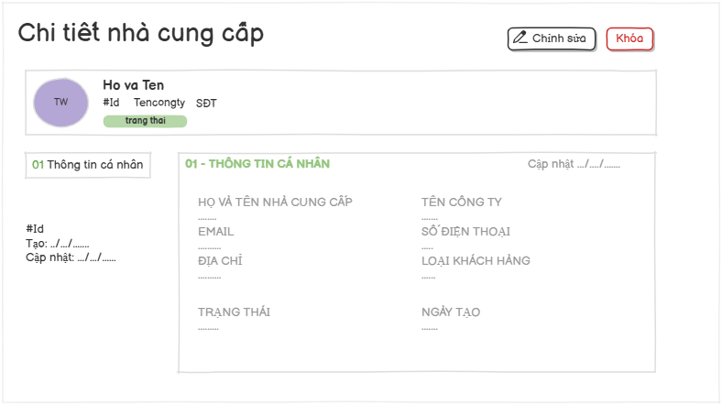
Screen Description:
- Screen Name: Supplier Details
- Access Role: Warehouse Manager
- Main Functionality: This screen displays comprehensive, read-only profile information for a specific supplier entity. It allows users to review supplier identity records, contact details, corporate information, operational status, and system registration timestamps. From this screen, authorized users can initiate management actions such as profile modifications, account locking/unlocking, or navigating through structured information tabs.

Field Name | Description
Edit | Action button labeled "Chỉnh sửa" with a pencil icon located in the top-right header toolbar. Clicking it opens the supplier modification mode or redirects to the edit screen.
Activate/Deactivate | Action button labeled "Kích hoạt" with green styling. Clicking it changes the supplier status to active. Action button labeled "Vô hiệu hoá" with red styling. Clicking it changes the supplier status to locked.
Supplier Profile Summary | Highlighted summary block at the top displaying the supplier's initial avatar, Contact Person's Name ("Ho va Ten"), Supplier ID ("#Id"), Company Name ("Tencongty"), Phone Number ("SĐT"), and an account status badge ("trang thai").
Personal Information Card | Main data block labeled "01 - THÔNG TIN CÁ NHÂN" displaying read-only fields including: Full Name, Email, Address, Status, Company Name, Phone Number, Customer Type, Created Date, and Last Updated timestamp.

4.0.3 Create supplier
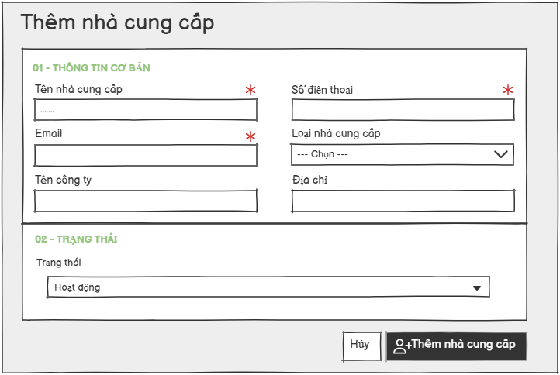
Screen Description:
- Screen Name: Create Supplier
- Access Role: Warehouse Manager
- Main Functionality: This screen provides a blank input form that allows authorized users to register a new supplier profile into the system. It contains mandatory and optional fields divided into logical sections. Users can either submit the form to save the new entry or cancel the action to discard inputs.

Field Name | Description
Supplier Name | Text input field labeled "Tên nhà cung cấp". Marked as a required field (*). It accepts an alphanumeric string representing the official name of the supplier.
Phone Number | Text input field labeled "Số điện thoại". Marked as a required field (*). It validates standard numerical sequences representing the contact number of the supplier.
Email | Text input field labeled "Email". Marked as a required field (*). It validates standard email format constraints for supplier correspondence.
Supplier Type | Dropdown selection field labeled "Loại nhà cung cấp". Optional field to categorize the type or classification of the supplier. Placeholder text: "--- Chọn ---".
Company Name | Text input field labeled "Tên công ty". Optional field to record the registered or legal corporate entity name of the supplier.
Address | Text input field labeled "Địa chỉ". Optional field to document the physical or operating address location of the supplier.
Status | Dropdown selection field labeled "Trạng thái". Sets the current operational or partnership availability state of the supplier. Defaults to "Hoạt động" (Active).
Cancel | Action button labeled "Hủy". Discards all current temporary text edits and structural selections within the layout without applying changes, returning the user to the previous screen.
Add Supplier Button | Primary action button labeled "Thêm nhà cung cấp " with a user-plus icon. Performs form validation on required fields and creates a new backend database record for the supplier.

4.0.4 Edit supplier
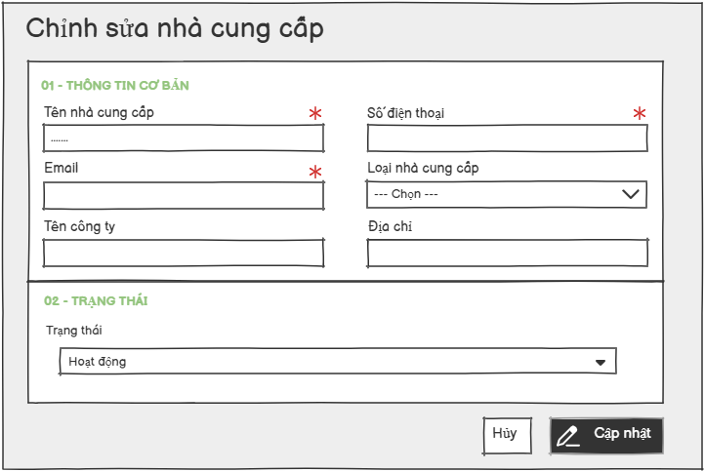
Screen Description:
- Screen Name: Edit Supplier
- Access Role: Warehouse Manager
- Main Functionality: This screen provides an input form pre-populated with existing data that allows authorized users to modify and update an established supplier profile. It contains mandatory and optional fields divided into logical sections (Basic Information and Account Status). Users can either submit the updated form to save changes or cancel the action to keep original records.

Field Name | Description
Supplier Name | Text input field labeled "Tên nhà cung cấp". Marked as a required field (*). It accepts an alphanumeric string representing the official name of the supplier.
Phone Number | Text input field labeled "Số điện thoại". Marked as a required field (*). It validates standard numerical sequences representing the contact number of the supplier.
Email | Text input field labeled "Email". Marked as a required field (*). It validates standard email format constraints for supplier correspondence.
Supplier Type | Dropdown selection field labeled "Loại nhà cung cấp". Optional field to categorize the type or classification of the supplier. Placeholder text: "--- Chọn ---".
Company Name | Text input field labeled "Tên công ty". Optional field to record the registered or legal corporate entity name of the supplier.
Address | Text input field labeled "Địa chỉ". Optional field to document the physical or operating address location of the supplier.
Status | Dropdown selection field labeled "Trạng thái". Sets the current operational or partnership availability state of the supplier. Defaults to "Hoạt động" (Active).
Cancel | Action button labeled "Hủy". Discards all current temporary text edits and structural selections within the layout without applying changes, returning the user to the previous screen.
Update | Primary action button labeled "Cập nhật" with a pencil icon. Performs structural validation on required parameters and updates backend database record attributes with the modified supplier variables.

5.0 Proposal Management

5.0.1 List proposal:
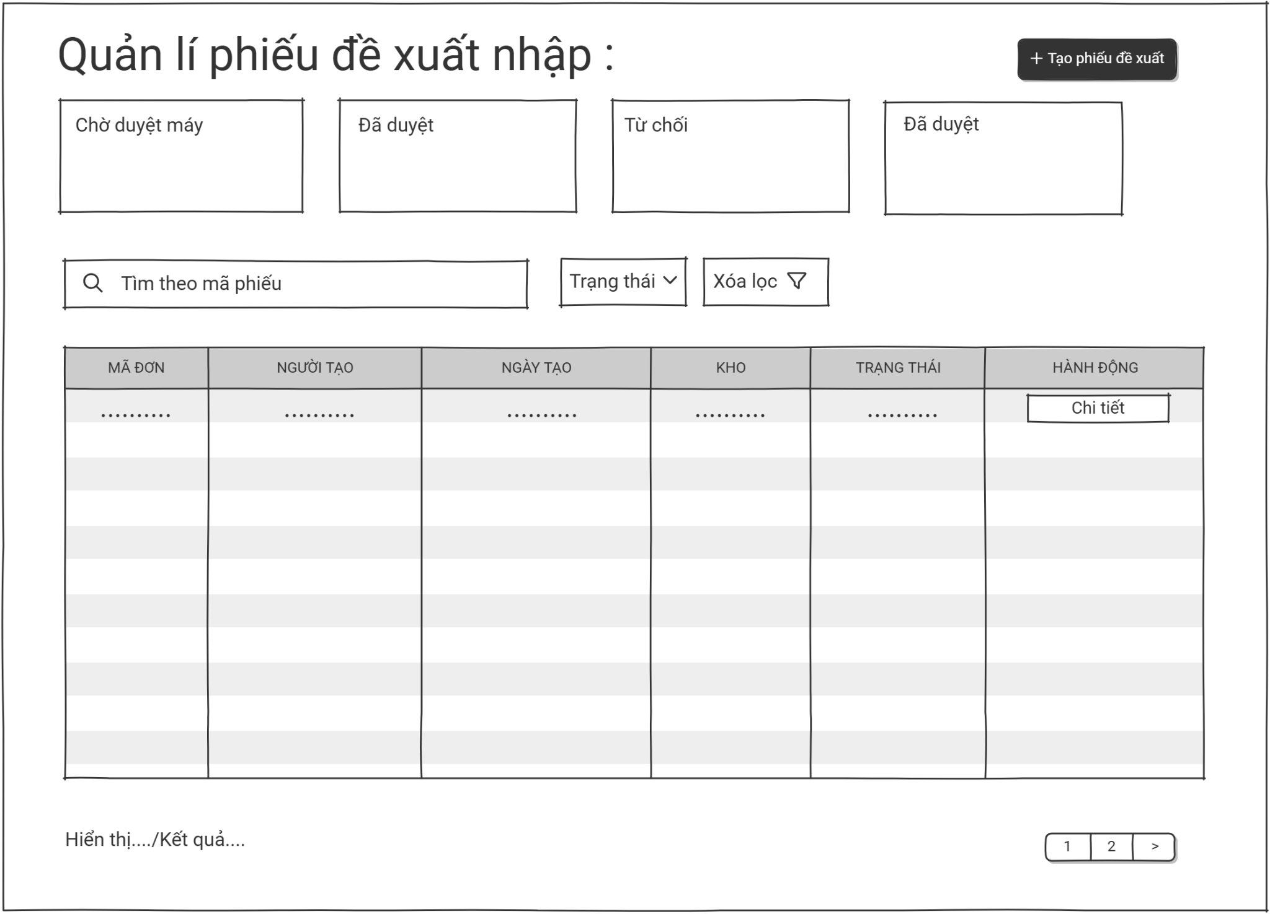
Screen Name: Import Proposal Management
Access Role: Sale Staff, Sale Manager
Main Functionality: This screen provides a filterable list of all import proposals (phiếu đề xuất nhập). Authorized users can search by proposal code, filter by status, and view details of each proposal. The screen displays key information in a table format and supports pagination.

Field Name | Description
Search by Proposal Code | Text input field labeled "Tìm theo mã phiếu". Allows users to search for a specific import proposal by entering its unique proposal code.
Status Filter | Dropdown selection labeled "Trạng thái". Used to filter the proposal list by status. Available options include: "Chờ duyệt" (Pending Approval), "Đã duyệt" (Approved), "Từ chối" (Rejected).
Clear Filters | Action button labeled "Xóa lọc". Resets all active filters (search query and status filter) to show the full proposal list again.
Proposal Table | Tabular display with the following columns: MÃ ĐƠN (Proposal Code), NGƯỜI TẠO (Created By), NGÀY TẠO (Created Date), KHO (Warehouse), TRẠNG THÁI (Status), HÀNH ĐỘNG (Action).
View Details (Action) | Button labeled "Chi tiết" within the Action column of each table row. Opens the detailed view or edit screen for the corresponding import proposal.
Pagination Info | Text display labeled "Hiển thị...../Kết quả....". Shows current page and total number of records (e.g., "Hiển thị 1-5 / 20 kết quả").
Status Badges | Visual indicators shown in the TRẠNG THÁI column. Common values: "Chờ duyệt" (Pending - often highlighted in yellow/orange), "Đã duyệt" (Approved - typically green), "Từ chối" (Rejected - usually red).

5.0.2 Create proposal
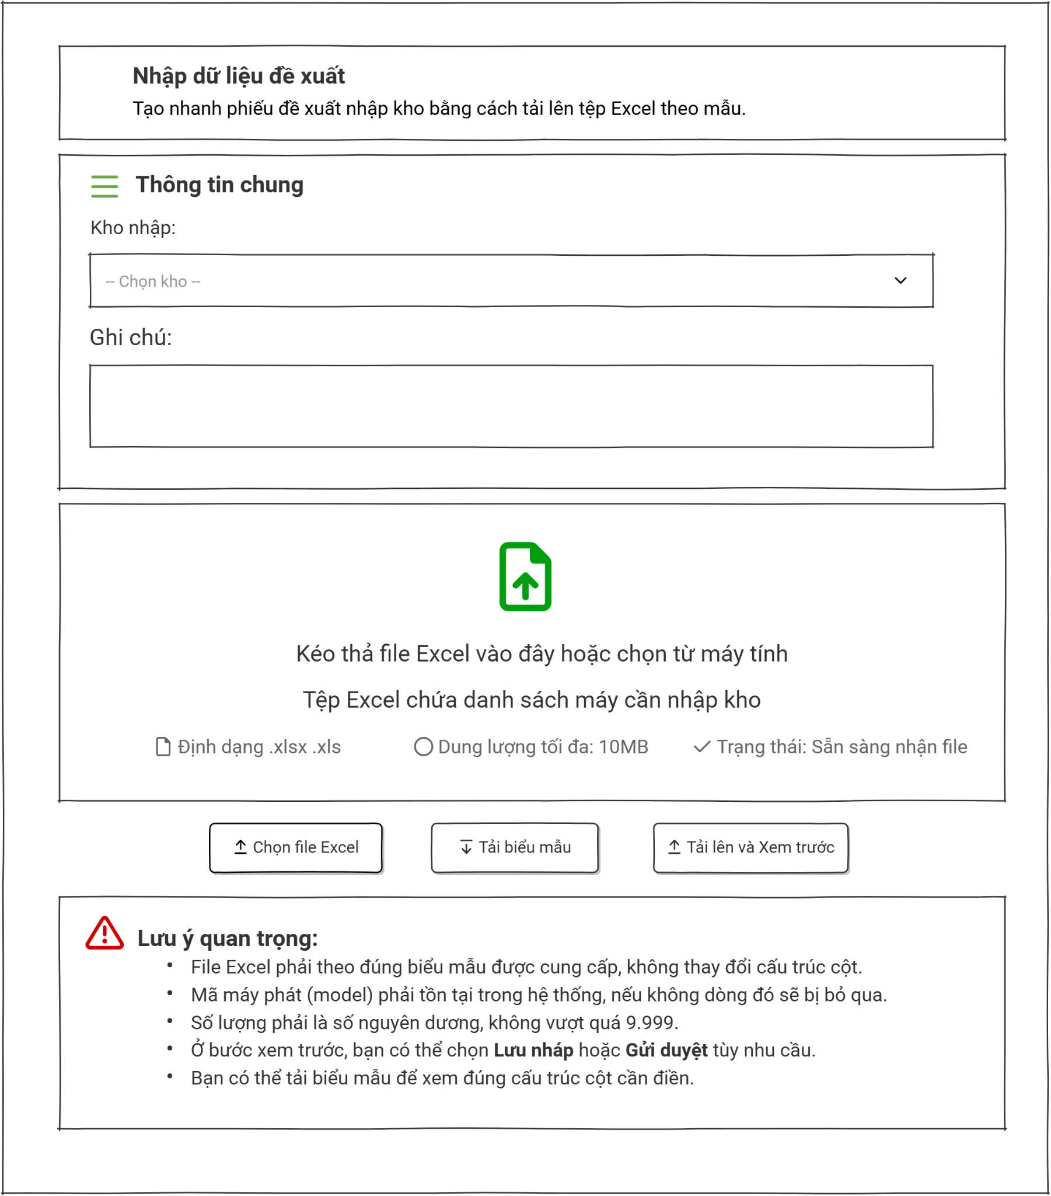
Screen Name: Import Goods via Excel
Access Role: Sale Staff
Main Functionality: This screen allows authorized users to create a goods import proposal by uploading a structured Excel file. It requires selecting a destination warehouse, provides an optional notes field, and includes specific validation guidelines for the uploaded data. Users can download a template file, upload their data, and preview it before final submission.

Field Name | Description
Receiving Warehouse | Dropdown selection field labeled "Kho nhập:". Marked as a required step to specify the destination warehouse for the imported goods. Placeholder text: "-- Chọn kho --".
Notes | Text area input field labeled "Ghi chú:". Optional field for users to enter additional remarks, descriptions, or notes regarding the import batch.
Drag and Drop Zone | Drag-and-drop zone with a file icon. Allows users to drag and drop an Excel file or browse from their computer. Supported formats are .xlsx and .xls, with a maximum file size of 10MB.
Select Excel File | Secondary action button labeled "Chọn file Excel" with an upload icon. Opens the system file explorer to let users select and upload an Excel file from their computer.
Download Template | Action button labeled "Tải biểu mẫu" with a download icon. Downloads the standardized Excel template file containing the required column structure.
Upload and Preview | Primary action button labeled "Tải lên và Xem trước" with an upload icon. Uploads the selected file, validates the data format, and navigates the user to a preview screen.

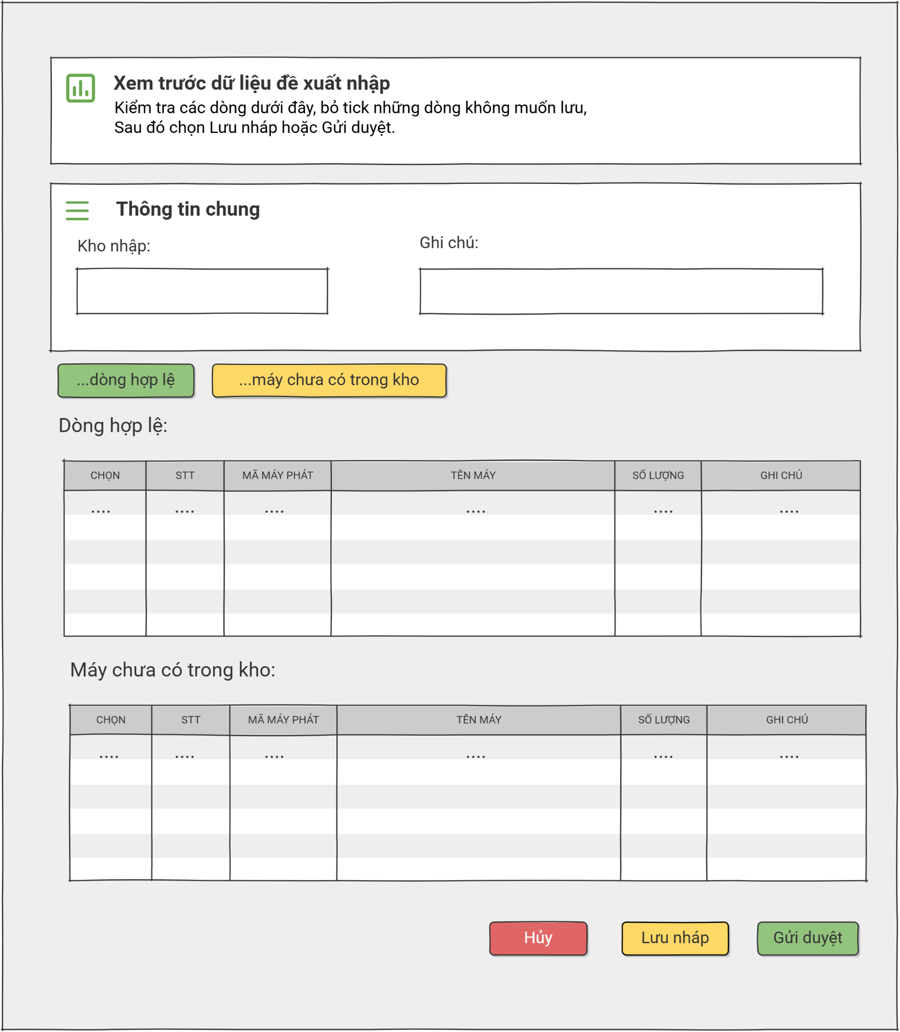
Screen Name: Preview Imported Goods
Data Access Role: Sale Staff
Main Functionality: This screen allows authorized users to review and validate data parsed from an uploaded Excel file before officially saving or submitting the import proposal. Users can check or uncheck individual items across different validation status tables to decide which rows to process.

Field Name | Description
Receiving Warehouse | Read-only or pre-populated text field labeled "Kho nhập:". Displays the destination warehouse selected from the previous step.
Notes | Read-only or pre-populated text field labeled "Ghi chú:". Displays the notes or remarks entered from the previous step.
Valid Rows Status Tab | Status indicator button labeled "...dòng hợp lệ" with a green background. Represents the quick navigation filter or count for data rows that passed initial system validation.
New Models Status Tab | Status indicator button labeled "...máy chưa có trong kho" with a yellow background. Represents the quick navigation filter or count for generator models that currently do not exist in the selected warehouse inventory.
Valid Rows Table | Data table labeled "Dòng hợp lệ:". Displays successfully validated items with columns: Select (CHỌN), No. (STT), Generator Code (MÃ MÁY PHÁT), Equipment Name (TÊN MÁY), Quantity (SỐ LƯỢNG), and Note (GHI CHÚ).
New Models Table | Data table labeled "Máy chưa có trong kho:". Displays items whose models are recognized by the system but have no prior inventory records in this specific warehouse. It contains identical columns to the valid rows table.
Cancel | Action button labeled "Hủy" with a red background. Discards the current previewed import batch data and returns the user to the previous upload screen.
Save Draft | Action button labeled "Lưu nháp" with a yellow background. Saves the currently selected records as a draft import proposal for later modification or review.
Submit for Approval | Primary action button labeled "Gửi duyệt" with a green background. Submits the checked items to the formal approval workflow for final warehouse entry confirmation.

5.0.3 Proposal detail:
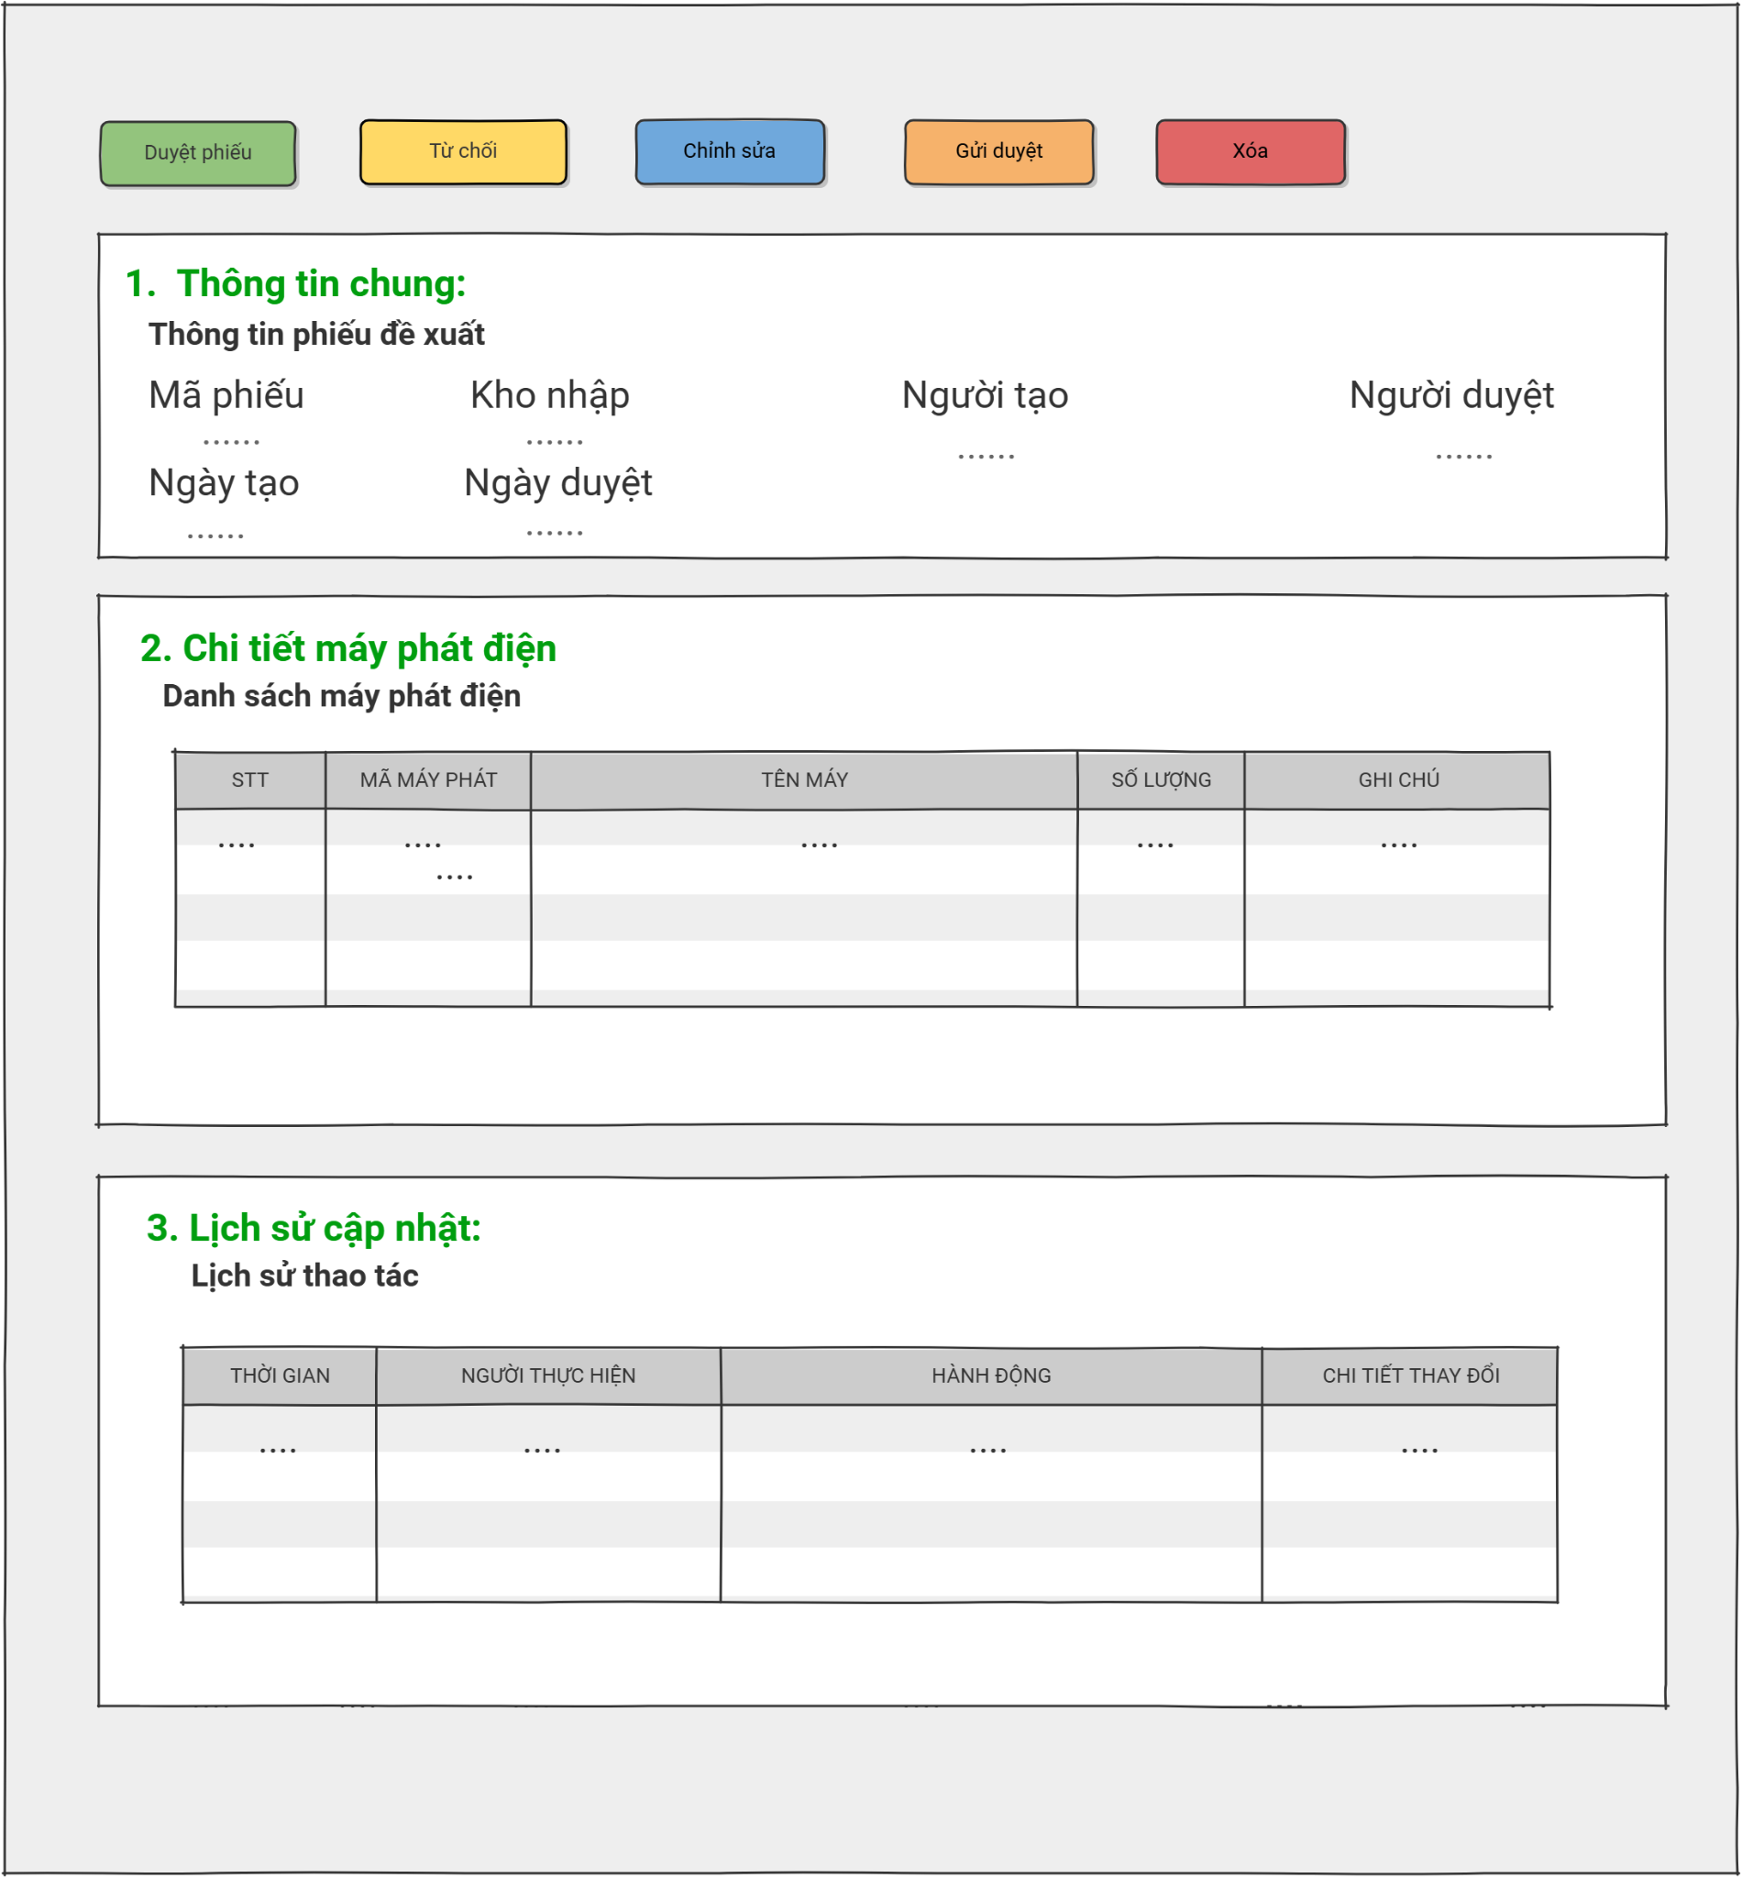
Screen Name: Goods Import Proposal Details
Access Role: Sale Staff, Sale Manager
Main Functionality: This screen allows authorized users to view the comprehensive details of a specific goods import proposal. It displays general proposal metadata, an itemized list of generators, and a complete operational log history. Depending on their permissions and the document state, users can approve, reject, edit, submit for approval, or delete the proposal.

Field Name | Description
Approve Proposal | Action button labeled "Duyệt phiếu" with a green background. Approves the current proposal and moves it to the next step in the workflow.
Reject | Action button labeled "Từ chối" with a yellow background. Rejects the proposal, preventing further processing without modifications.
Edit | Action button labeled "Chỉnh sửa" with a blue background. Navigates the user to the editing screen to modify the current proposal details.
Submit for Approval | Action button labeled "Gửi duyệt" with an orange background. Submits a draft or modified proposal to the authorized reviewers for formal approval.
Delete | Action button labeled "Xóa" with a red background. Permanently removes the proposal record from the system database.
New Models Table | Data table labeled "Máy chưa có trong kho:". Displays items whose models are recognized by the system but have no prior inventory records in this specific warehouse. It contains identical columns to the valid rows table.
Cancel | Action button labeled "Hủy" with a red background. Discards the current previewed import batch data and returns the user to the previous upload screen.
Save Draft | Action button labeled "Lưu nháp" with a yellow background. Saves the currently selected records as a draft import proposal for later modification or review.
Submit for Approval | Primary action button labeled "Gửi duyệt" with a green background. Submits the checked items to the formal approval workflow for final warehouse entry confirmation.

5.0.4 Edit proposal:
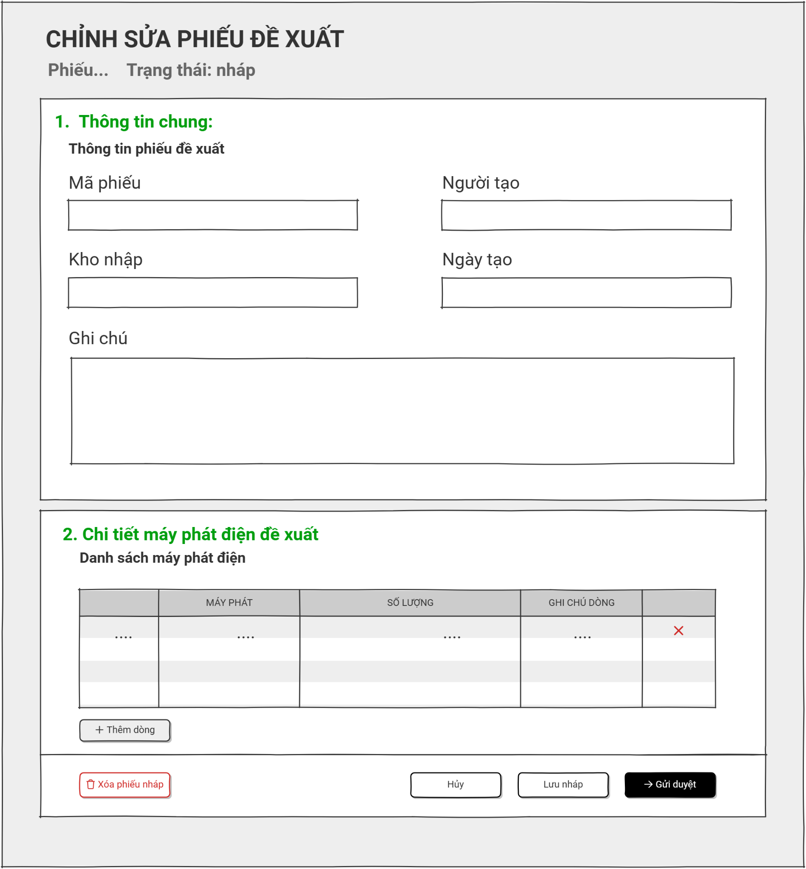

6.0 System Log
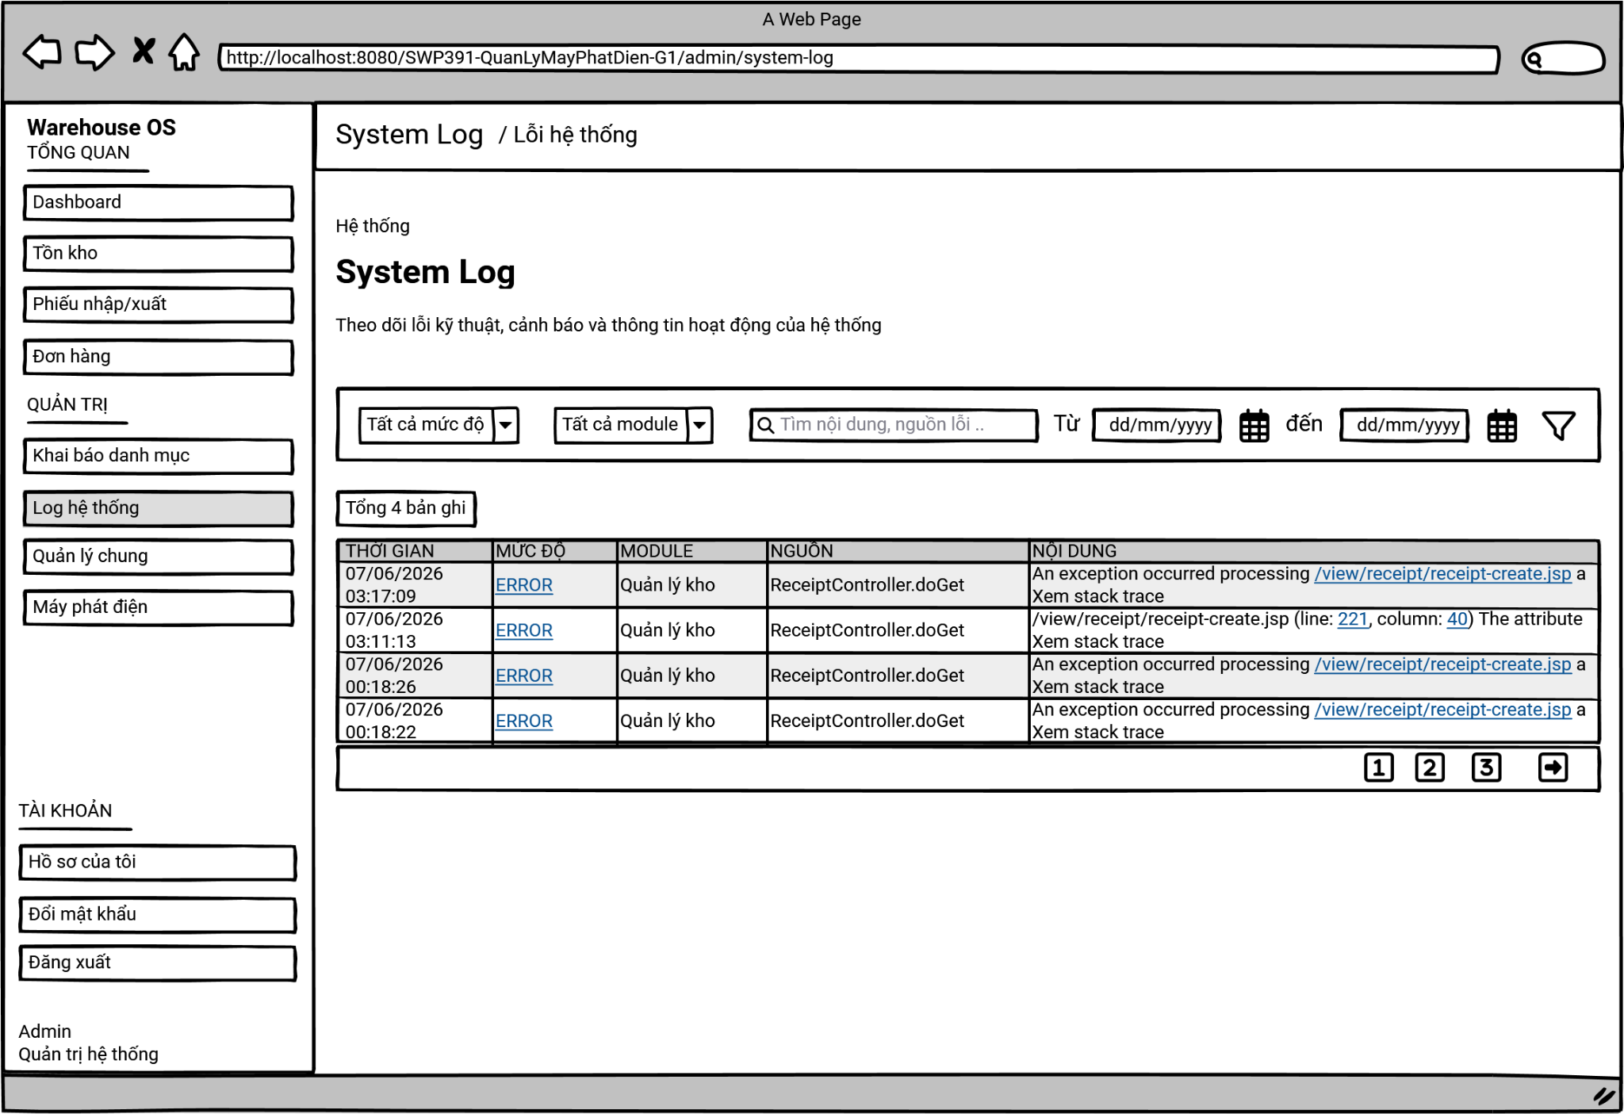
This screen allows the Administrator or technical support staff to monitor, search, and review technical errors, warnings, and operational activities across the entire system.
On this screen, the Administrator can:
- Monitor System Health: view a consolidated list of system logs to track technical issues or verify system behavior.
- Filter by Severity Level: narrow down the log entries by selecting a specific severity level (e.g., Error, Warning, Info) from a dropdown menu.
- Filter by Module: isolate logs generated by specific functional areas or modules within the system (e.g., "Quản lý kho").
- Search by Keyword: use a text search bar to find specific error messages, exception types, or source files/controllers (e.g., "ReceiptController.doGet").
- Filter by Date Range: define a specific start and end date to investigate issues that occurred during a particular timeframe.
- Investigate Details: view deep technical details by clicking on error links or "Xem stack trace" to aid in debugging and troubleshooting.

Field Name | Description
Severity Filter | Severity Dropdown: "Tất cả mức độ"  - A dropdown menu allowing the user to filter logs by their technical severity level (e.g., ERROR, WARN, INFO).
Module Filter | Module Dropdown: "Tất cả module"  - A dropdown menu to filter the logs based on the system module where the event occurred.
Search Input | Search Bar: "Tìm nội dung, nguồn lỗi .."  - A text input field with a magnifying glass icon used to search for specific keywords within the log's content or source origin.
Date Range | Date Pickers: "Từ" [dd/mm/yyyy] "đến" [dd/mm/yyyy]  - Input fields with calendar icons to specify a start date and an end date to filter the system logs within a specific time frame.
Filter Button | Filter Button: (Funnel Icon)  - A button featuring a funnel/filter icon used to execute the search and apply the selected criteria to the log table below.
Record Count | Result Summary: "Tổng [X] bản ghi"  - A text label indicating the total number of log entries found based on the currently applied filters (e.g., "Tổng 4 bản ghi").
Log Table | System Log Table:  - A structured grid displaying the technical logs.  - Columns include:  + THỜI GIAN (Timestamp): The exact date and time the event occurred.  + MỨC ĐỘ (Severity Level): The classification of the log (e.g., ERROR). Often displayed as a clickable link for more details.  + MODULE: The specific subsystem or feature area (e.g., Quản lý kho).  + NGUỒN (Source): The specific class, method, or file that threw the error (e.g., ReceiptController.doGet).  + NỘI DUNG (Content): The specific error message, exception description, and actionable links like "Xem stack trace" for developers.

III. System Design

1. Software Architecture

1.1 Overall Architecturural Diagram
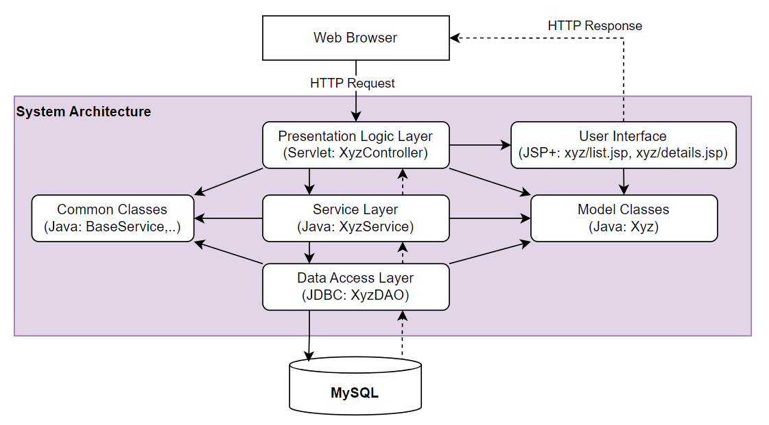

1.2 Component Descriptions
No | Component | Description
01 | Presentation Logic Layer | <Description of the component>
02 | User Interface | <Description of the package>
03 | …
-

2. Code Package Design

2.1 Package Diagram
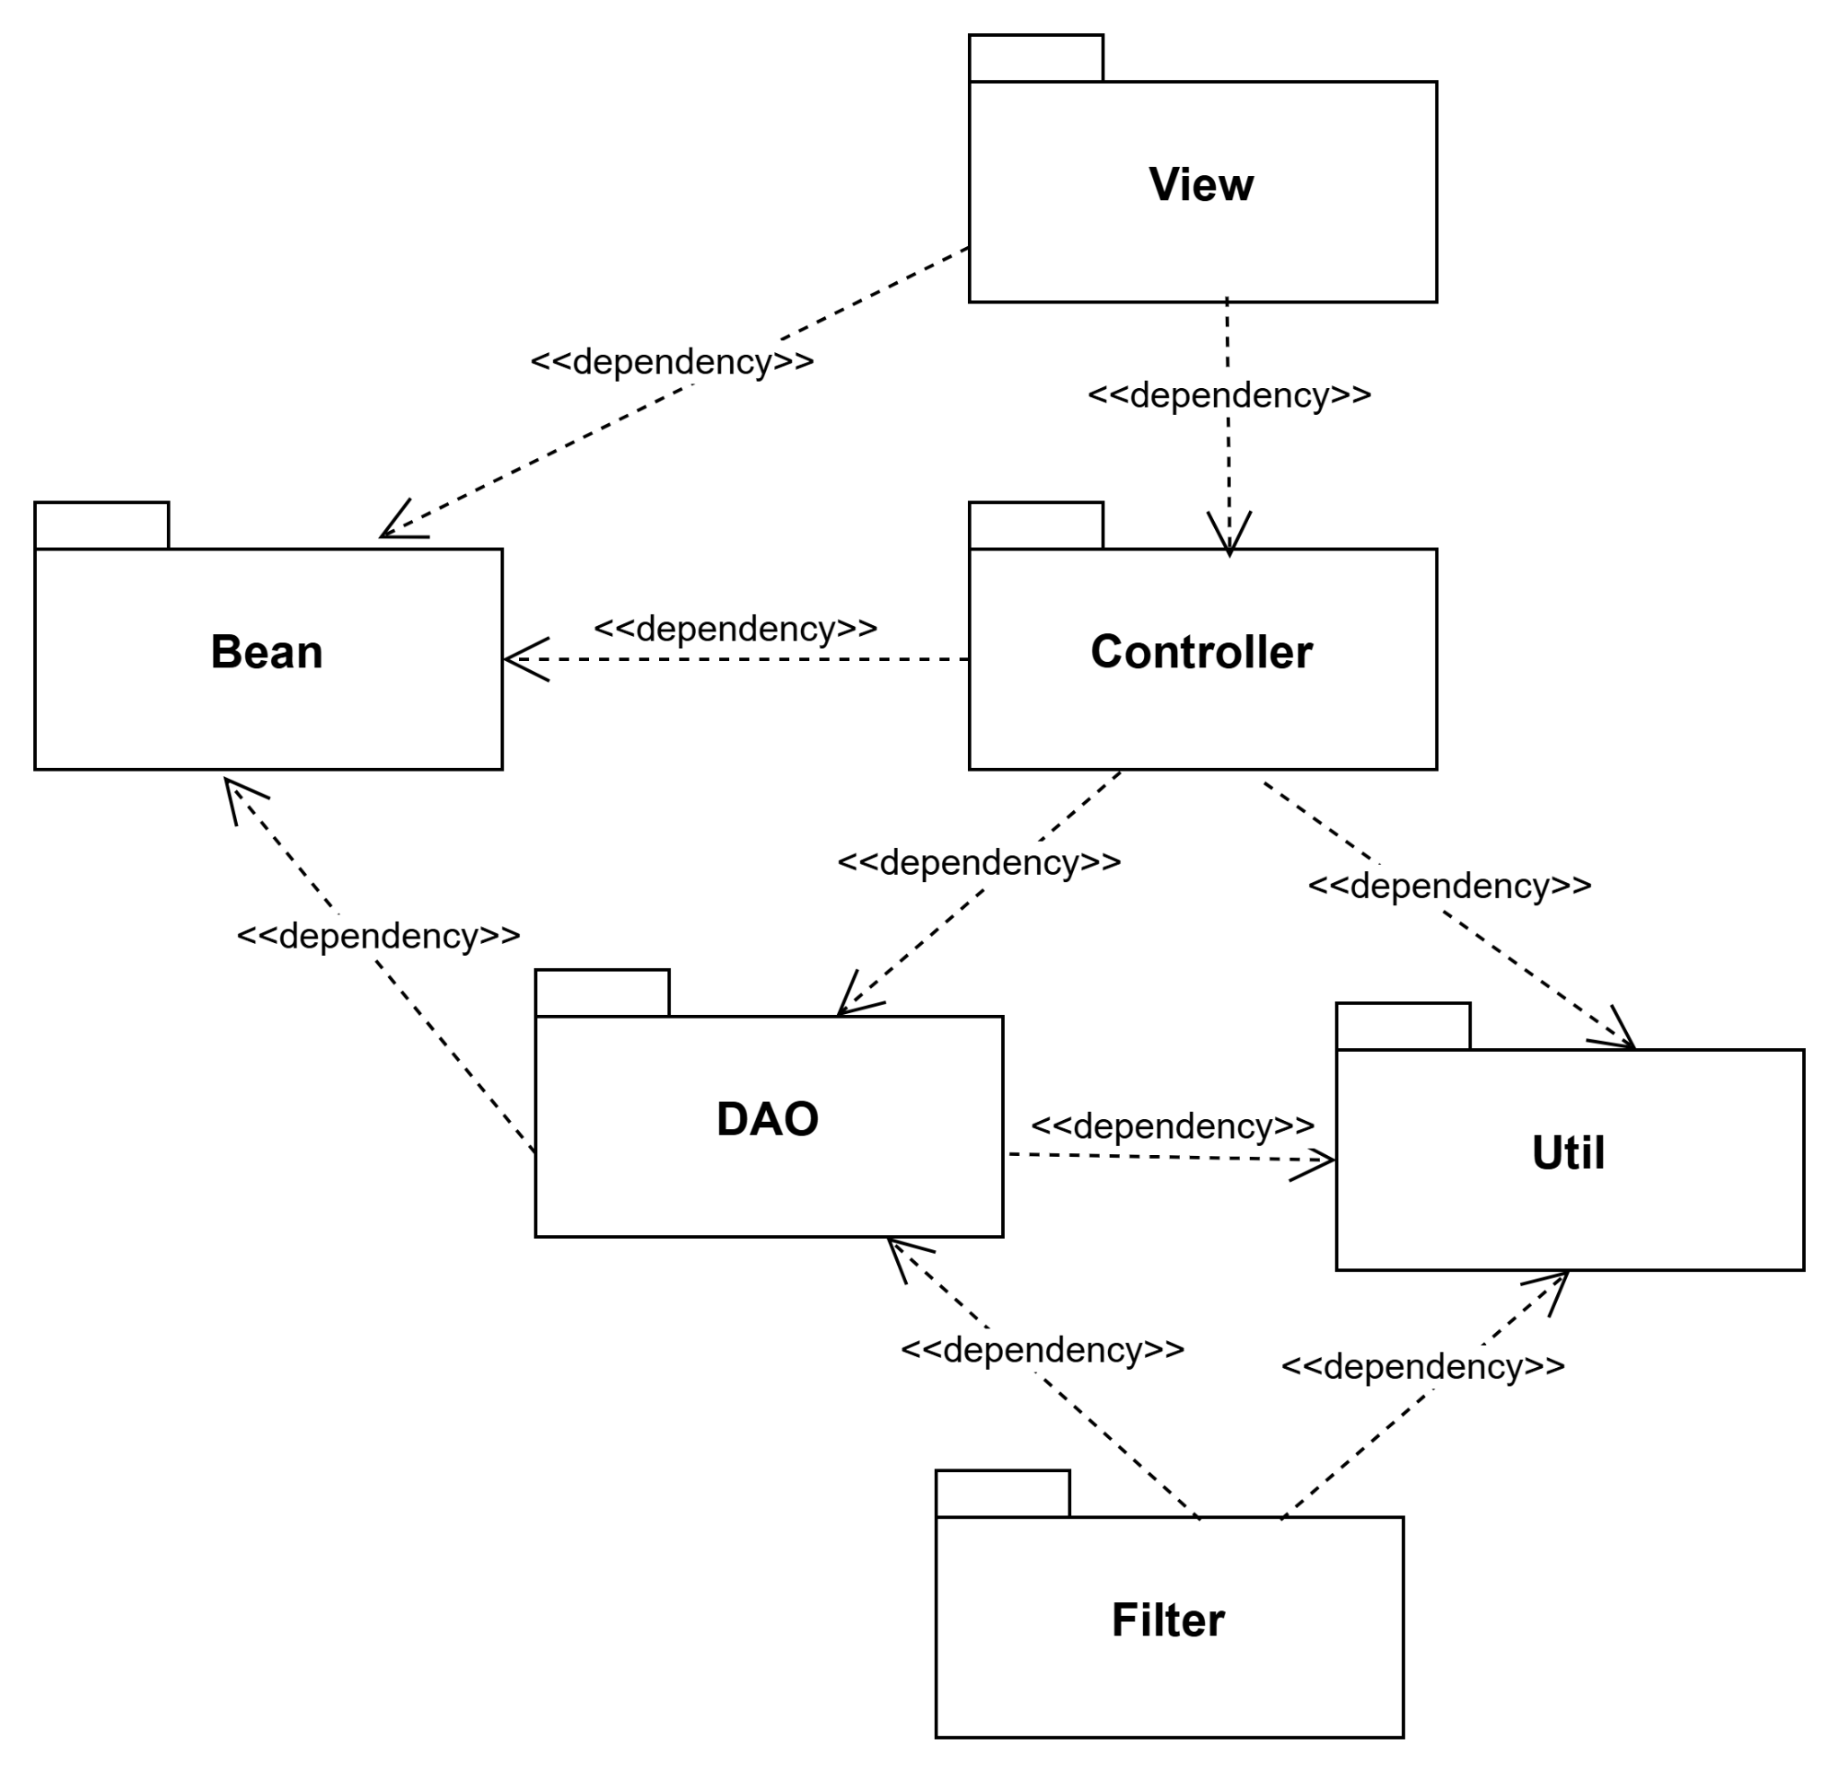
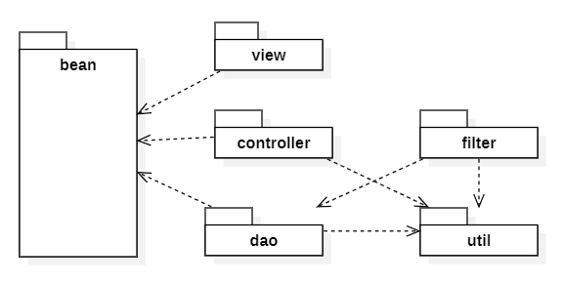

2.2 Package Descriptions
No | Package | Description
01 | View | Contains the user interface components of the application (JSP, HTML, CSS, and JavaScript files). This package is responsible for presenting data visually to the 4 main actors (Admin, Warehouse Manager, Warehouse Staff, and Sales Staff) and capturing user interaction events (button clicks, form submissions) to send requests to the system.
02 | Bean | Defines the pure data entity classes (JavaBeans/POJO) that map directly to the tables in the warehousedb database . It serves as intermediate objects used to encapsulate and transfer information seamlessly across the View, Controller, and DAO layers
03 | Controller | Contains Java Servlet classes acting as the central control mechanism of the internal warehouse management system. This package intercepts and analyzes HTTP requests from the View layer, handles routing logic, invokes corresponding data processing methods in the DAO layer, and determines which View page should be rendered back to the user.
04 | DAO | The Data Access Object package. It encapsulates all database query logic and executes direct SQL statements against the MySQL database. This layer interacts with the database management system using connections provided by the Util package to retrieve or update inventory and account data.
05 | Util | Contains configuration classes and common utility helper tools used throughout the entire project. The core responsibility of this package is to manage the database connection lifecycle (DB Connection), configure security encryption for passwords that support the DAO and Controller layers.
06 | Filter | Acts as an intermediary middleware component positioned before the Controller layer to handle pre-processing and post-processing tasks for HTTP Requests/Responses. This package is responsible for verifying user authentication status, validating access permissions for the 4 roles (Authorization).

3. Database Design
[Provide the files description, database table relationship & table descriptions like example below]

3.1 Database Schema
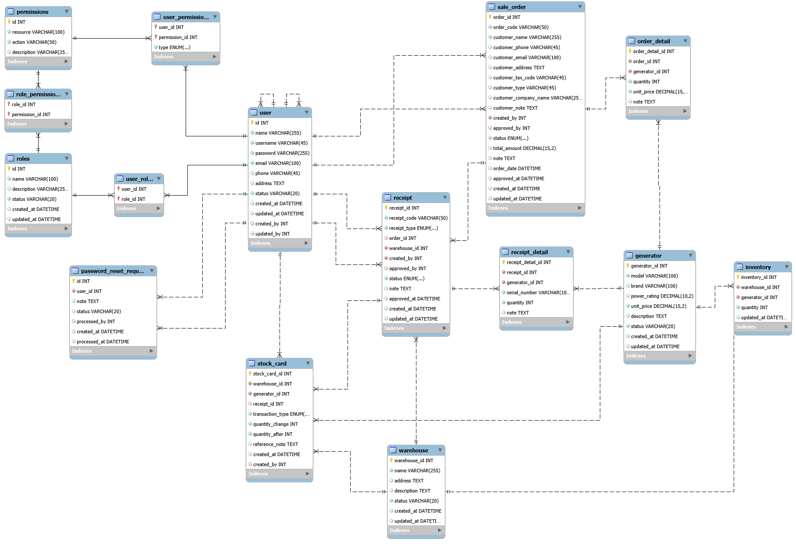

3.2 Table Descriptions

3.2.1 – user
Stores all user accounts in the system (Admin, Warehouse Manager, Warehouse Staff, Sales Staff, Sale Manager).
No | Field | PK | FK | UN | NN | Description
01 | id | X |  |  | X | Unique user identifier, auto increment
02 | name |  |  |  | X | Full name
03 | username |  |  | X | X | Unique login username
04 | password |  |  |  | X | Encrypted password (BCrypt)
05 | email |  |  | X | X | Email address
06 | phone |  |  |  |  | Contact phone number
07 | address |  |  |  |  | Contact address
08 | status |  |  |  | X | Account status: active, inactive, pending, locked
09 | created_at |  |  |  |  | Record creation timestamp
10 | updated_at |  |  |  |  | Last update timestamp
11 | created_by |  | X |  |  | ID of user who created the record (FK → user.id)
12 | updated_by |  | X |  |  | ID of user who last updated the record (FK → user.id)

3.2.2 – role
System roles used for RBAC (admin, warehouse_manager, sales_staff, sale_manager, ...).
No | Field | PK | FK | UN | NN | Description
01 | id | X |  |  | X | Unique role identifier, auto increment
02 | name |  |  | X | X | Role name
03 | description |  |  |  |  | Role description
04 | status |  |  |  | X | Status: active, inactive
05 | created_at |  |  |  |  | Record creation timestamp
06 | updated_at |  |  |  |  | Last update timestamp

3.2.3 – permission
Atomic permission definitions (resource + action) used by RBAC.
No | Field | PK | FK | UN | NN | Description
01 | id | X |  |  | X | Unique permission identifier, auto increment
02 | resource |  |  |  | X | Protected resource name (users, roles, generators...)
03 | action |  |  |  | X | Action on resource (view, create, update, delete, approve...)
04 | description |  |  |  |  | Human-readable permission description
Unique constraint on (resource, action)

3.2.4 – user_role
Many-to-many junction linking users to their assigned roles.
No | Field | PK | FK | UN | NN | Description
01 | user_id |  | X |  | X | User ID (FK → user.id)
02 | role_id |  | X |  | X | Role ID (FK → role.id)

3.2.5 – role_permission
Many-to-many junction linking roles to their granted permissions.
No | Field | PK | FK | UN | NN | Description
01 | role_id |  | X |  | X | Role ID (FK → role.id)
02 | permission_id |  | X |  | X | Permission ID (FK → permission.id)

3.2.6 – user_permission
Individual permission overrides for a user. Overrides take priority over role-based permissions (GRANT adds, DENY revokes).
No | Field | PK | FK | UN | NN | Description
01 | user_id |  | X |  | X | User ID (FK → user.id)
02 | permission_id |  | X |  | X | Permission ID (FK → permission.id)
03 | type |  |  |  | X | Type/category code

3.2.7 – password_reset_request
Stores password reset requests submitted by users who have forgotten their credentials. Admin reviews and processes requests manually.
No | Field | PK | FK | UN | NN | Description
01 | id | X |  |  | X | Unique password_reset_request identifier, auto increment
02 | user_id |  | X |  | X | Reference to user.id (FK)
03 | note |  |  |  |  | Free-form notes
04 | status |  |  |  |  | Status flag
05 | processed_by |  | X |  |  | ID of admin who processed the request (FK → user.id)
06 | created_at |  |  |  |  | Record creation timestamp
07 | processed_at |  |  |  |  | Admin processing timestamp

3.2.8 – system_log
Application system log (info, warning, error) with optional user reference and stack trace.
No | Field | PK | FK | UN | NN | Description
01 | id | X |  |  | X | Unique system_log identifier, auto increment
02 | level |  |  |  | X | Log level: INFO, WARNING, ERROR
03 | module |  |  |  | X | Module the category belongs to
04 | user_id |  | X |  |  | Reference to user.id (FK)
05 | source |  |  |  |  | Source class or method
06 | message |  |  |  | X | Log message text
07 | stack_trace |  |  |  |  | Exception stack trace
08 | created_at |  |  |  | X | Record creation timestamp

3.2.9 – activity_log
Stores audit log of user activities on entities (categories, users, etc.) for tracking and compliance.
No | Field | PK | FK | UN | NN | Description
01 | id | X |  |  | X | Unique activity_log identifier, auto increment
02 | user_id |  | X |  | X | Reference to user.id (FK)
03 | entity_type |  |  |  | X | Affected entity type
04 | action |  |  |  | X | Action on resource (view, create, update, delete, approve...)
05 | entity_id |  |  |  |  | ID reference
06 | entity_name |  |  |  |  | Affected entity name
07 | details |  |  |  |  | Additional details
08 | created_at |  |  |  |  | Record creation timestamp

3.2.10 – category
Centralized table for system categories. Each row is a category record; the `type` column distinguishes sub-types (brand, fuel_type, generator_type, phase, condition, origin, customer_type, receipt_reason) and additional type-specific fields are stored in child tables.
No | Field | PK | FK | UN | NN | Description
01 | id | X |  |  | X | Unique category identifier, auto increment
02 | module |  |  |  |  | Module the category belongs to
03 | name |  |  |  | X | Category name
04 | type |  |  |  | X | Type/category code
05 | description |  |  |  |  | Category description
06 | status |  |  |  |  | Status: active, inactive
07 | created_at |  |  |  |  | Record creation timestamp
08 | updated_at |  |  |  |  | Last update timestamp

3.2.11 – category_brand
Brand-specific extension for category rows of type `brand`. Stores country, website, founded year and warranty period.
No | Field | PK | FK | UN | NN | Description
01 | category_id | X | X |  | X | Category ID (FK → category.id)
02 | country |  |  |  |  | Country of origin
03 | website |  |  |  |  | Official website URL
04 | founded_year |  |  |  |  | Year the brand was founded
05 | warranty_period |  |  |  |  | Warranty period (months)

3.2.12 – category_condition
Marker extension for category rows of type `condition` (new / used).
No | Field | PK | FK | UN | NN | Description
01 | category_id | X | X |  | X | Category ID (FK → category.id)

3.2.13 – category_customer_type
Customer-type extension for category rows (individual, company, government). Stores tax type.
No | Field | PK | FK | UN | NN | Description
01 | category_id | X | X |  | X | Category ID (FK → category.id)
02 | tax_type |  |  |  |  | Tax classification

3.2.14 – category_fuel_type
Fuel-type extension for category rows (gasoline, diesel, etc.). Stores unit and typical price.
No | Field | PK | FK | UN | NN | Description
01 | category_id | X | X |  | X | Category ID (FK → category.id)
02 | unit |  |  |  |  | Measurement unit
03 | typical_price |  |  |  |  | Typical price per unit

3.2.15 – category_generator_type
Marker extension for category rows of type `generator_type` (inverter, industrial, residential).
No | Field | PK | FK | UN | NN | Description
01 | category_id | X | X |  | X | Category ID (FK → category.id)

3.2.16 – category_origin
Origin extension for category rows of type `origin`. Stores ISO country code.
No | Field | PK | FK | UN | NN | Description
01 | category_id | X | X |  | X | Category ID (FK → category.id)
02 | country_code |  |  |  |  | ISO country code

3.2.17 – category_phase
Marker extension for category rows of type `phase` (1-phase, 3-phase).
No | Field | PK | FK | UN | NN | Description
01 | category_id | X | X |  | X | Category ID (FK → category.id)

3.2.18 – category_receipt_reason
Marker extension for category rows of type `receipt_reason` (reasons for stock adjustments).
No | Field | PK | FK | UN | NN | Description
01 | category_id | X | X |  | X | Category ID (FK → category.id)

3.2.19 – customer
Stores customer master data used in sale orders. Replaces the inline customer fields previously embedded in `sale_order`.
No | Field | PK | FK | UN | NN | Description
01 | id | X |  |  | X | Unique customer identifier, auto increment
02 | name |  |  |  | X | Display name. Tên khách hàng hoặc tên công ty
03 | phone |  |  |  |  | Contact phone number
04 | email |  |  |  |  | Email address
05 | address |  |  |  |  | Contact address
06 | company_name |  |  |  |  | Company name (NULL for individuals). NULL nếu là cá nhân
07 | customer_type_id |  | X |  |  | Reference to category.id (FK)
08 | status |  |  |  | X | Status flag
09 | created_at |  |  |  |  | Record creation timestamp
10 | created_by |  | X |  |  | ID of user who created the record (FK → user.id)
11 | updated_at |  |  |  |  | Last update timestamp
12 | updated_by |  | X |  |  | ID of user who last updated the record (FK → user.id)

3.2.20 – supplier
Stores supplier master data used when creating import receipts.
No | Field | PK | FK | UN | NN | Description
01 | id | X |  |  | X | Unique supplier identifier, auto increment
02 | name |  |  |  | X | Display name. Tên nhà cung cấp hoặc tên công ty
03 | phone |  |  |  |  | Contact phone number
04 | email |  |  |  |  | Email address
05 | address |  |  |  |  | Contact address
06 | company_name |  |  |  |  | Company name (NULL for individuals). NULL nếu là cá nhân
07 | customer_type_id |  | X |  |  | Reference to category.id (FK)
08 | status |  |  |  | X | Status flag
09 | created_at |  |  |  |  | Record creation timestamp
10 | created_by |  | X |  |  | ID of user who created the record (FK → user.id)
11 | updated_at |  |  |  |  | Last update timestamp
12 | updated_by |  | X |  |  | ID of user who last updated the record (FK → user.id)

3.2.21 – generator
Catalog of generator products managed by the system.
No | Field | PK | FK | UN | NN | Description
01 | id | X |  |  | X | Unique generator identifier, auto increment
02 | model |  |  |  | X | Model code
03 | power_rating |  |  |  |  | Rated power output (kVA)
04 | unit_price |  |  |  | X | Unit price (VND)
05 | frequency |  |  |  |  | Frequency (Hz)
06 | weight |  |  |  |  | Weight (kg)
07 | description |  |  |  |  | Detailed product description
08 | status |  |  |  | X | Status: available, out_of_stock, discontinued
09 | created_at |  |  |  |  | Record creation timestamp
10 | updated_at |  |  |  |  | Last update timestamp
11 | created_by |  |  |  |  | ID of user who created the record
12 | updated_by |  |  |  |  | ID of user who last updated the record

3.2.22 – generator_category
Many-to-many junction linking generators to the categories that classify them (brand, fuel_type, phase, origin, etc.).
No | Field | PK | FK | UN | NN | Description
01 | generator_id |  | X |  | X | Generator ID (FK → generator.id)
02 | category_id |  | X |  | X | Category ID (FK → category.id)

3.2.23 – warehouse
Warehouse locations where generators are stocked.
No | Field | PK | FK | UN | NN | Description
01 | warehouse_id | X |  |  | X | Unique warehouse identifier, auto increment
02 | name |  |  |  | X | Warehouse name
03 | address |  |  |  |  | Warehouse address
04 | description |  |  |  |  | Warehouse description
05 | status |  |  |  | X | Status: active, inactive
06 | created_at |  |  |  |  | Record creation timestamp
07 | updated_at |  |  |  |  | Last update timestamp

3.2.24 – inventory
Current stock quantity of each generator at each warehouse.
No | Field | PK | FK | UN | NN | Description
01 | inventory_id | X |  |  | X | Unique inventory identifier, auto increment
02 | warehouse_id |  | X |  | X | Reference to warehouse.warehouse_id (FK)
03 | generator_id |  | X |  | X | Reference to generator.id (FK)
04 | quantity |  |  |  | X | Quantity value
05 | updated_at |  |  |  |  | Last update timestamp
Unique constraint on (warehouse_id, generator_id)

3.2.25 – stock_card
Stock movement history. Every import, export, or adjustment is recorded here for audit trail.
No | Field | PK | FK | UN | NN | Description
01 | stock_card_id | X |  |  | X | Unique stock_card identifier, auto increment
02 | warehouse_id |  | X |  | X | Reference to warehouse.warehouse_id (FK)
03 | generator_id |  | X |  | X | Reference to generator.id (FK)
04 | receipt_id |  | X |  |  | Reference to receipt.receipt_id (FK)
05 | transaction_type |  |  |  | X | Transaction type: IMPORT, EXPORT, ADJUST
06 | quantity_change |  |  |  | X | Signed quantity change (positive import, negative export)
07 | quantity_after |  |  |  | X | Stock quantity after the transaction
08 | reference_note |  |  |  |  | Reference note for the transaction
09 | created_at |  |  |  |  | Record creation timestamp
10 | created_by |  | X |  |  | ID of user who created the record (FK → user.id)

3.2.26 – sale_order
Sale/purchase orders. Each order is linked to a customer in the `customer` table and has a lifecycle status.
No | Field | PK | FK | UN | NN | Description
01 | order_id | X |  |  | X | Unique sale_order identifier, auto increment
02 | order_code |  |  | X | X | Order code (e.g. SO-YYYYMMDD-NNN)
03 | customer_id |  | X |  |  | Reference to customer.id (FK)
04 | created_by |  | X |  | X | ID of user who created the record (FK → user.id)
05 | approved_by |  | X |  |  | ID of approver user (FK → user.id)
06 | status |  |  |  | X | Order status: PENDING, APPROVED, REJECTED, CANCELLED
07 | total_amount |  |  |  |  | Total monetary amount (VND)
08 | note |  |  |  |  | Free-form notes
09 | customer_note |  |  |  |  | Customer-provided note
10 | order_date |  |  |  |  | Order date
11 | approved_at |  |  |  |  | Approval/rejection timestamp
12 | created_at |  |  |  |  | Record creation timestamp
13 | updated_at |  |  |  |  | Last update timestamp
14 | cancelled_by |  |  |  |  | ID of user who cancelled the record
15 | cancelled_at |  |  |  |  | Cancellation timestamp
16 | updated_by |  |  |  |  | ID of user who last updated the record
17 | rejected_by |  | X |  |  | ID of user who rejected the record (FK → user.id)
18 | reject_reason |  |  |  |  | Reason for rejection

3.2.27 – order_detail
Line items inside a sale order. Each row represents a generator with quantity and unit price at order time.
No | Field | PK | FK | UN | NN | Description
01 | order_detail_id | X |  |  | X | Unique order_detail identifier, auto increment
02 | order_id |  | X |  | X | Reference to sale_order.order_id (FK)
03 | generator_id |  | X |  | X | Reference to generator.id (FK)
04 | quantity |  |  |  | X | Quantity value
05 | unit_price |  |  |  | X | Unit price (VND)
06 | note |  |  |  |  | Free-form notes

3.2.28 – order_category
Many-to-many junction linking sale orders to the categories relevant to the order (used for reporting/filtering).
No | Field | PK | FK | UN | NN | Description
01 | order_id |  | X |  | X | Order ID (FK → sale_order.order_id)
02 | category_id |  | X |  | X | Category ID (FK → category.id)

3.2.29 – receipt
Import/export warehouse receipts. Each receipt is associated with a warehouse and optionally linked to a sale order.
No | Field | PK | FK | UN | NN | Description
01 | receipt_id | X |  |  | X | Unique receipt identifier, auto increment
02 | receipt_code |  |  | X | X | Receipt code (e.g. RX-YYYYMMDD-NNN)
03 | receipt_type |  |  |  | X | Receipt type: IMPORT, EXPORT
04 | order_id |  | X |  |  | Reference to sale_order.order_id (FK)
05 | warehouse_id |  | X |  | X | Reference to warehouse.warehouse_id (FK)
06 | created_by |  | X |  | X | ID of user who created the record (FK → user.id)
07 | approved_by |  | X |  |  | ID of approver user (FK → user.id)
08 | status |  |  |  | X | Receipt status: PENDING, COMPLETED, CANCELLED
09 | note |  |  |  |  | Free-form notes
10 | total_amount |  |  |  |  | Total monetary amount (VND)
11 | approved_at |  |  |  |  | Approval/rejection timestamp
12 | created_at |  |  |  |  | Record creation timestamp
13 | updated_at |  |  |  |  | Last update timestamp
14 | reason_id |  | X |  |  | Reference to category.id (FK)
15 | reason_note |  |  |  |  | Free-text reason explanation

3.2.30 – receipt_detail
Line items inside a warehouse receipt. Each row represents a physical generator unit identified by serial number.
No | Field | PK | FK | UN | NN | Description
01 | receipt_detail_id | X |  |  | X | Unique receipt_detail identifier, auto increment
02 | receipt_id |  | X |  | X | Reference to receipt.receipt_id (FK)
03 | generator_id |  | X |  | X | Reference to generator.id (FK)
04 | serial_number |  |  |  | X | Generator serial number
05 | quantity |  |  |  | X | Quantity value
06 | unit_price |  |  |  |  | Unit price (VND)
07 | note |  |  |  |  | Free-form notes
Unique constraint on (serial_number, receipt_id)

